|  |  |
| --- | --- |
| Image result for stethoscope keyboard  **I.T. ADMIN,**  **SECURITY & UTILITIES**  USER’S MANUAL | BRIEF DEFINITION  Is a liaison between technical and non-technical people within a company. A person should have strong customer service and communication skills, both written and oral, with passion for technology and concern with stakeholders. |

Table of Contents

**Overview** 1

**Acknowledgement** 2

**Module Description** 2

**Wireframes/page layout** 3

**Menu Features/List of Function** 32

**Flow of functions** 85

**Procedures per Functions** 85

**Reports** 96

**Terms/Glossary** 102

**Appendix** 102

**FAQ** 102

**Document Revision Log** 102

**Document Sign Off** 103

# **Overview**

As an IT administrator, you’ll be responsible for maintaining the company's IT network, servers and security systems. This role is absolutely essential within any organization to ensure business continuity – if an IT network fails, the impact on the day to day running of the business can be significant.

To ensure the integrity of all the daily functions of the business, this User’s manual will help as a tool in guiding the user how to go about the functions as an I.T. Admin related task.

# **Acknowledgement**

It is highly indebted to MEAHCO Group, especially to Mr. Abner Hinanay and Mr. Peter Carmelo for their guidance and constant supervision as well as for providing necessary information regarding the project & also for their support in completing this manual.

It would not have been possible without the kind support and help of many individuals. I would like to extend my sincere thanks Jericho Seguenza, Sheldon Santos, Venus Coja, Arjay Villegas and Mr. Angelo Escorido for giving their time, attention and their insights in helping to accomplish this document.

# **Module Description**

The I.T. Admin Module allows you to set up additional users and passwords for anyone you would like to give access, this module is used to setup the master file for the records of the doctor’s needs, order and request, Mark-up, procedures equipment, Security, Tariff, Inventory, Operating Room and Financial Interface.

You can then pick the individual modules of the HIS (Hospital Information System) to grant them access. Additionally, you can give users access to all modules with a single click.

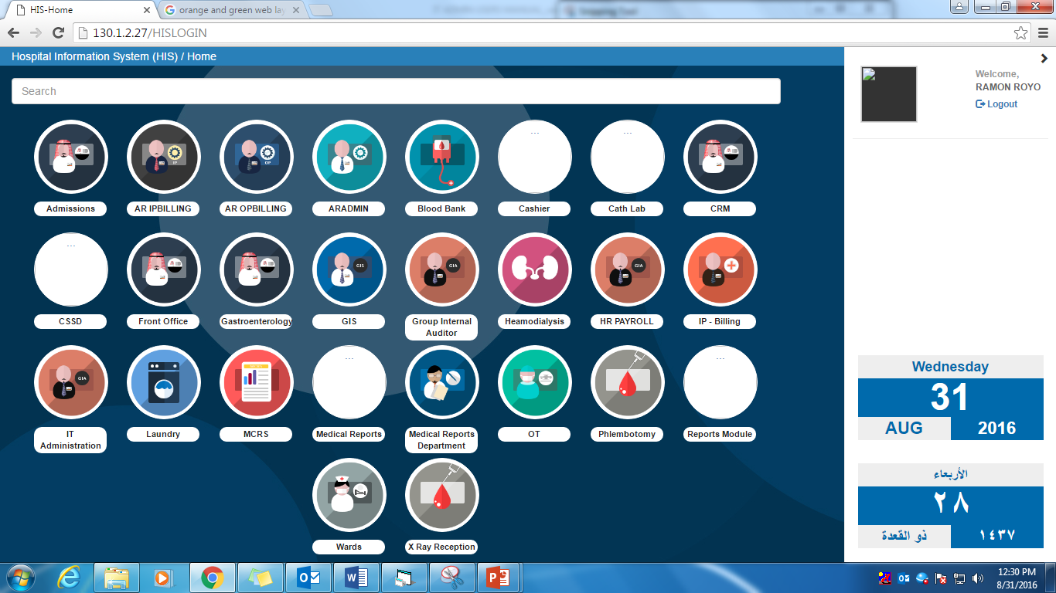

Click on IT Administration button to enter the module.

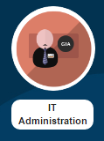

# **Wireframes/page layout**

A website wireframe, also known as a page schematic or screen blueprint, is a visual guide that represents the skeletal framework of a website.

1. Main Menu of HIS – Hospital Information System

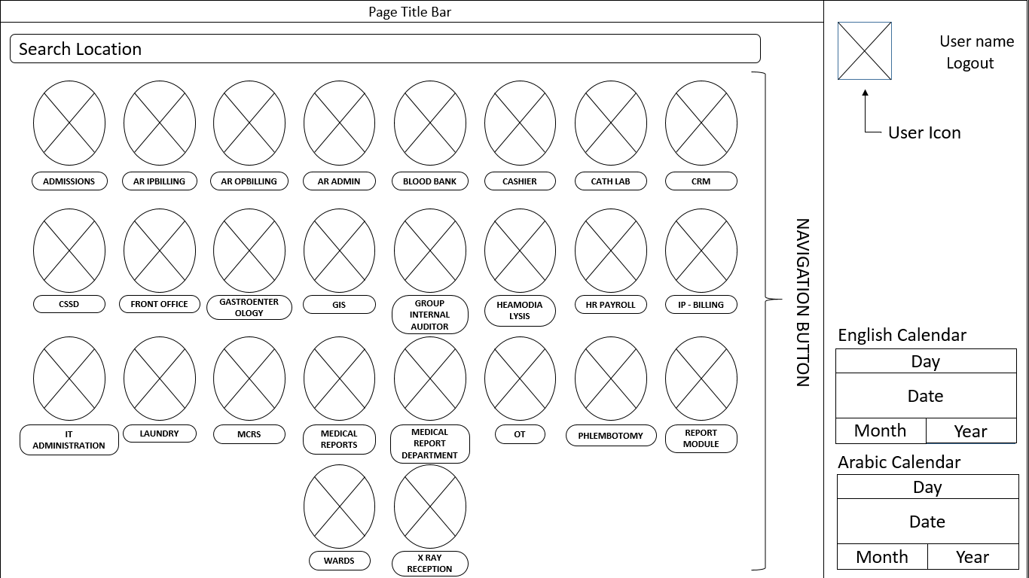

1. File
   1. Health Check-up

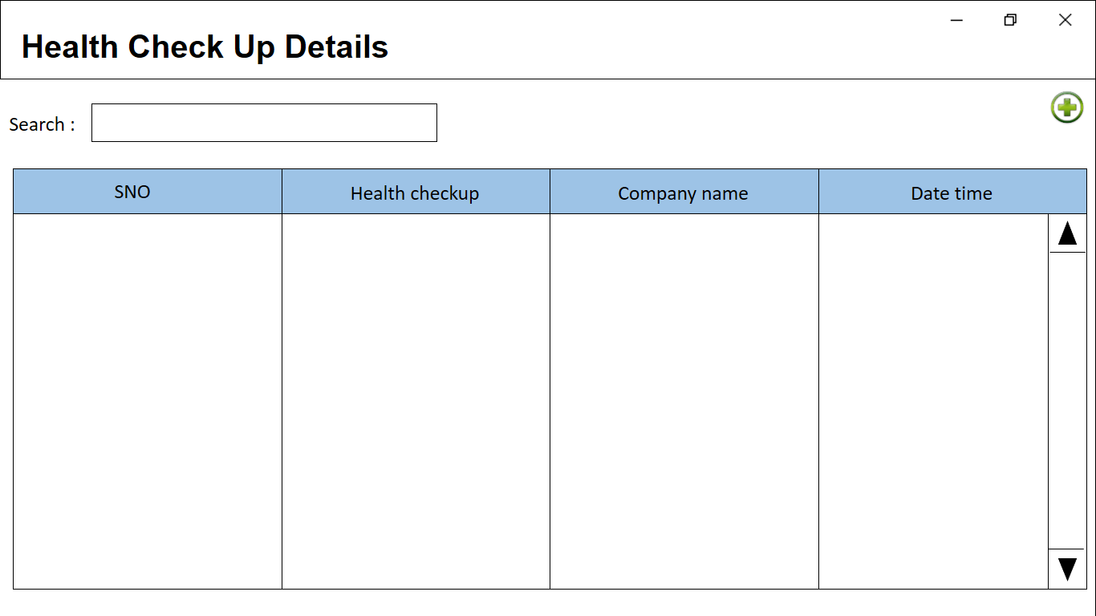

After clicking on add.

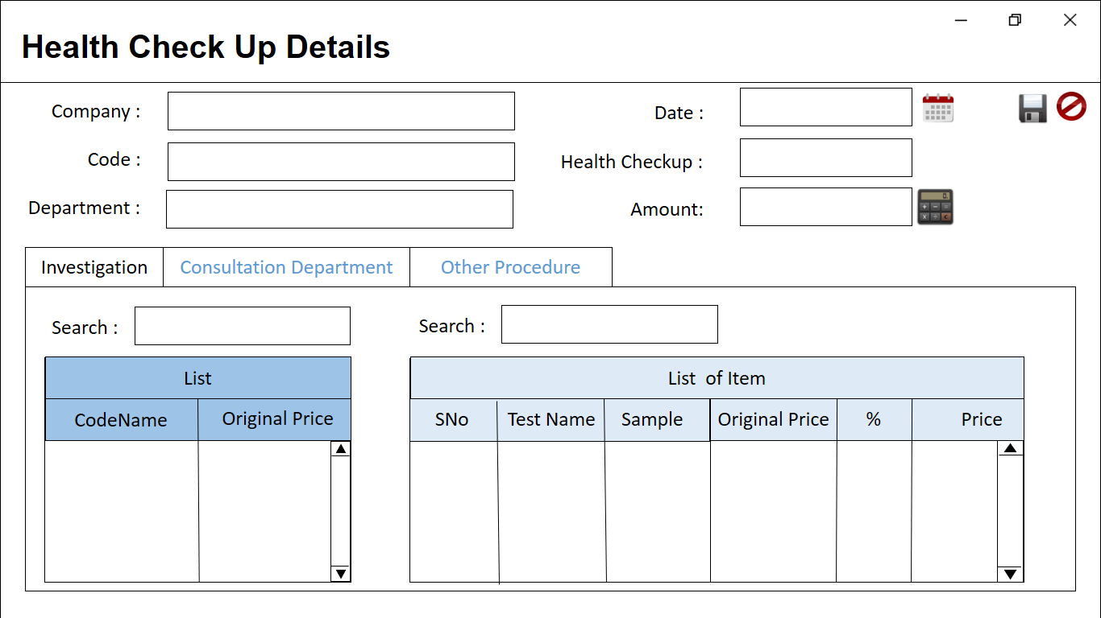

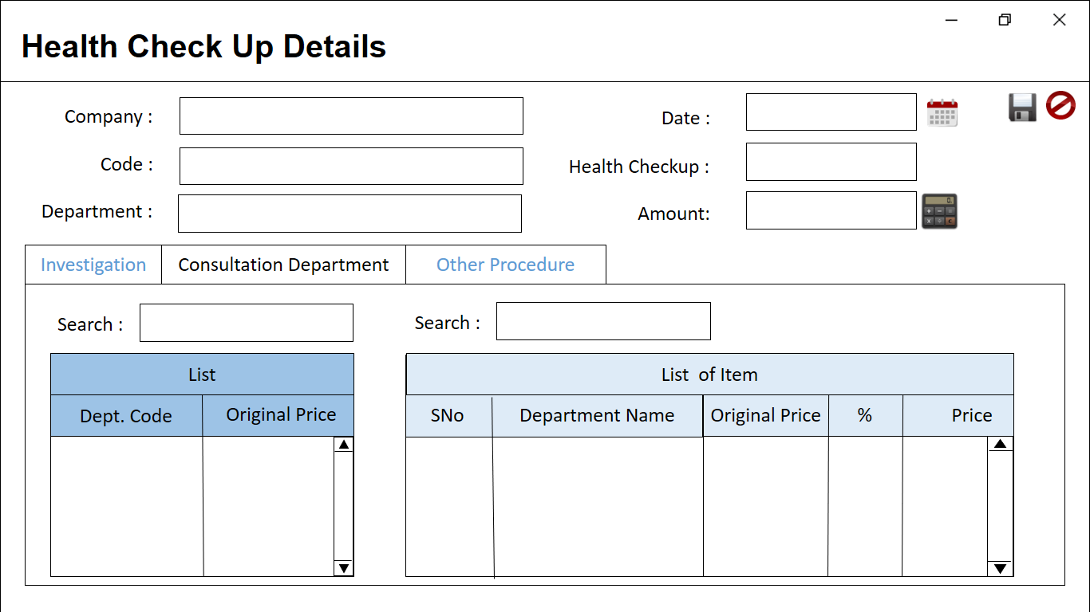

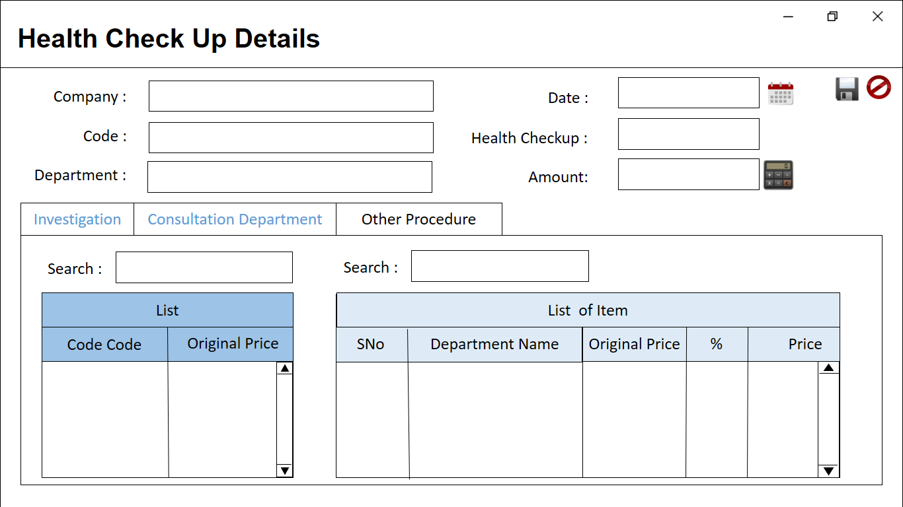

* 1. General
     + Location

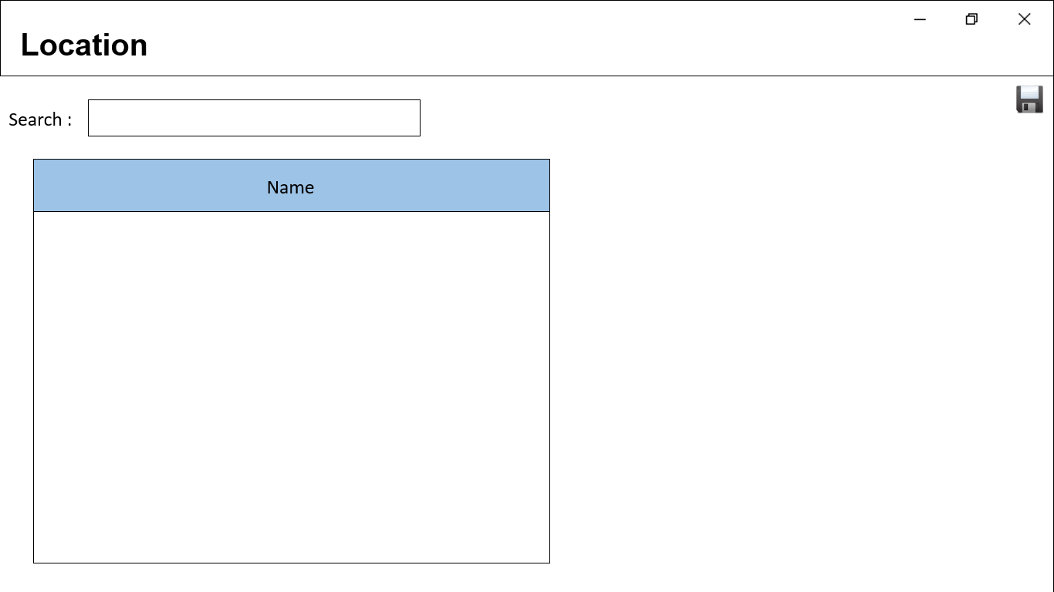

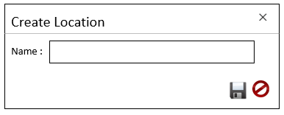

* + - Religion

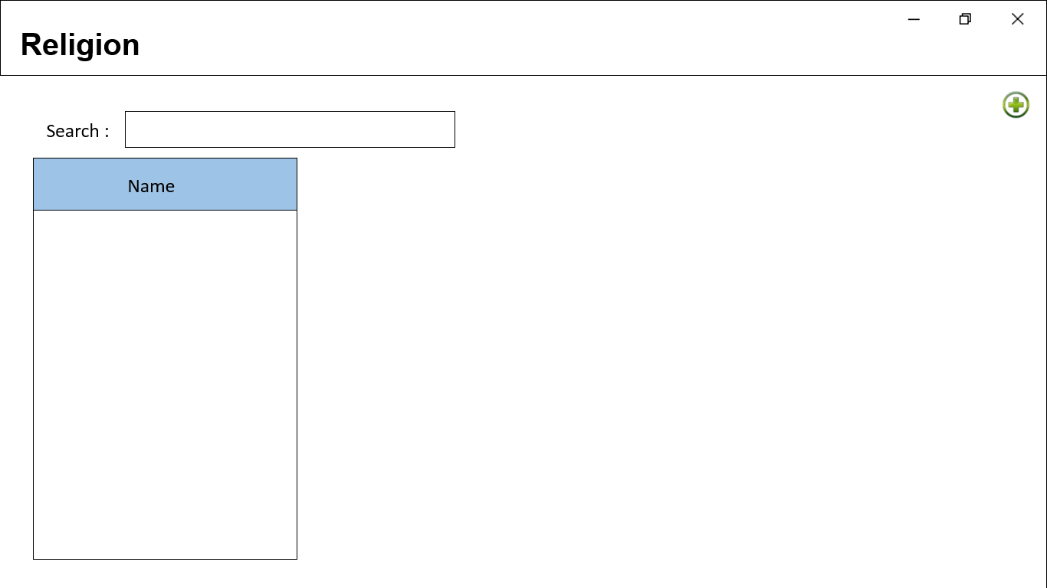

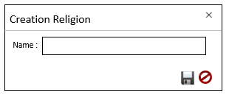

* + - Title
    - Marital Status
    - Relationship
    - Occupation
    - Organization Information
    - City
    - Nationality
    - Misc. Transactions – General Cashier
  1. HomeCare Mapping

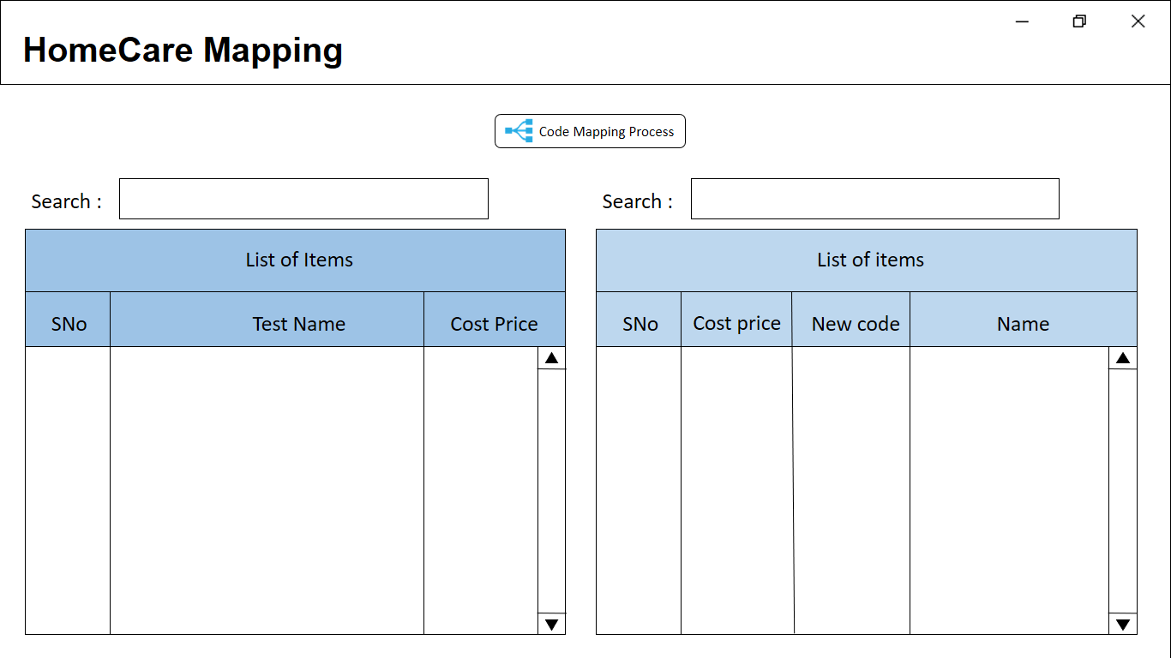

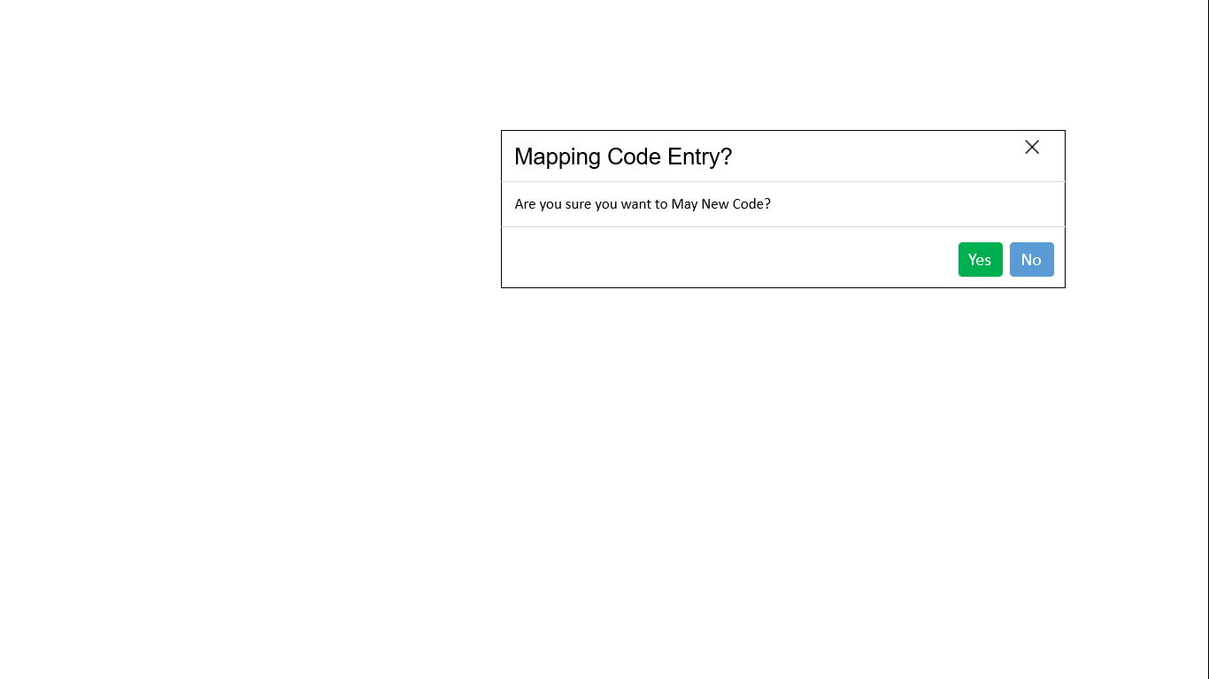

* 1. Doctor-Specialization Mapping

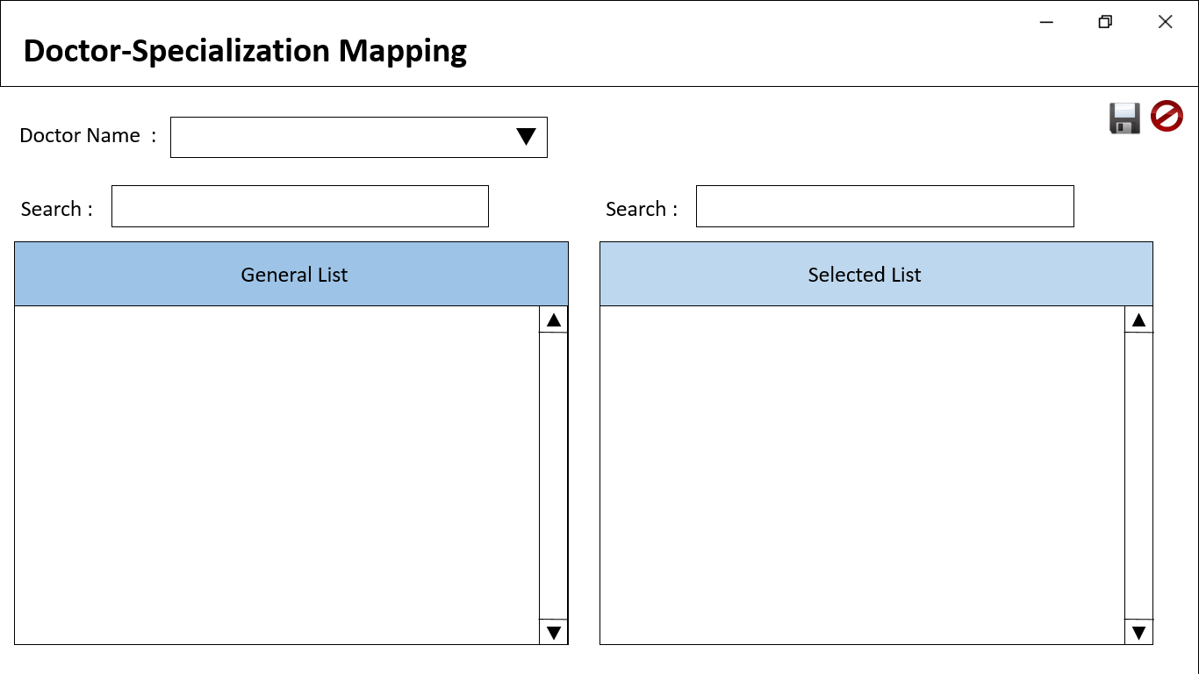

* 1. Doctor-Receptionist Mapping

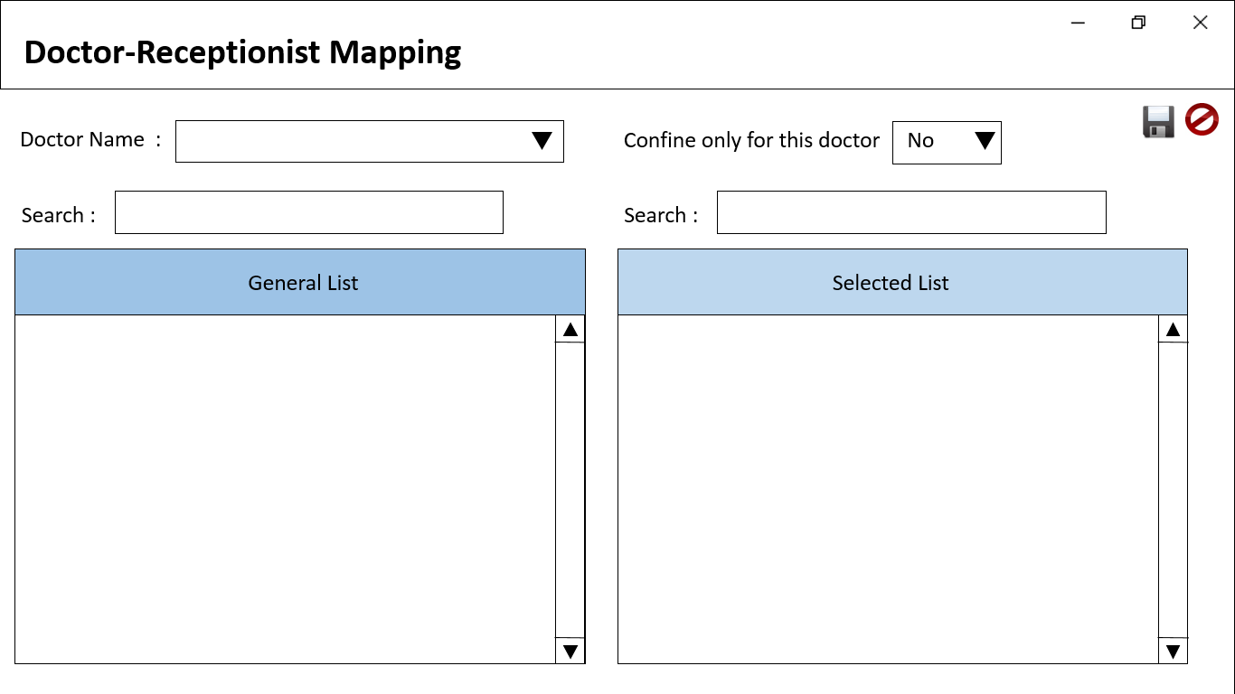

* 1. Package Visit

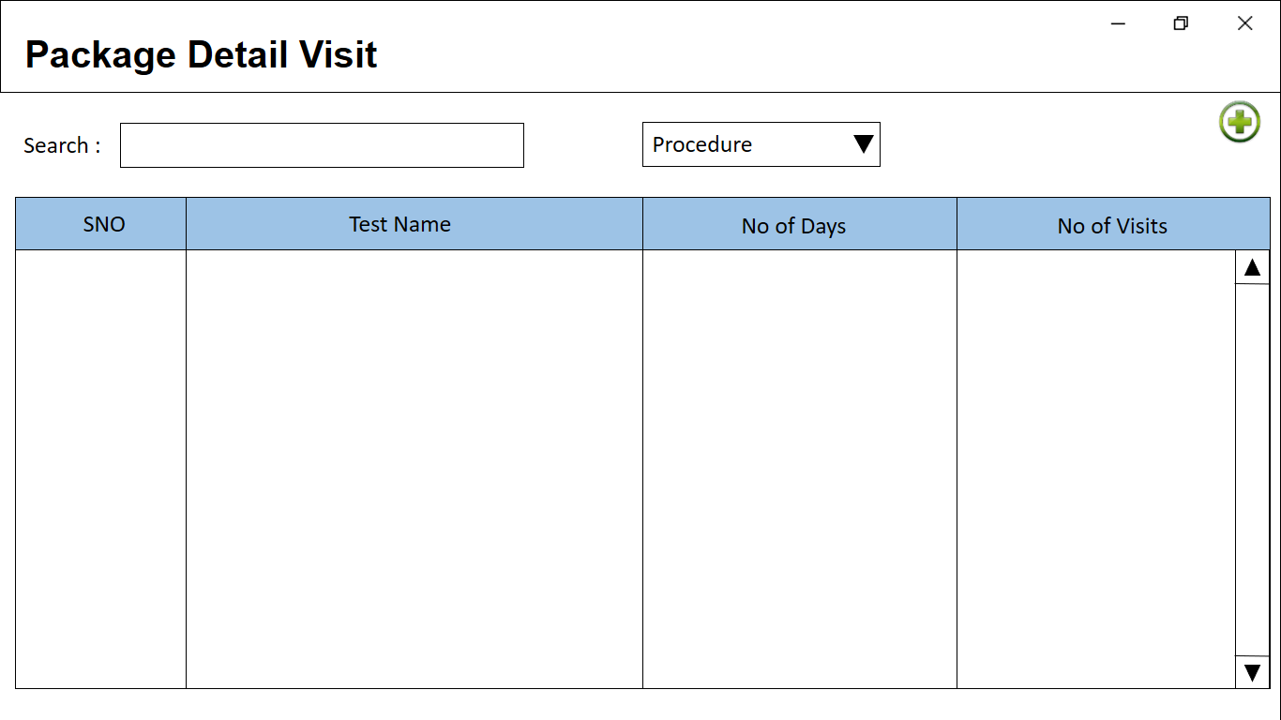

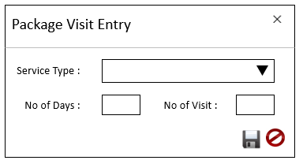

* 1. OP Package Visit Modify

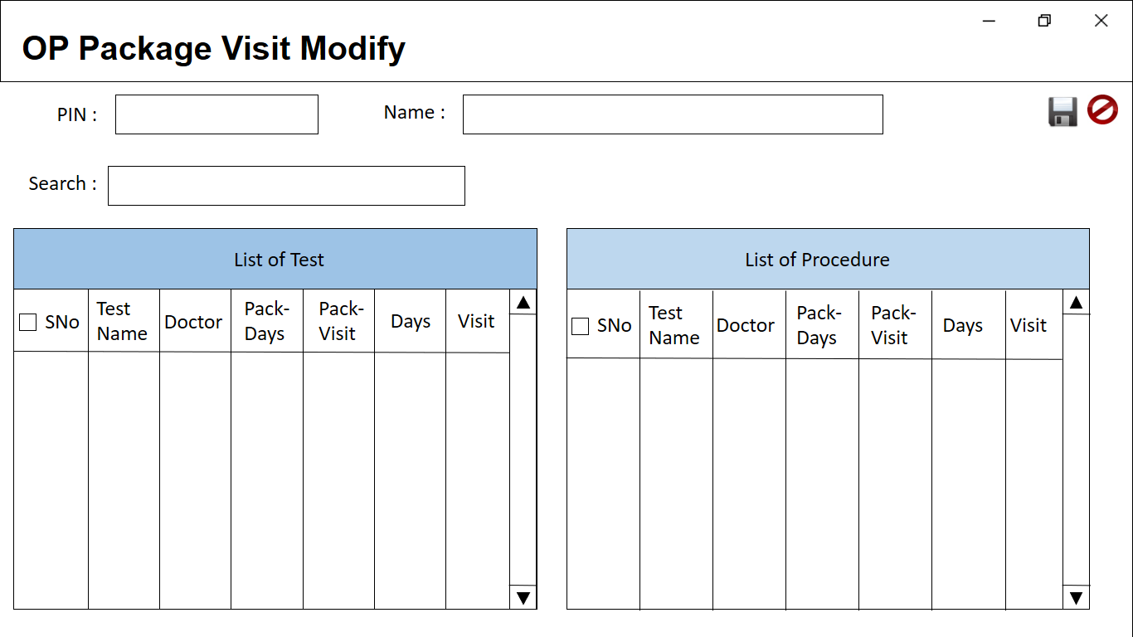

* 1. Cash Discount

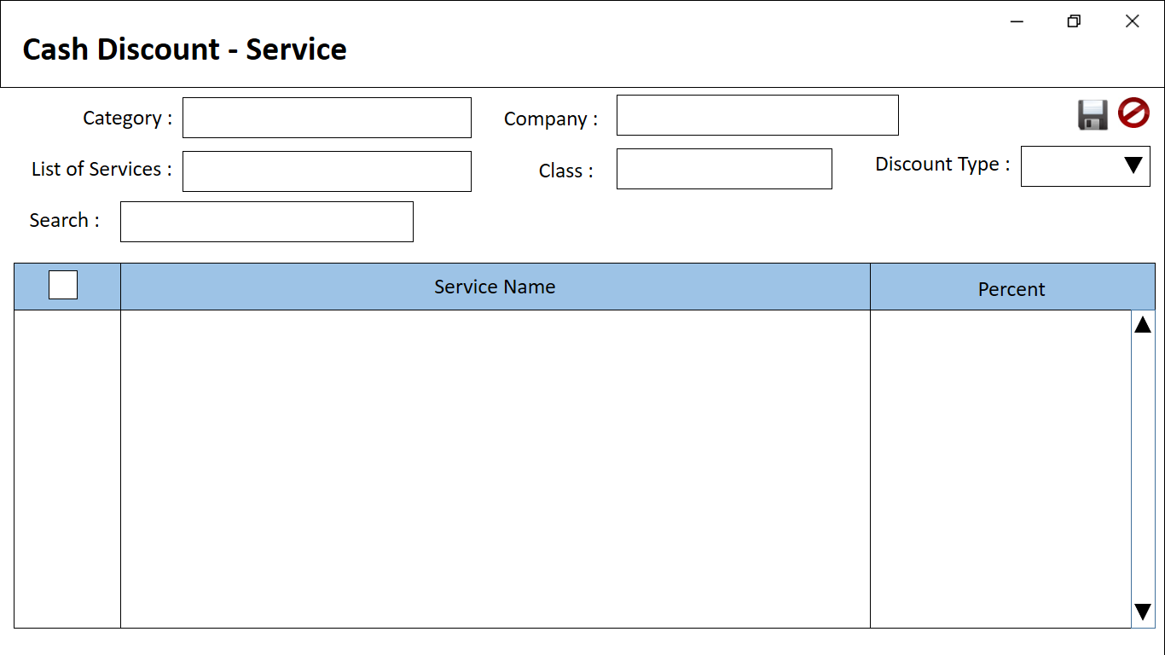

* 1. Cash Discount - Type

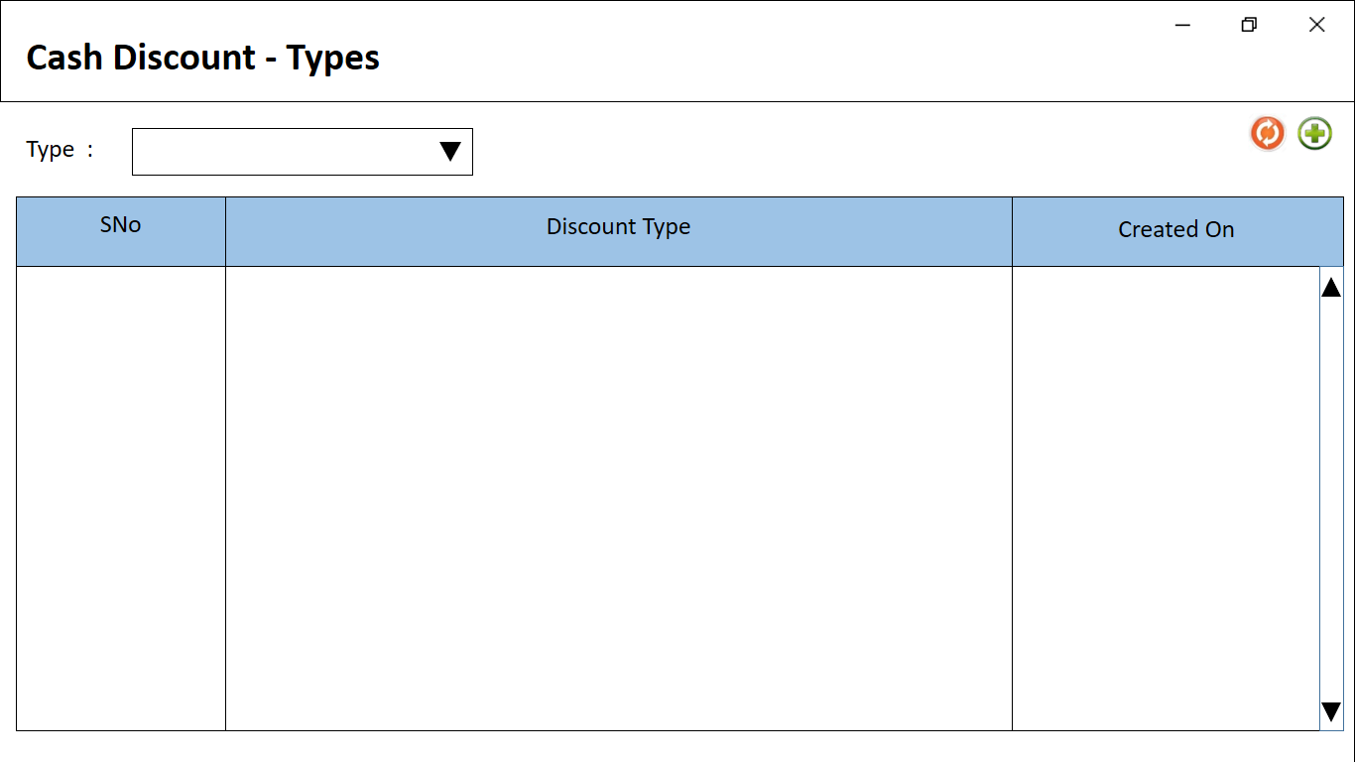

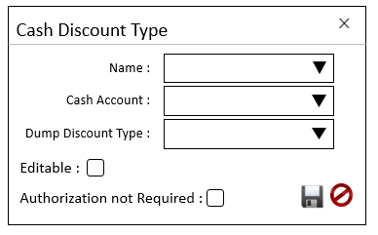

* 1. Cash Discount Dept. Wise

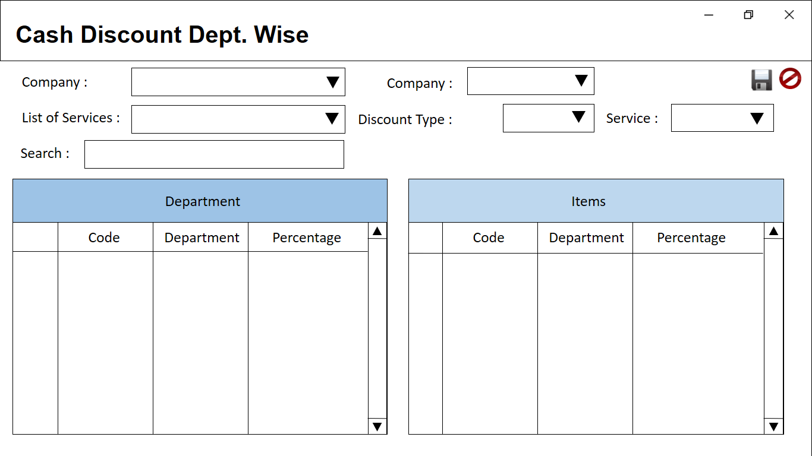

* 1. OP Non Discountable Items

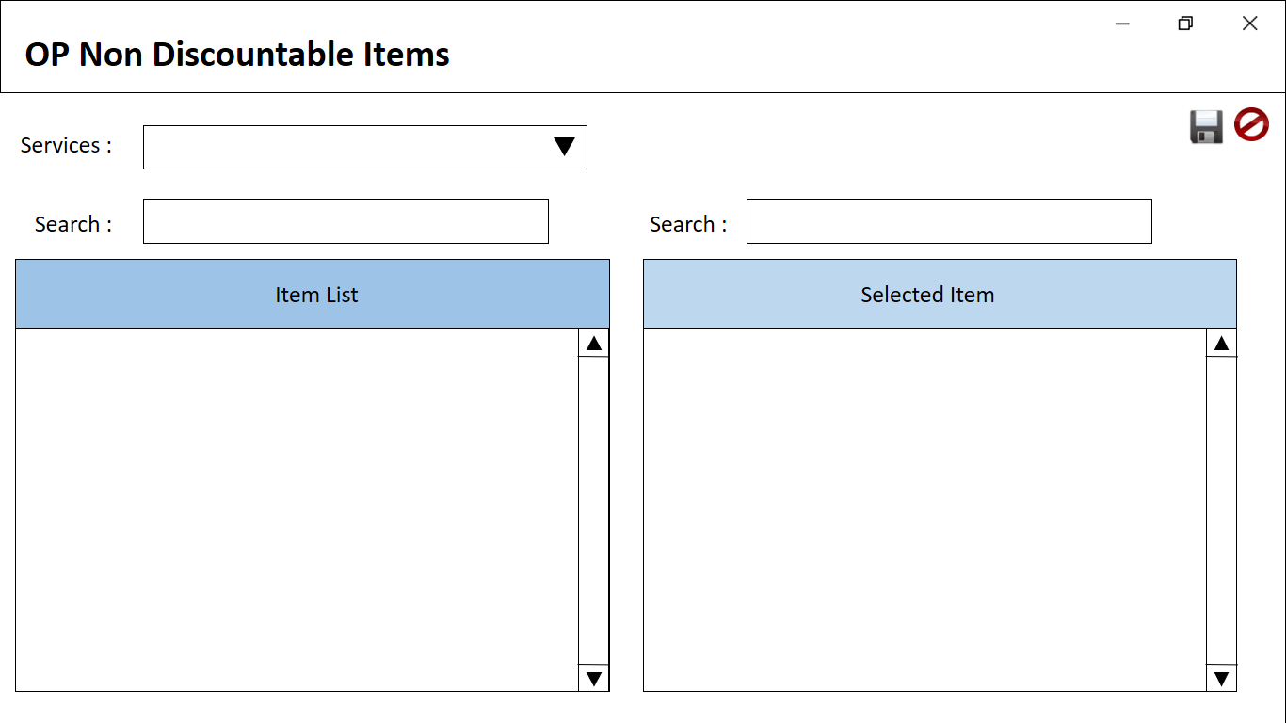

* 1. Employee Discount Authorization

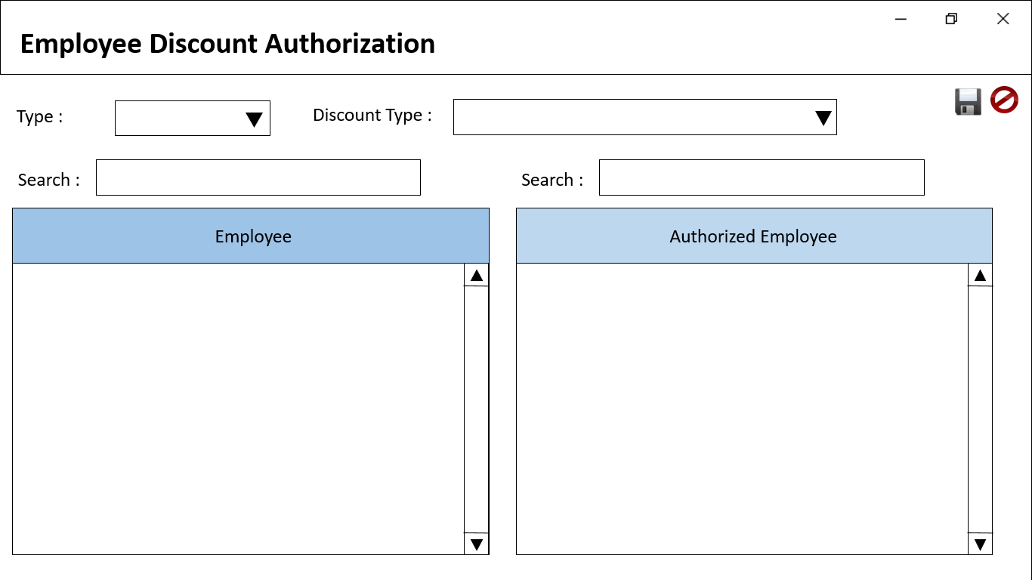

* 1. OP Doctor Clinic

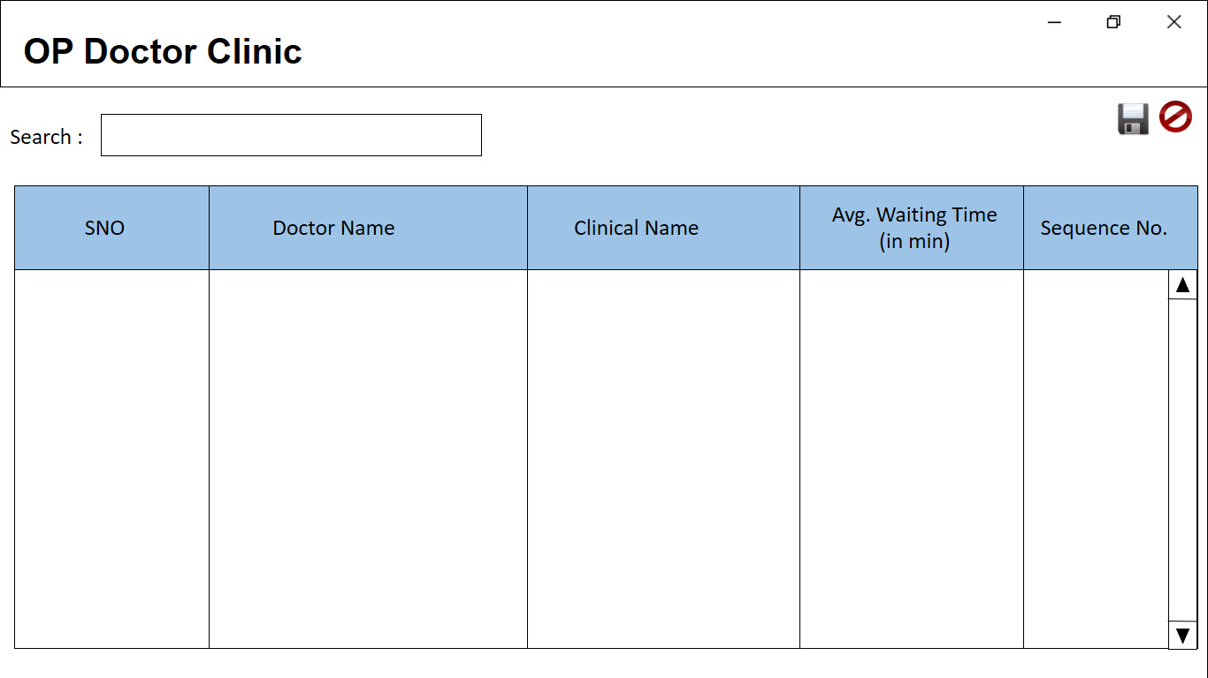

* 1. Laundry Items

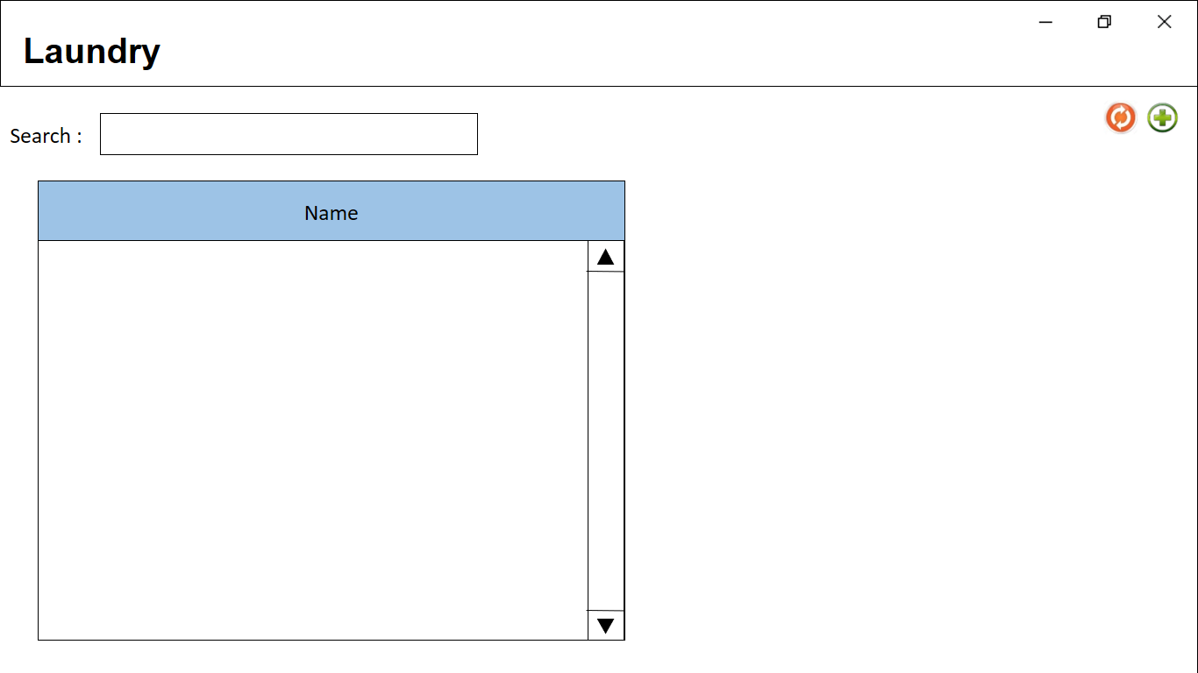

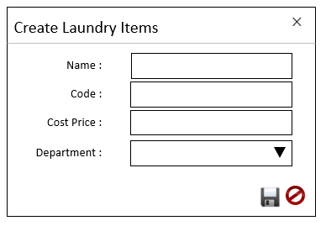

* 1. Map Other Package Procedure

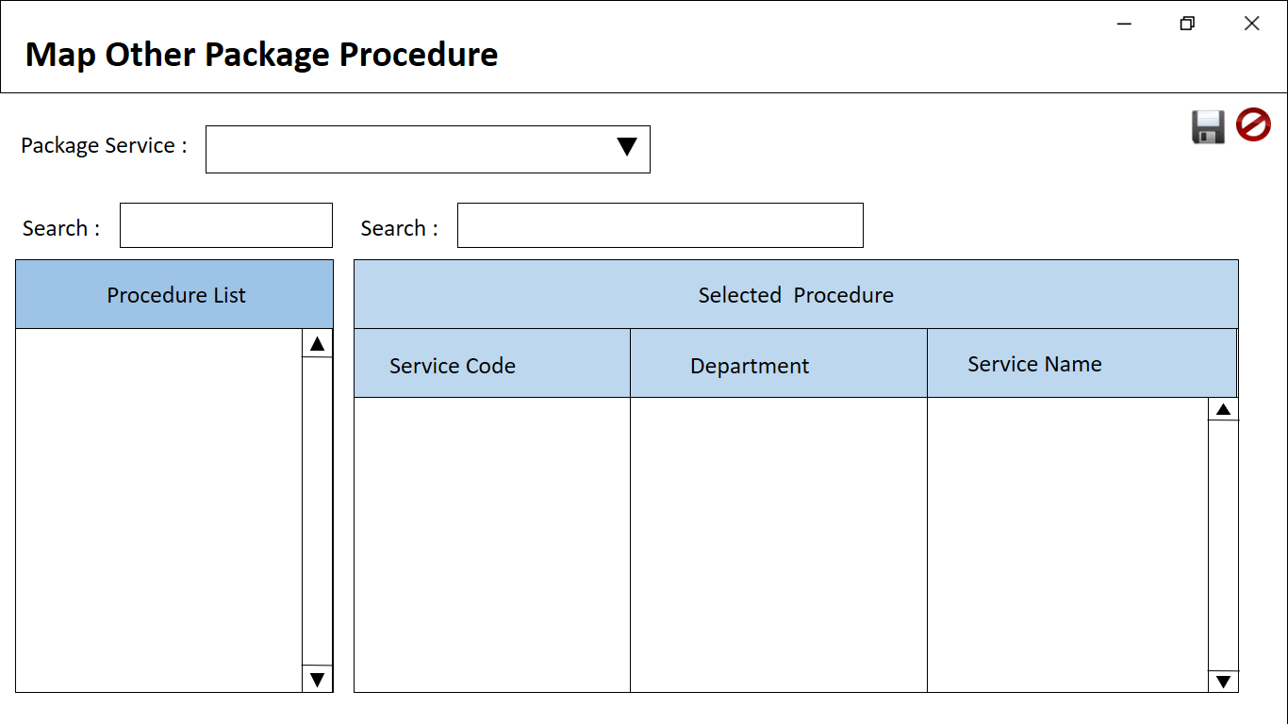

* 1. OP Bill Prefix

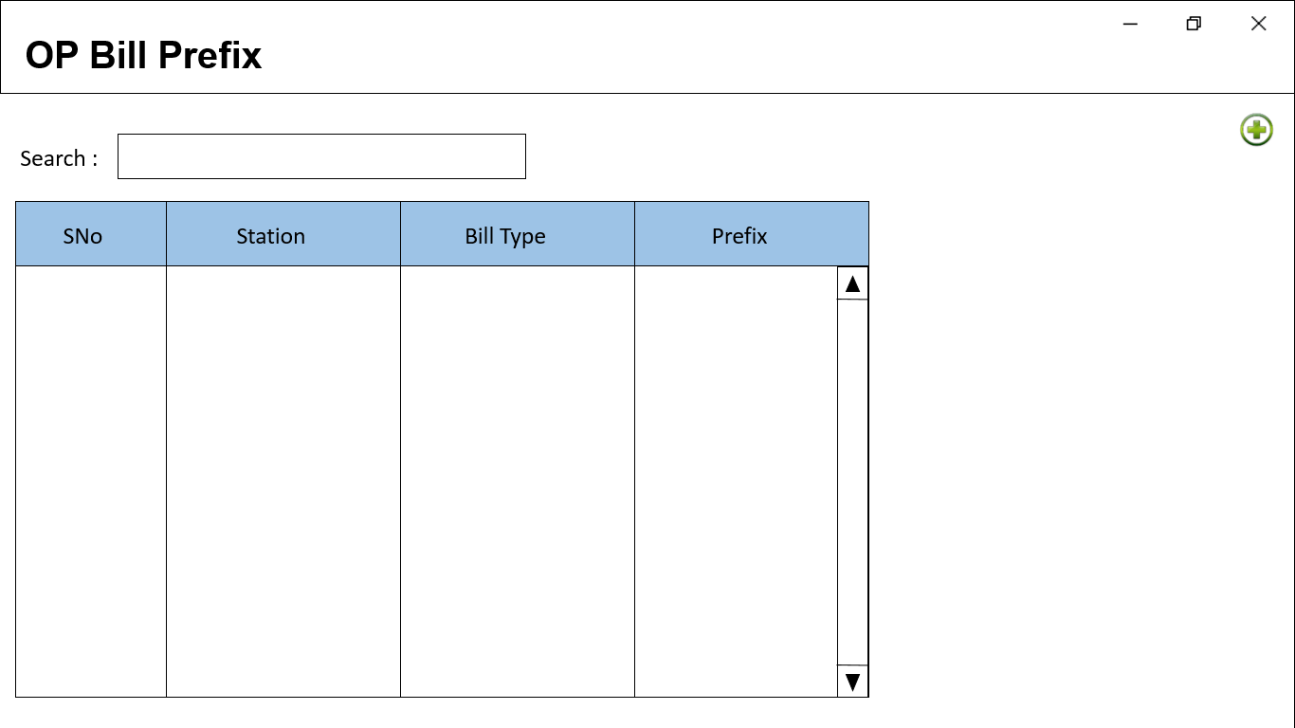

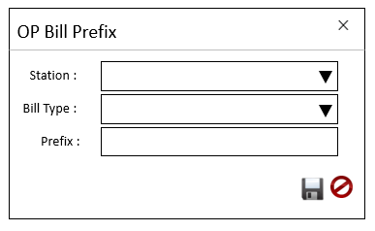

* 1. Machine Setup

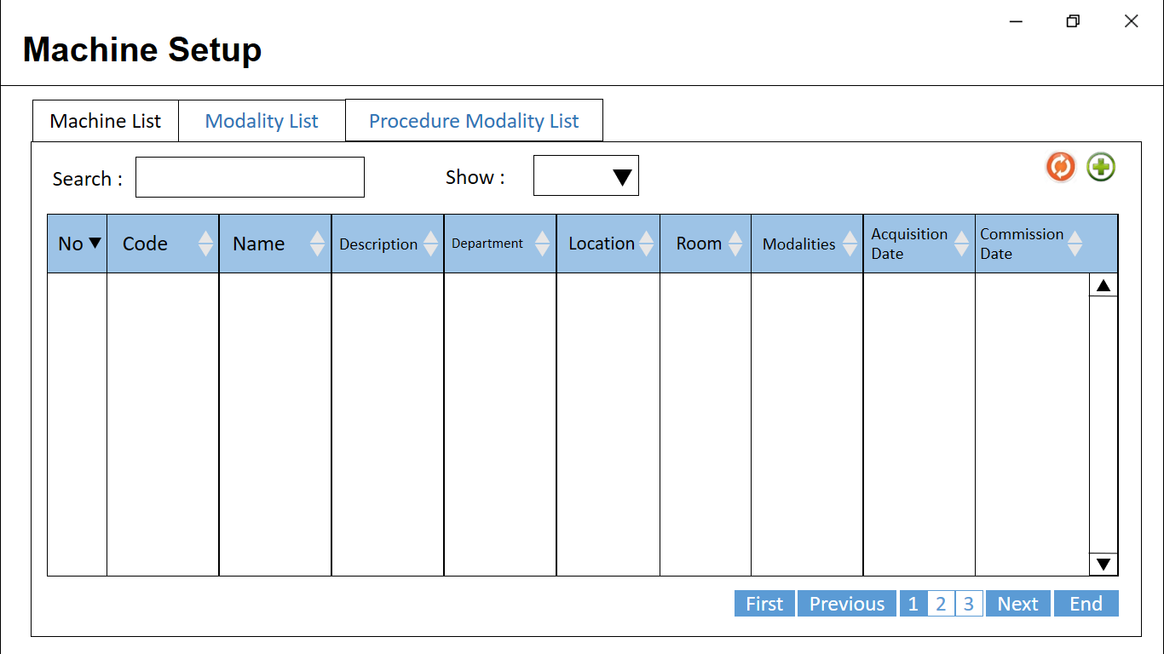

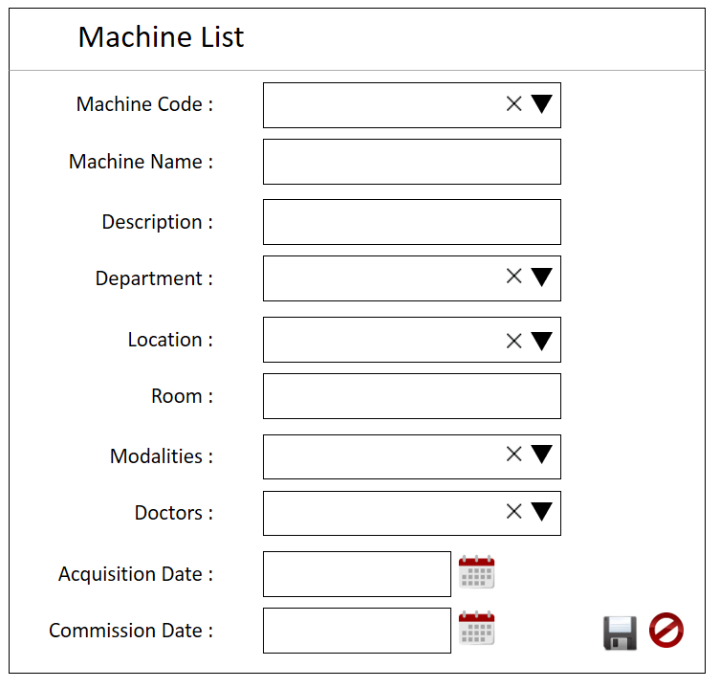

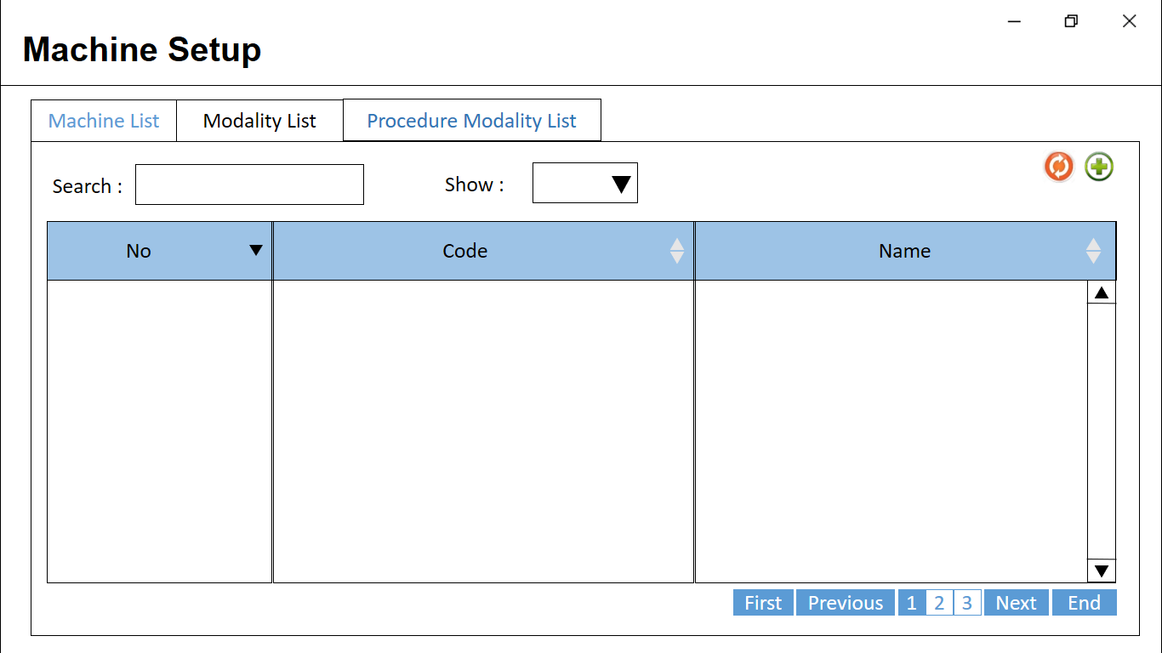

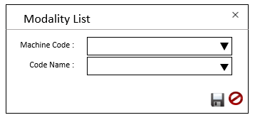

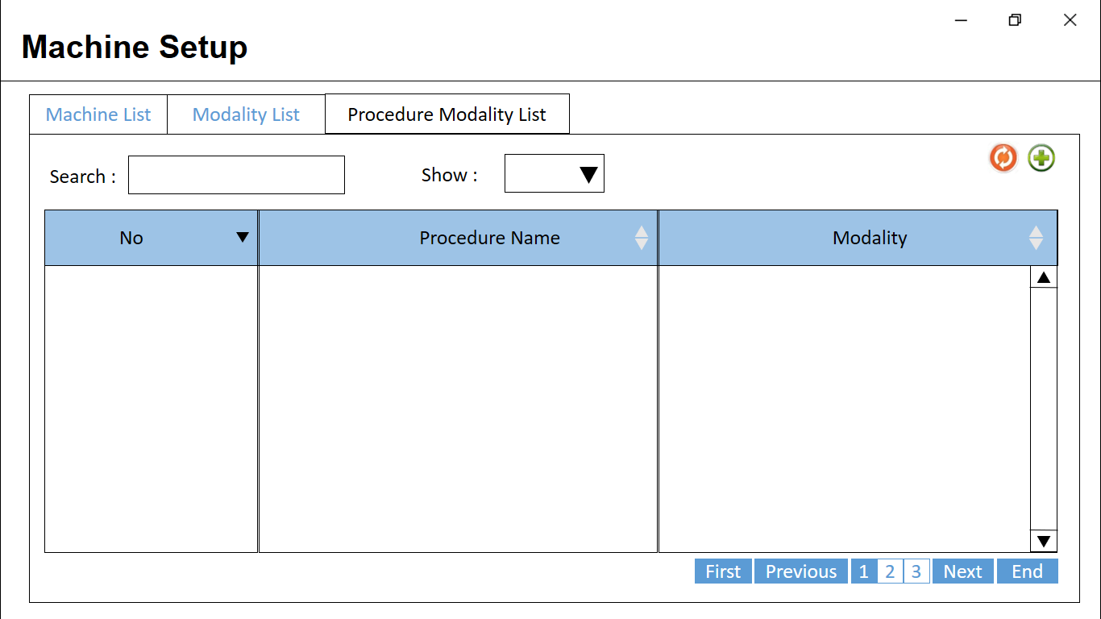

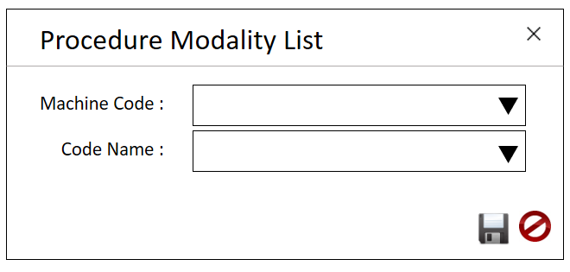

1. General
   1. Religion

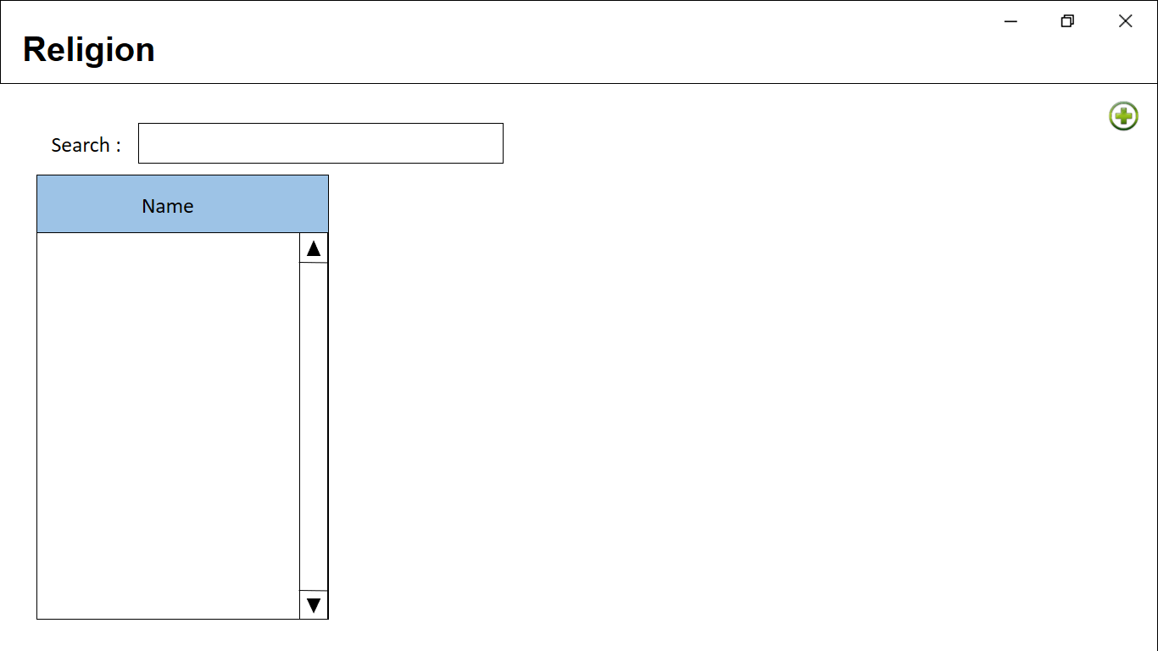

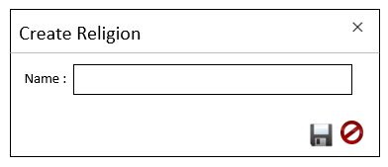

* 1. Location

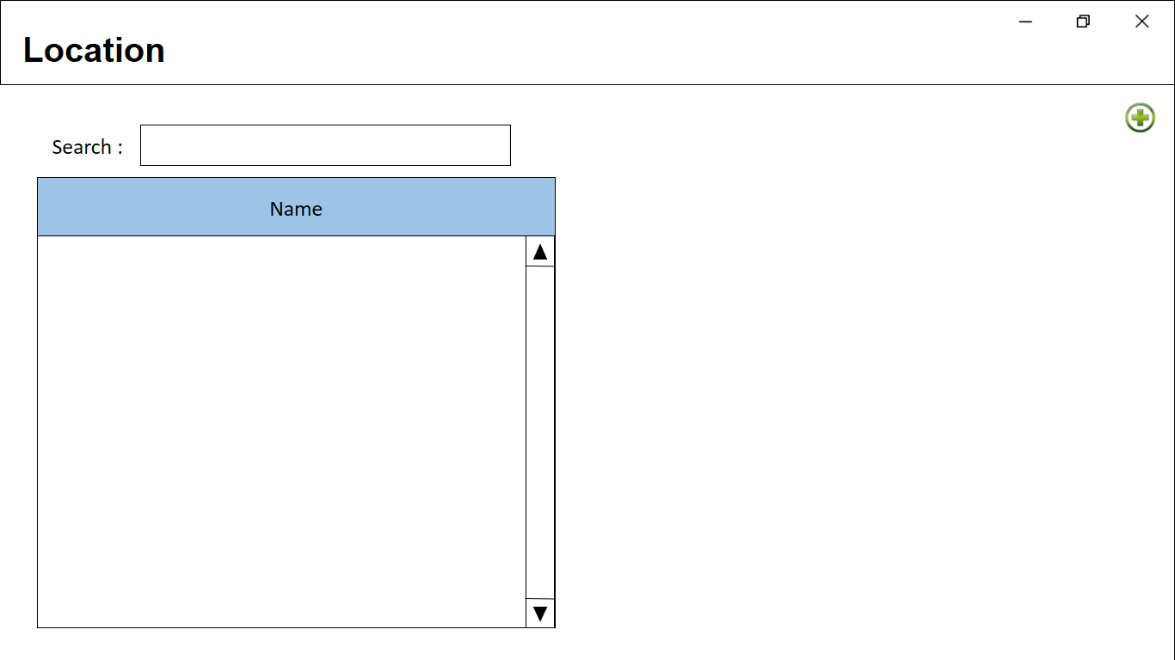



* 1. City

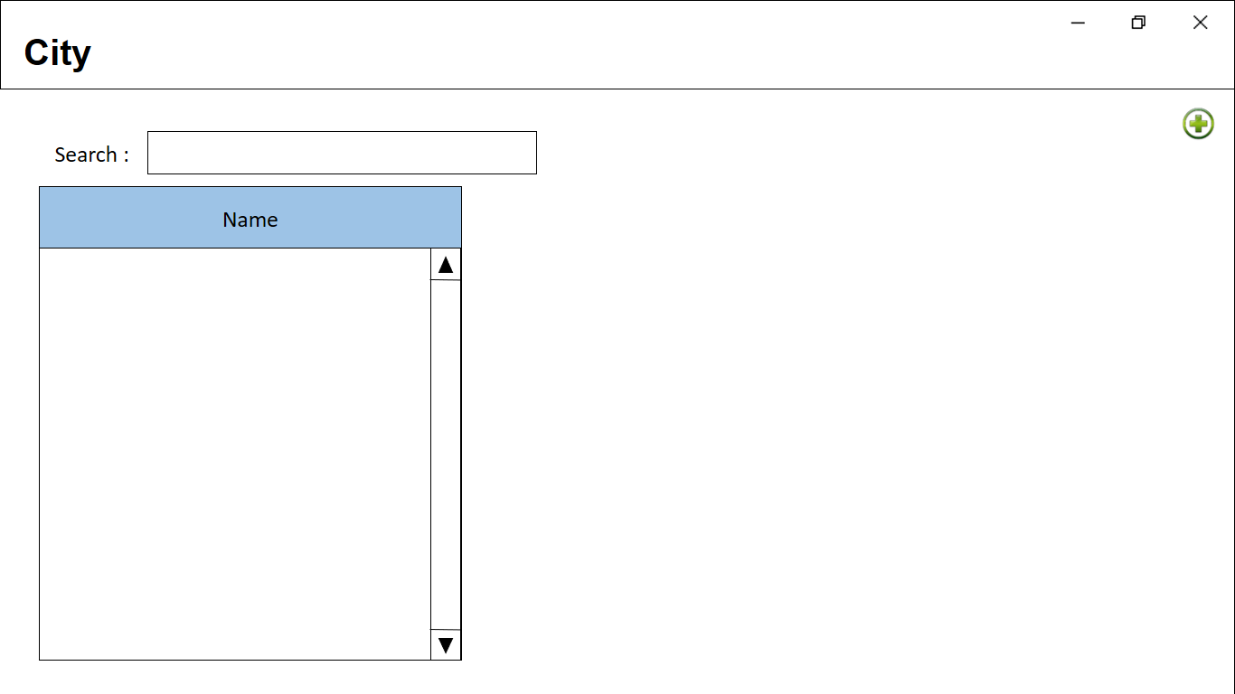

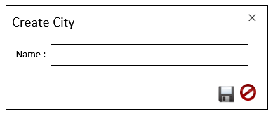

* 1. Gen Cashier Trans Type

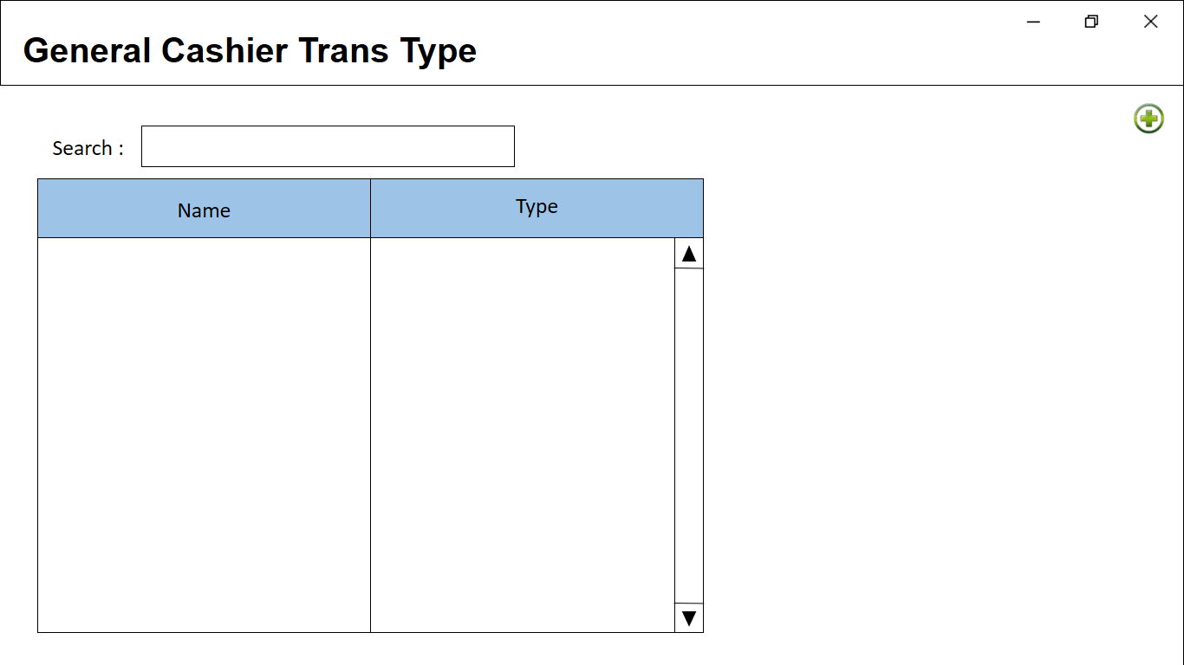

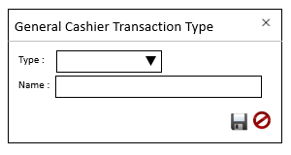

* 1. Occupation

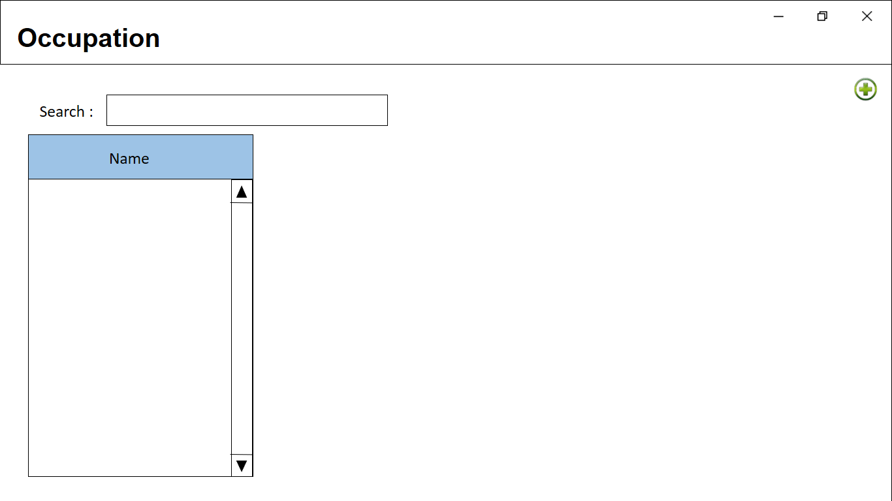

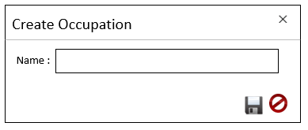

* 1. Relationship

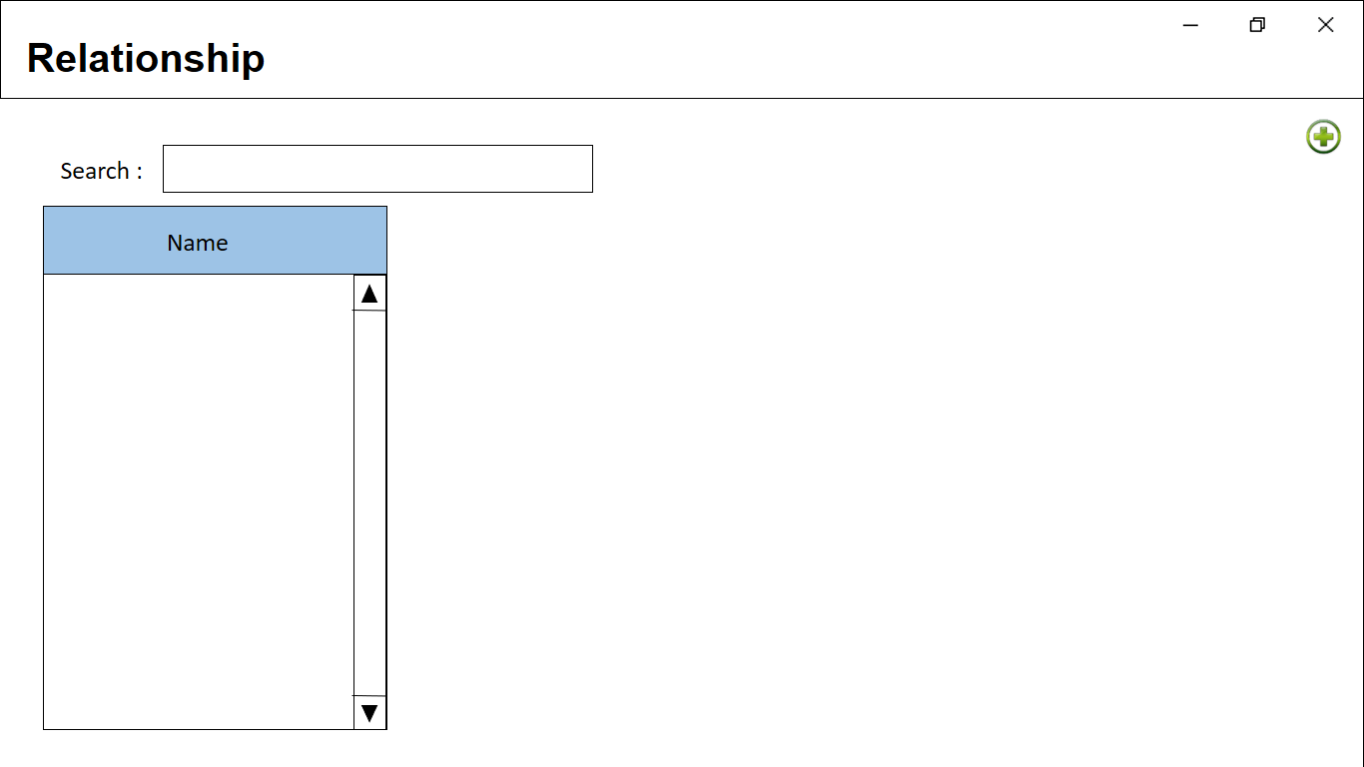

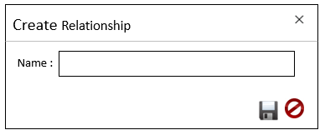

* 1. Marital Status

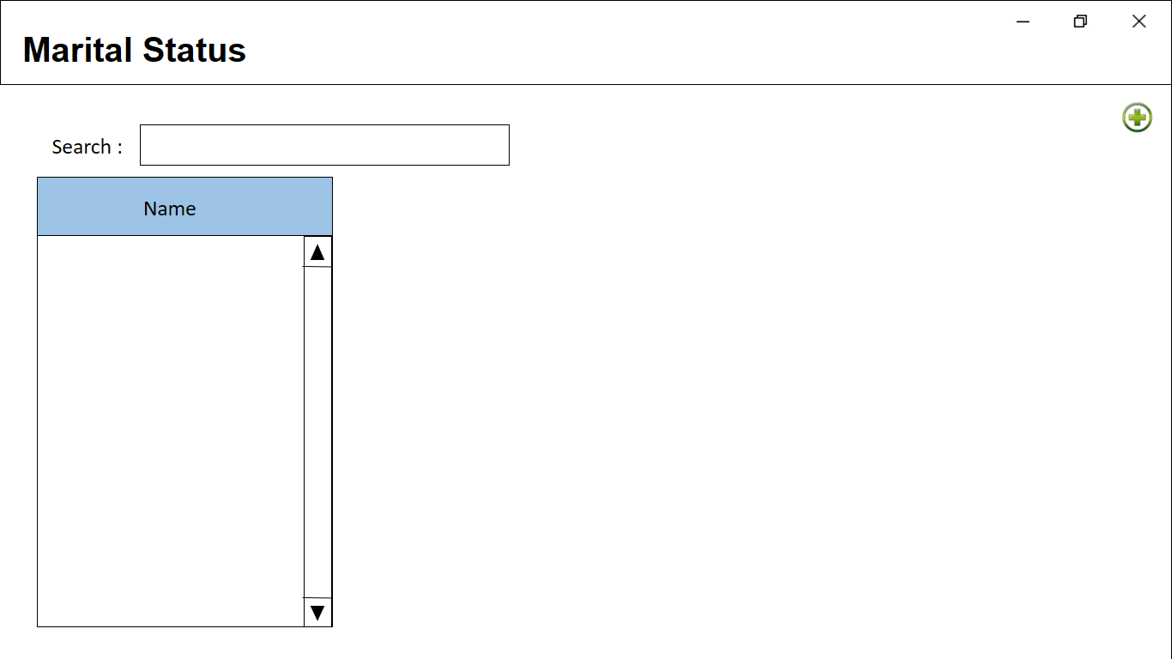

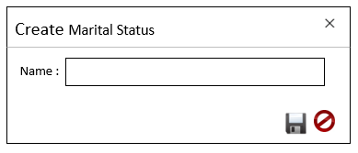

* 1. Organization Information

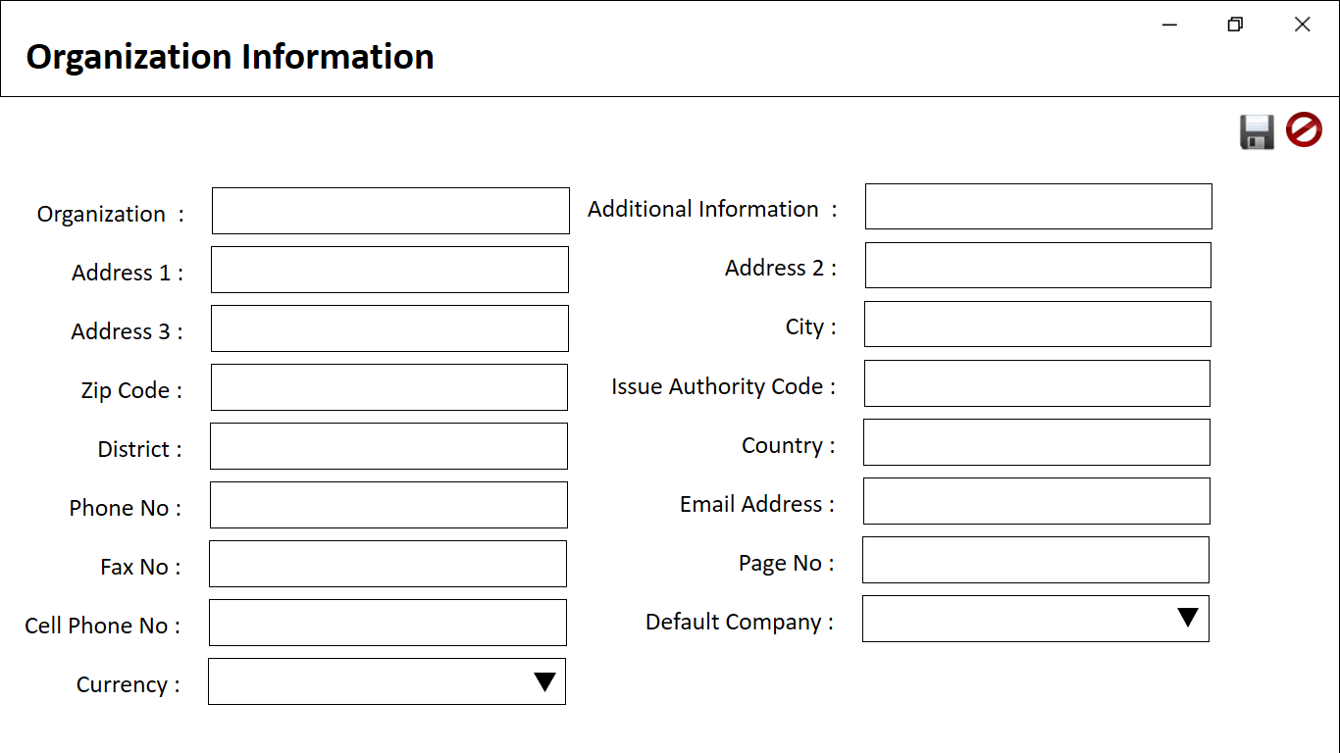

* 1. Title

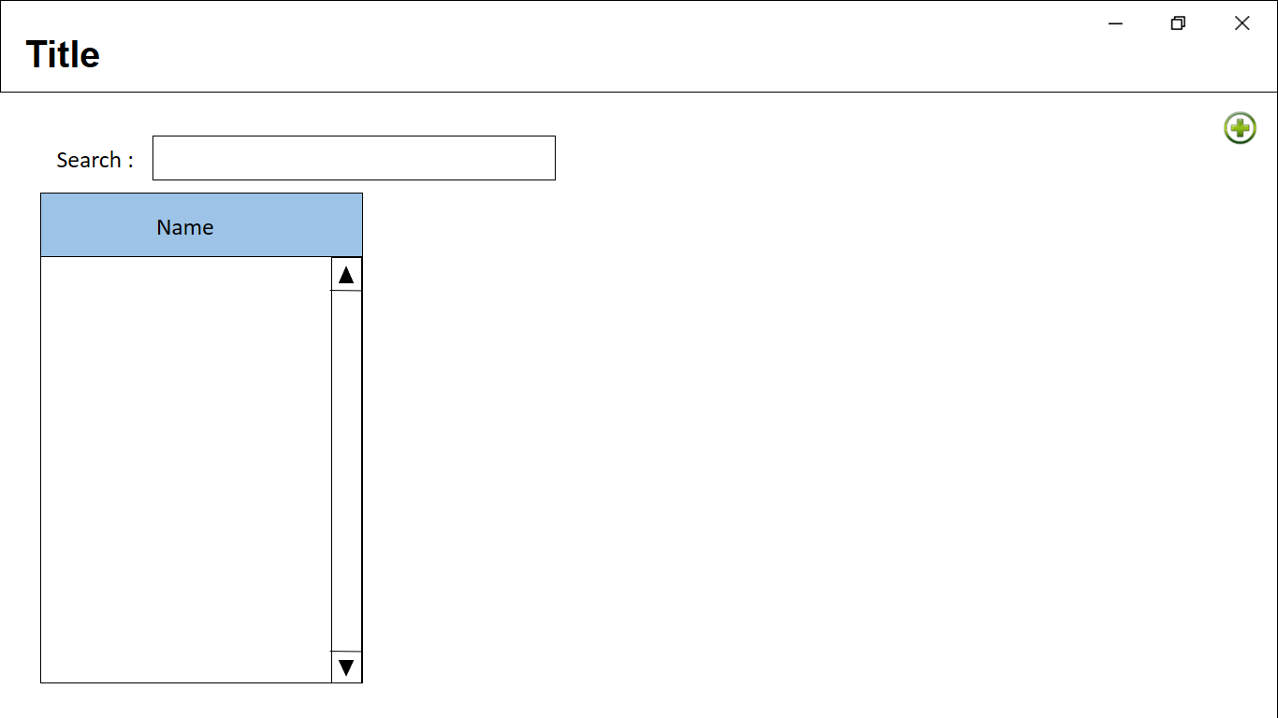

1. IP Order Cancellations
   1. Change Deposit Type

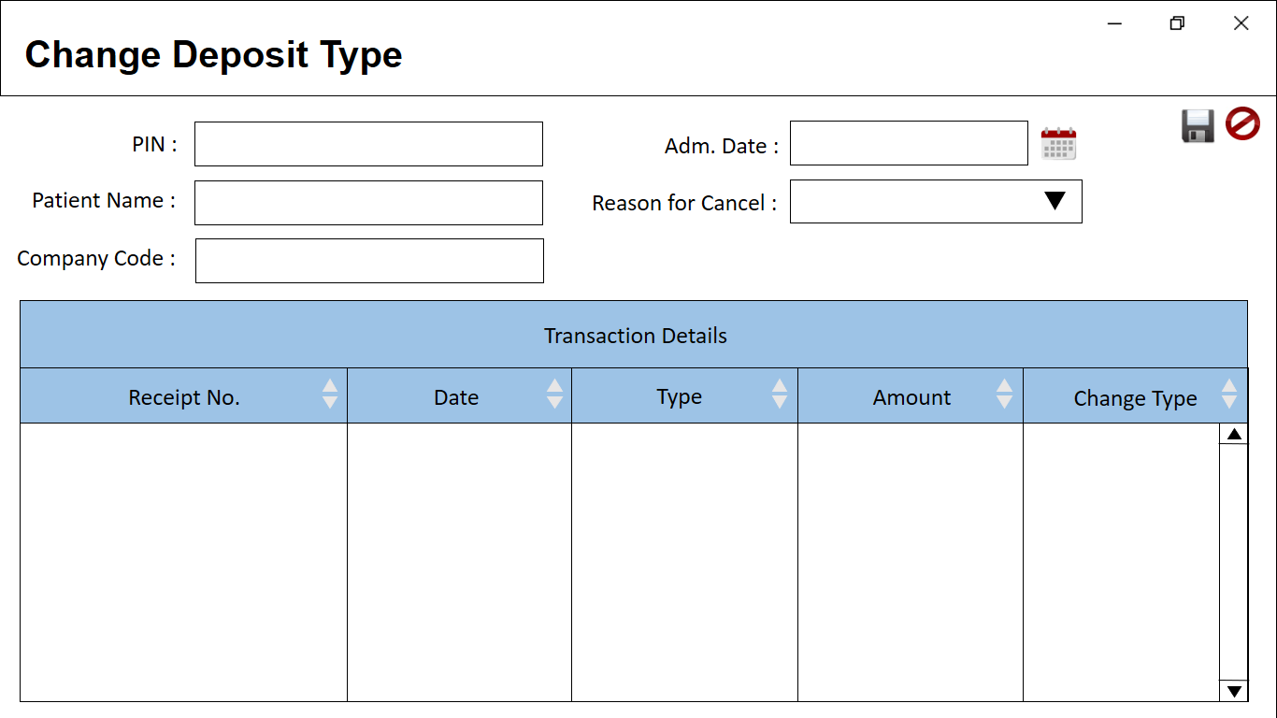

* 1. Cancel IP Deposit

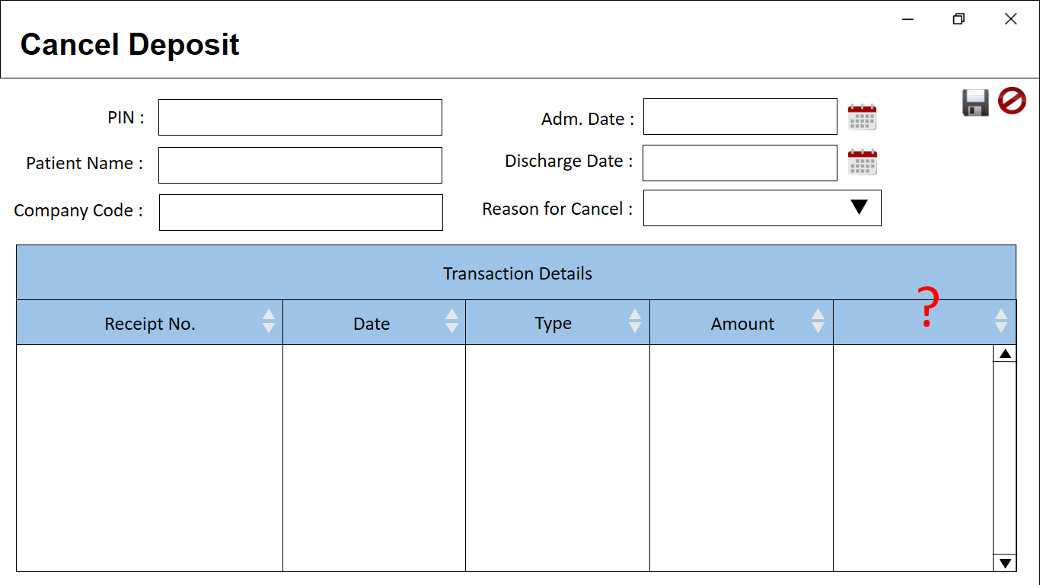

1. Order and Request
   1. Transaction Order Process

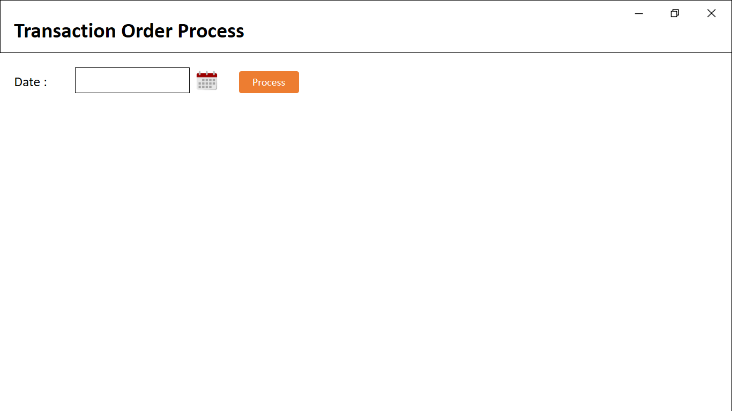

1. Mark-up
   1. CST Mark-Up(Cash & Credit)

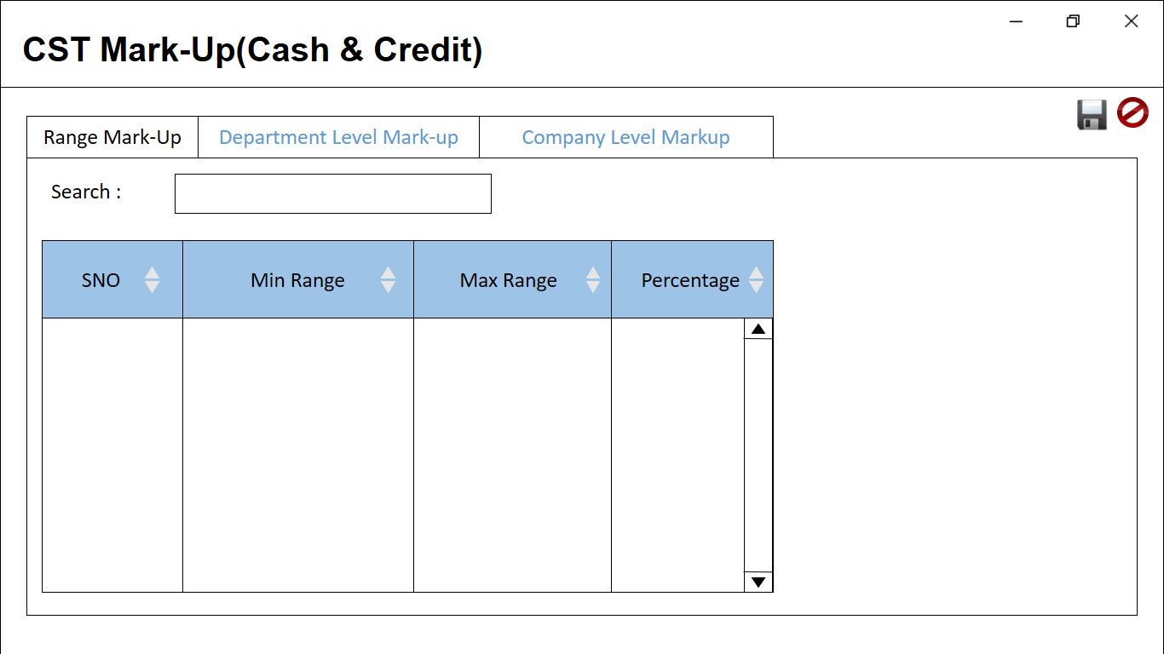

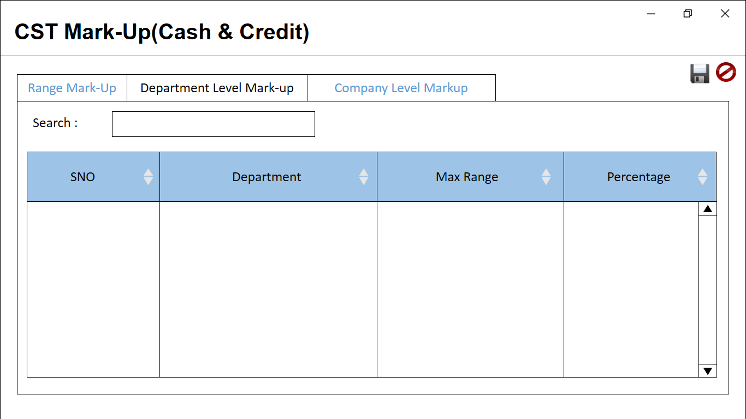

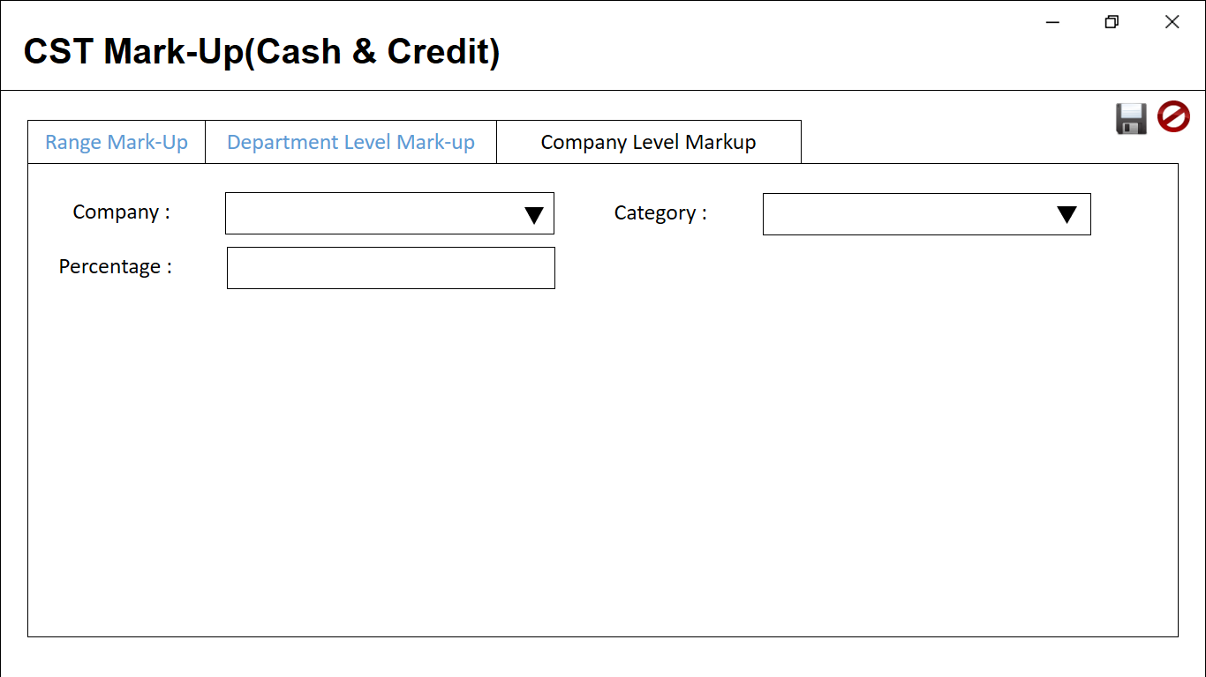

* 1. CST BedType MarkUp(Cash & Credit)

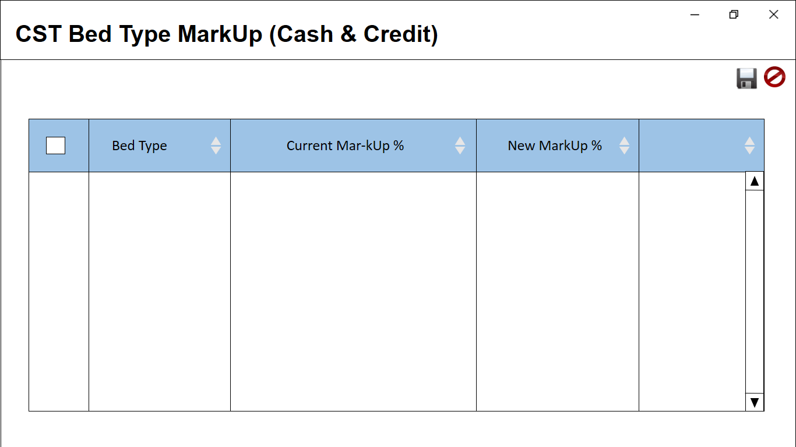

* 1. IP Cash MarkUp Configuration

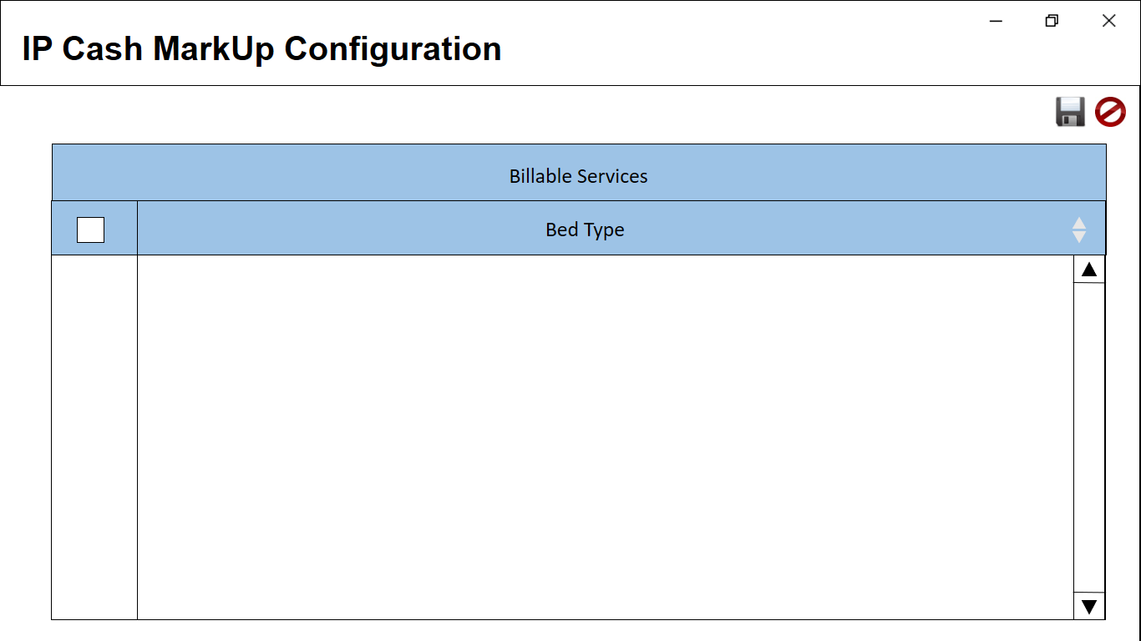

* 1. IP Pharmacy Service Charge

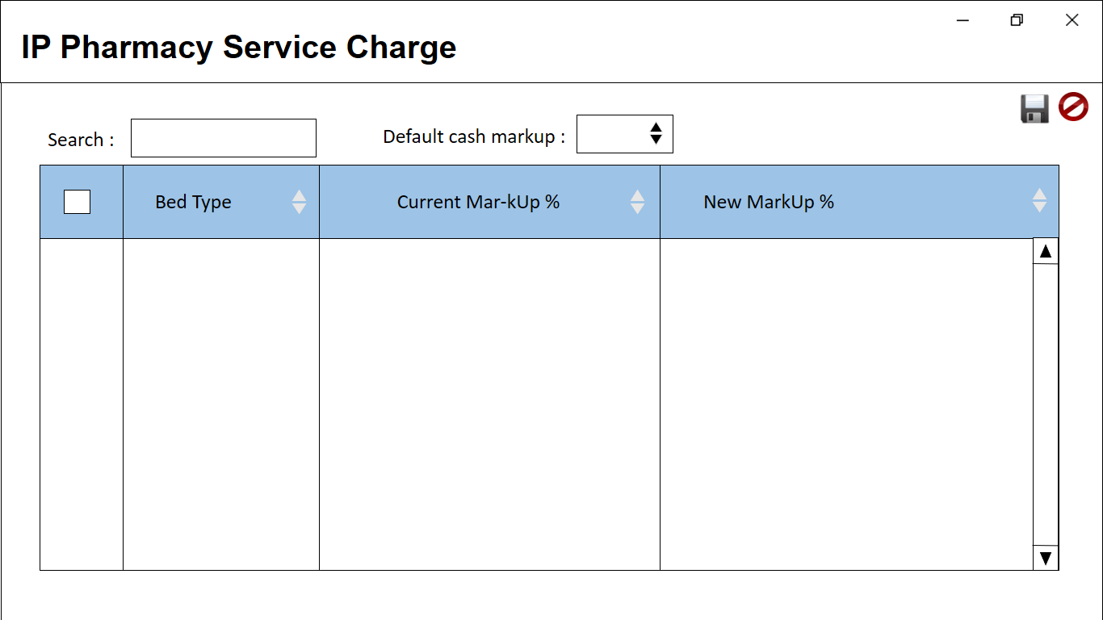

* 1. CST Zero Price Item

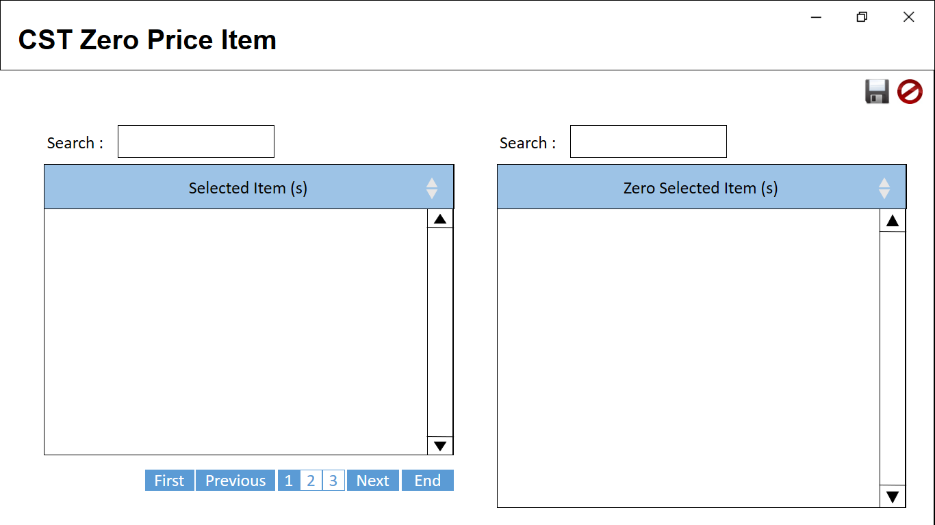

# **Menu Features/List of Function**

**Page layout**

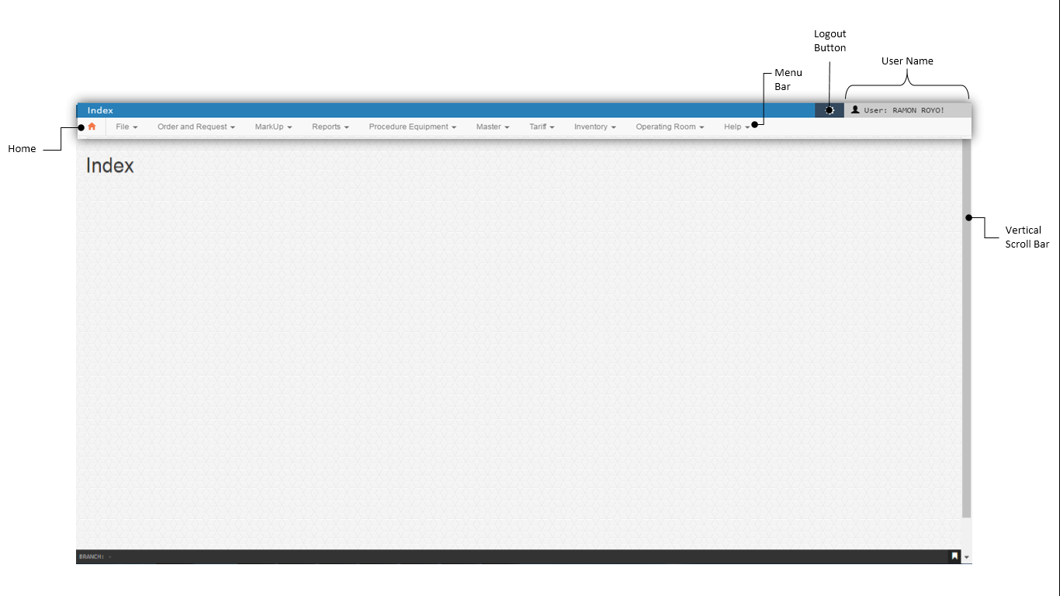

1. File

Is a collection of records pertaining to one of the main subjects of an information system, such as Mapping, IP and OP Doctors Clinic and other General Information. Master files contain descriptive data, such as Home Care, Laundry Items, Location summary information and Cash Discount.

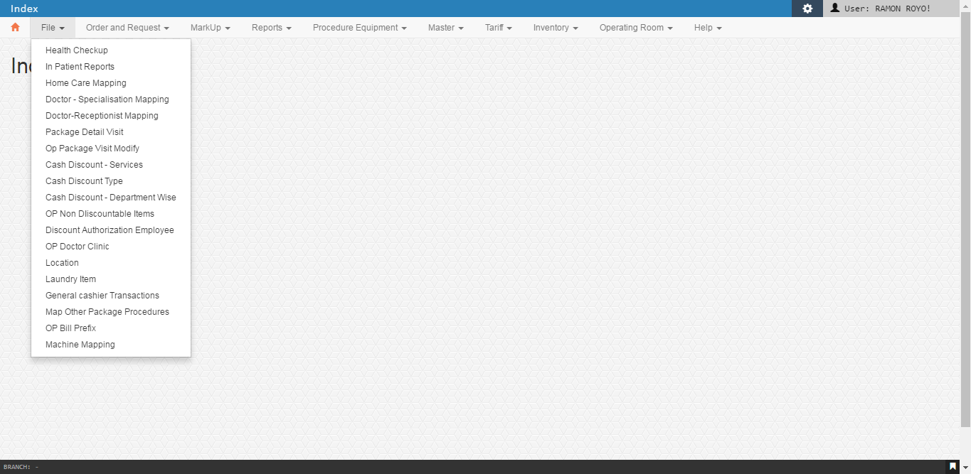

* 1. Health Checkups

This is where the update of information of the Health Check Up Details. A list consisting of Company Name per checkup with date. User is able to add, edit, and update the information. The user can view the list of Test price during Investigation, Consultation, and Other Procedure.

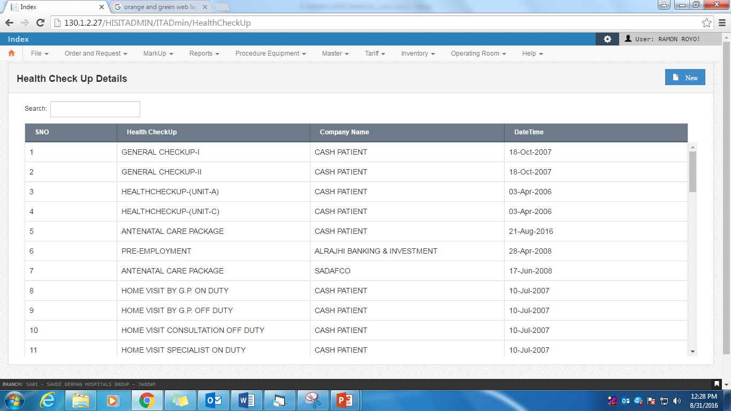

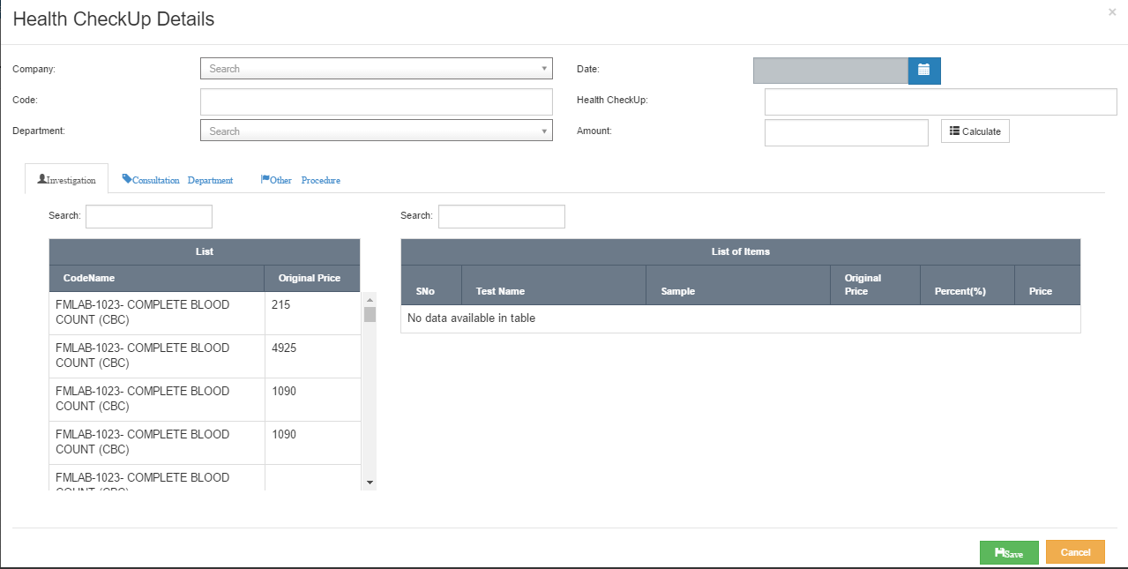

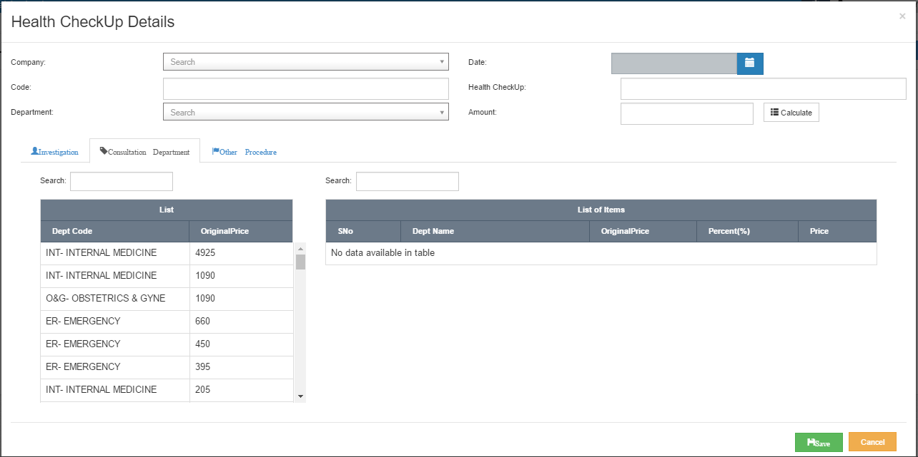

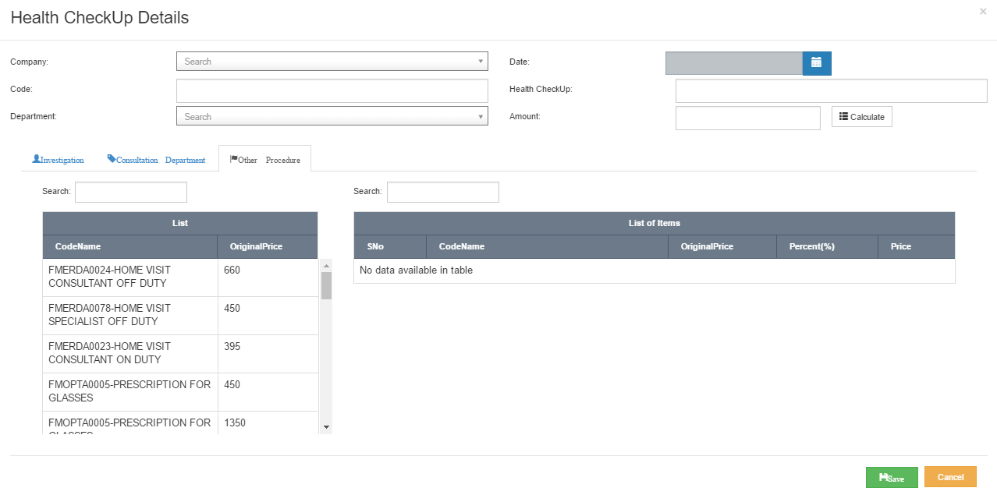

* 1. Home Care Mapping

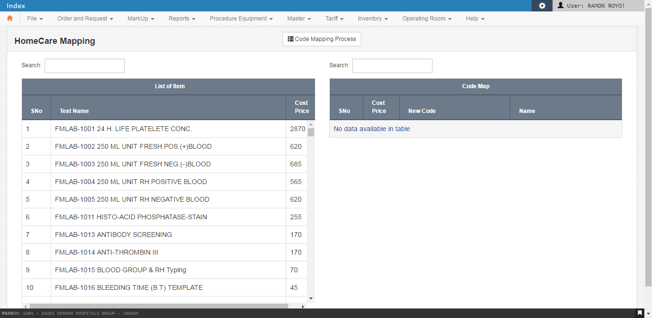

* 1. Doctor – Specialization Mapping

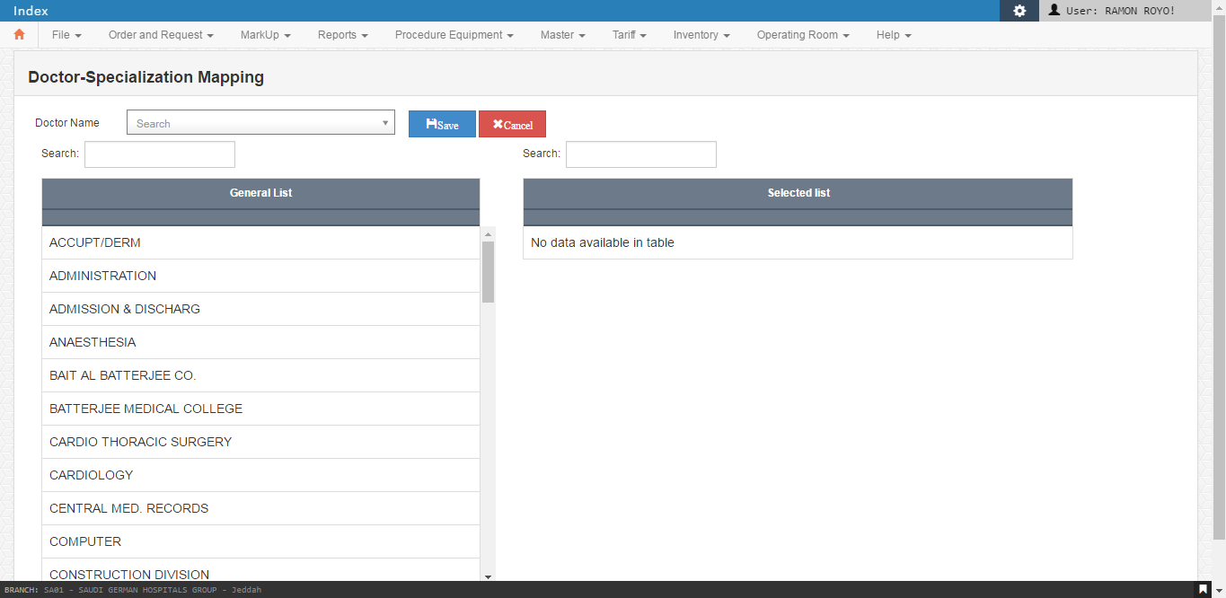

* 1. Doctor – Receptionist Mapping

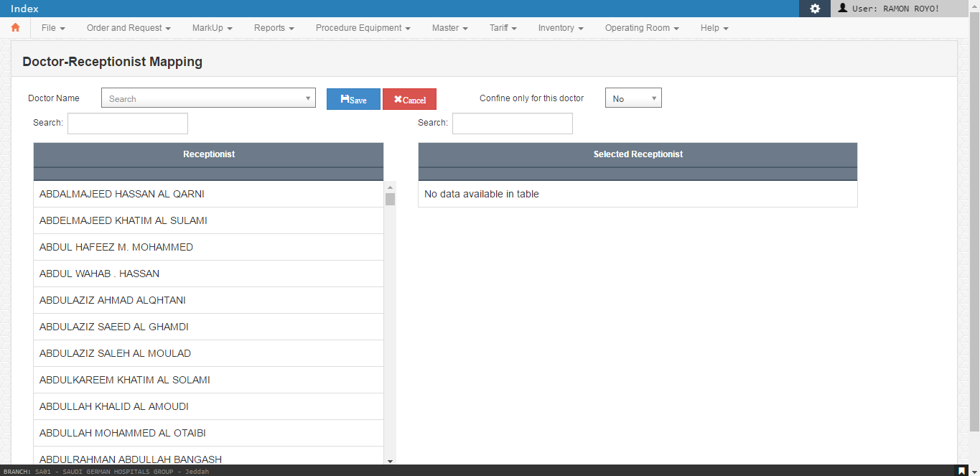

* 1. Package Detail Visit

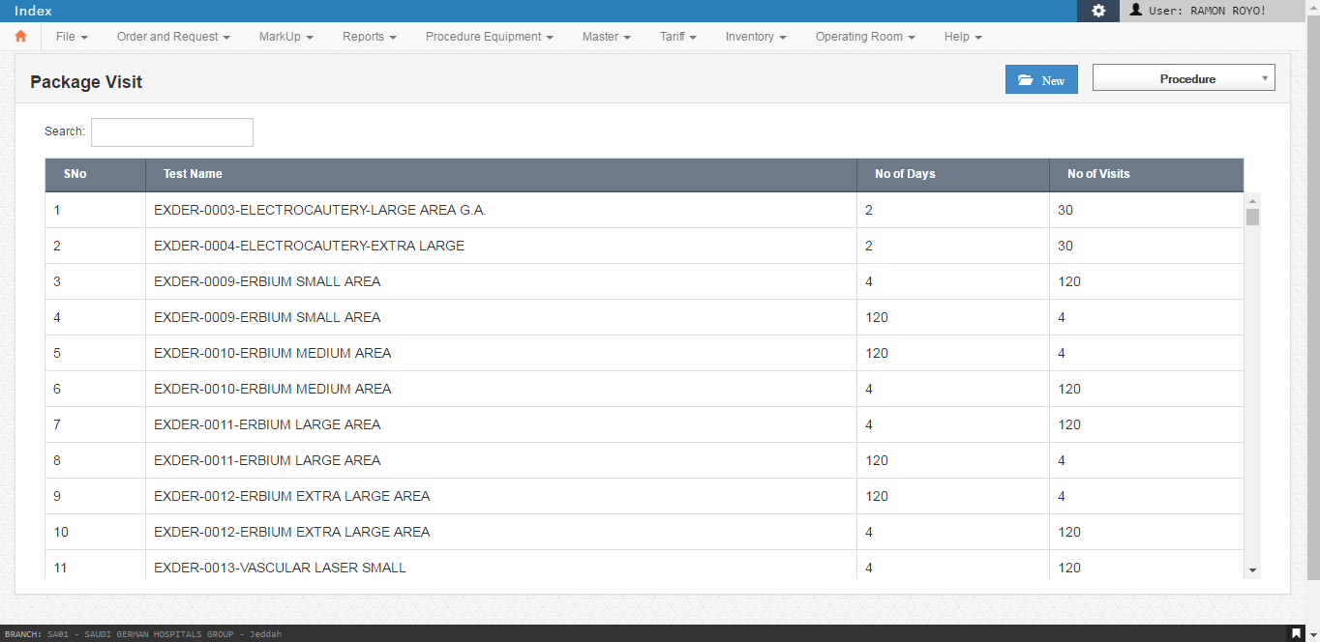

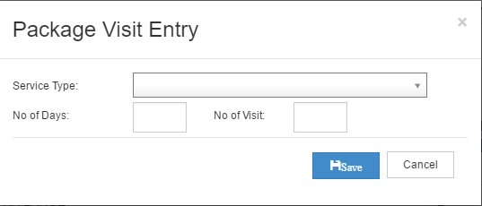

* 1. OP Package Visit Modify

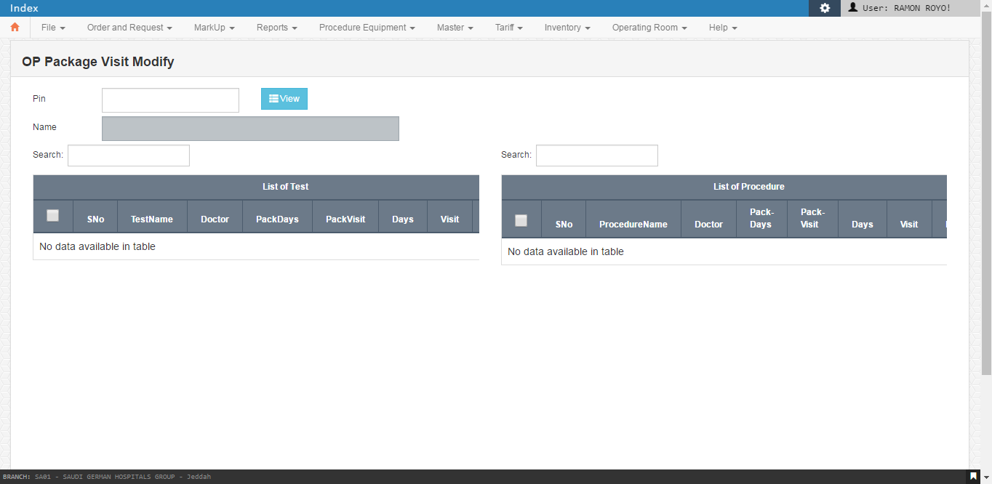

* 1. Cash Discount – Services

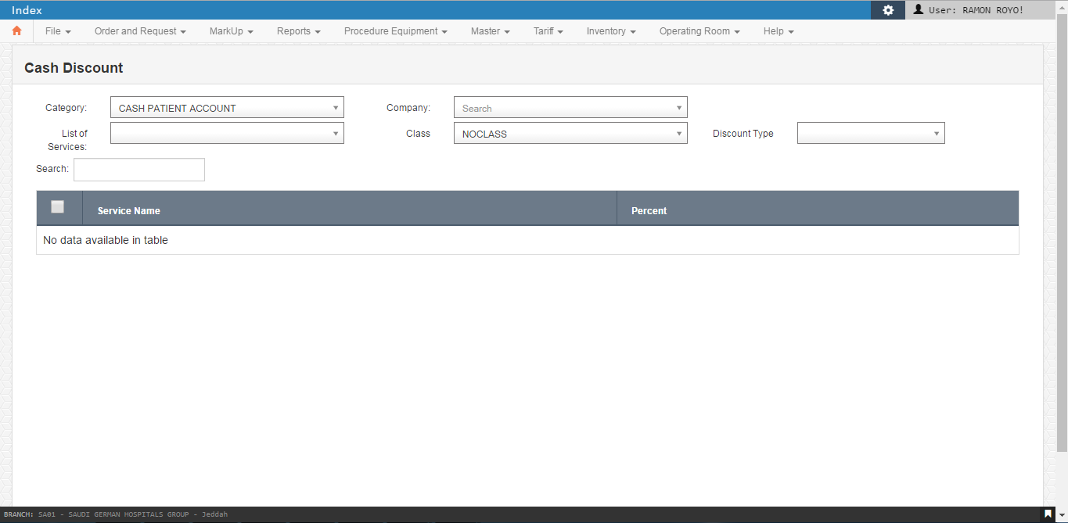

* 1. Cash Discount Type

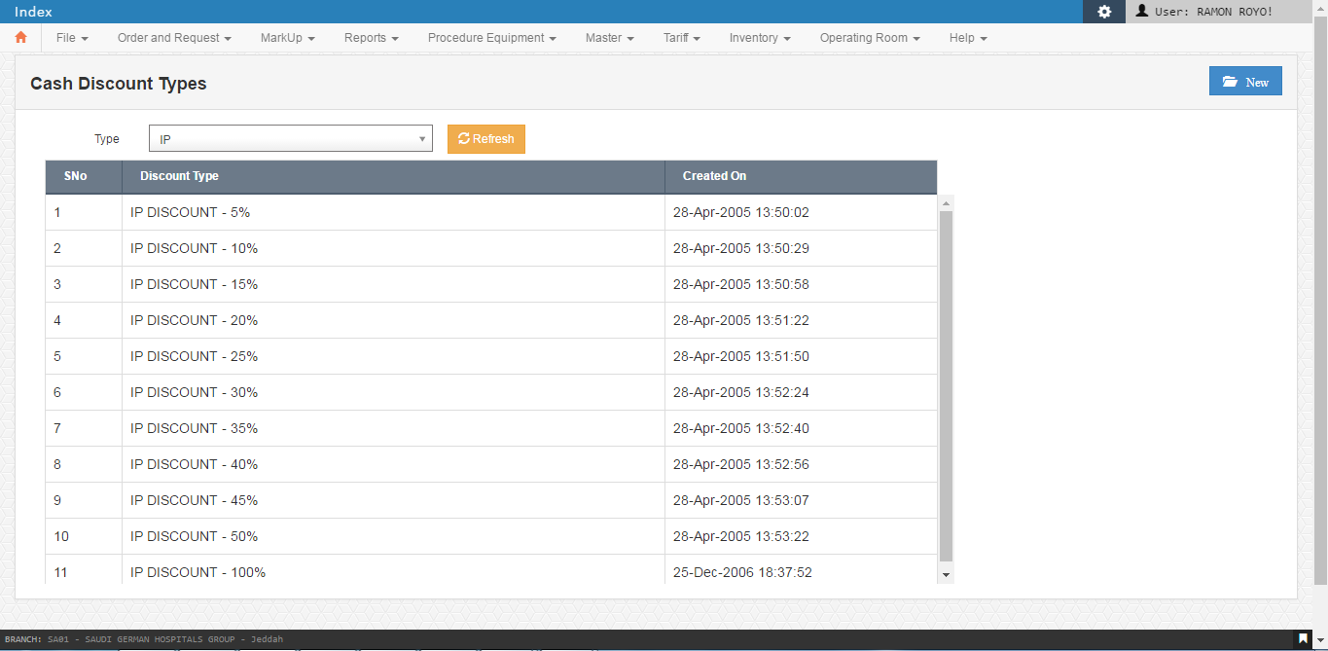

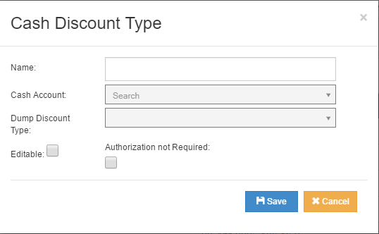

* 1. Cash Discount – Department Wise

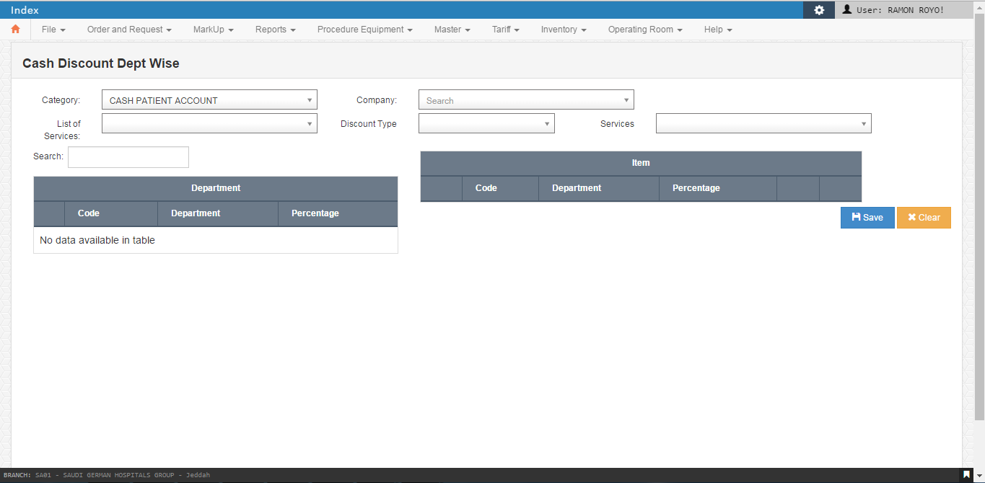

* 1. OP Non Discountable Items

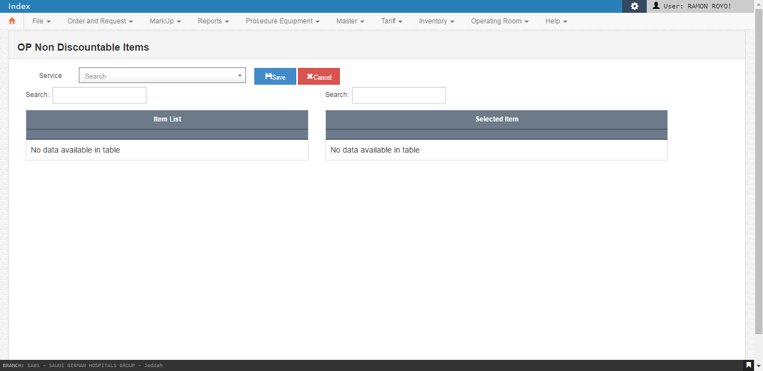

* 1. Discount Authorization Employee

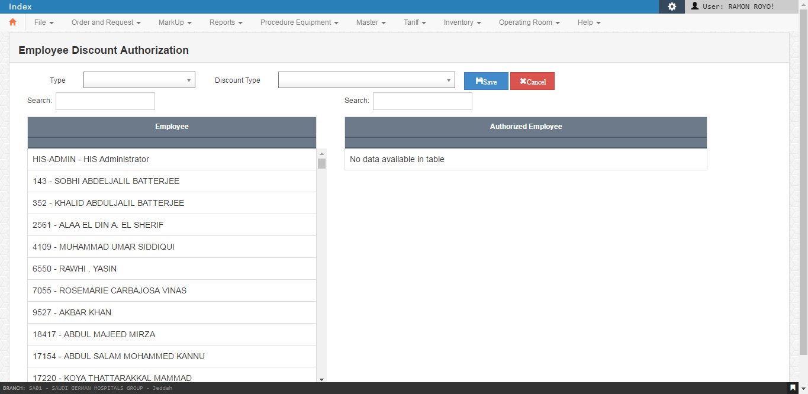

* 1. OP Doctor Clinic

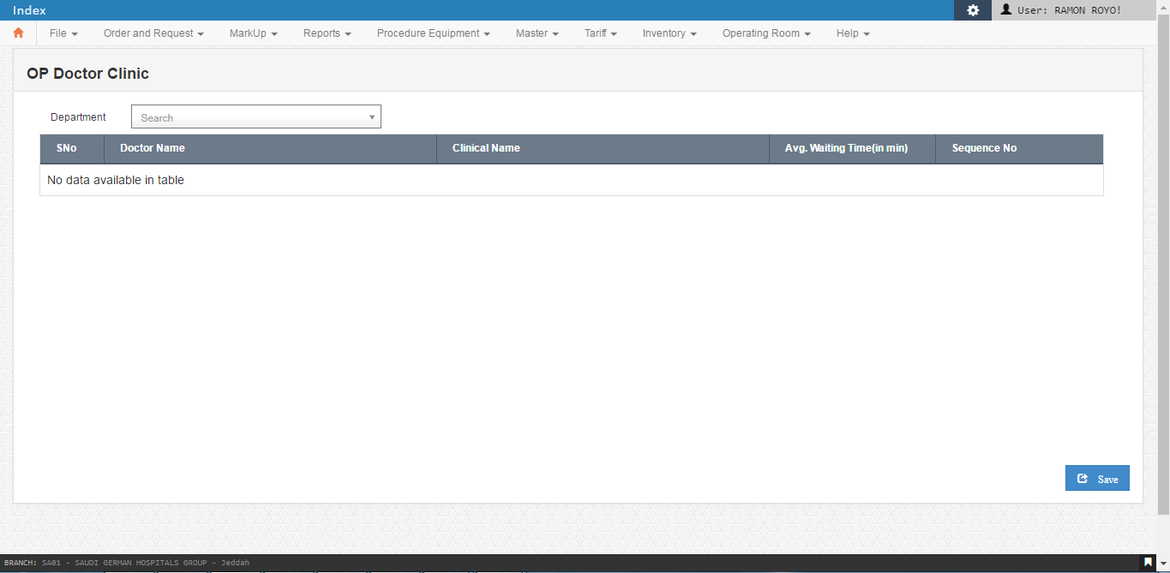

* 1. Location

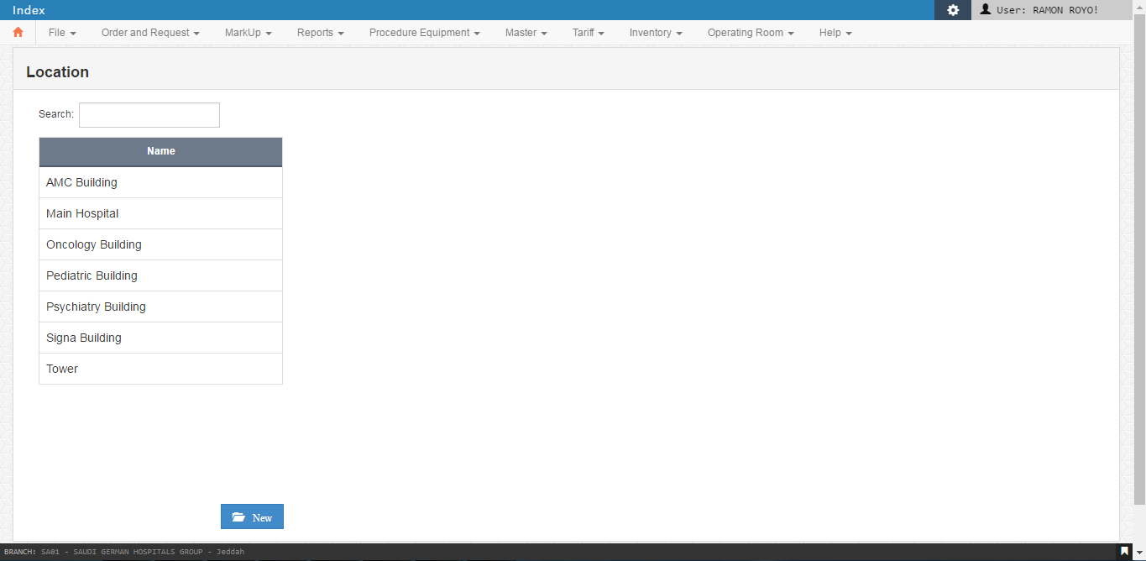

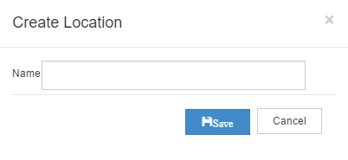

* 1. Laundry Item

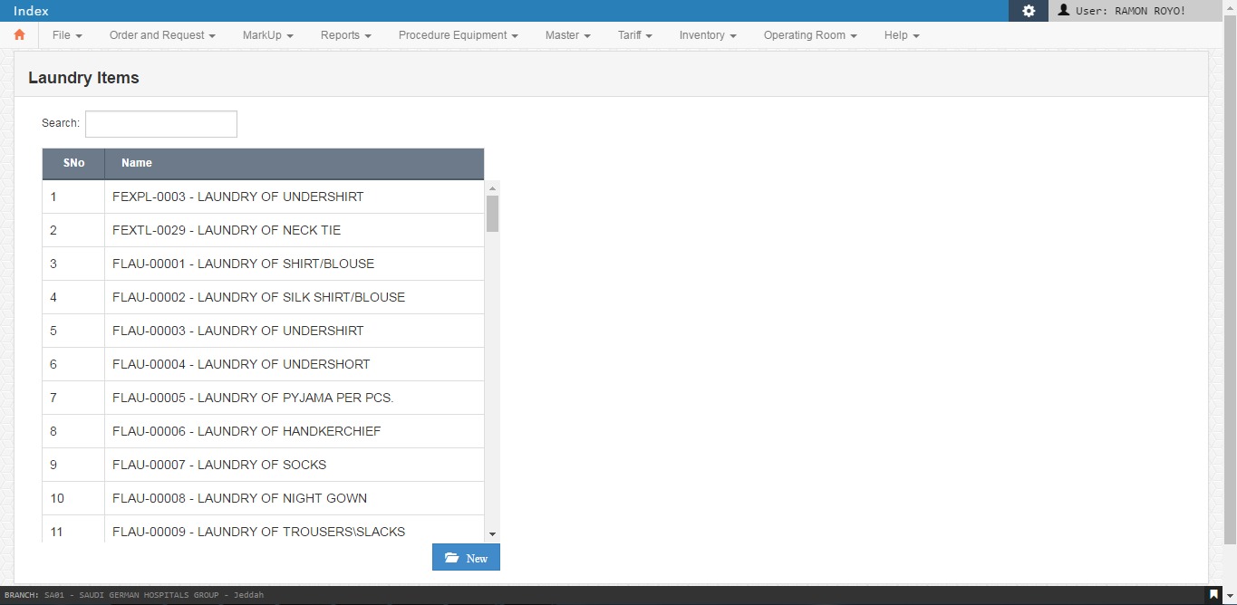

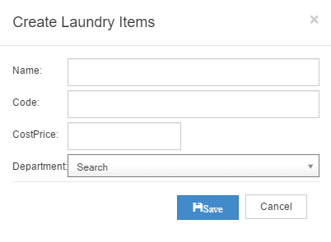

* 1. General Cashier Transactions

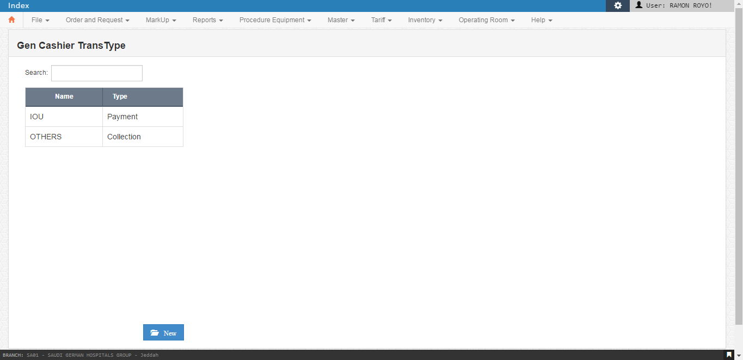

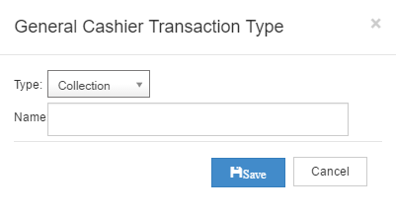

* 1. Map Other Package Procedures

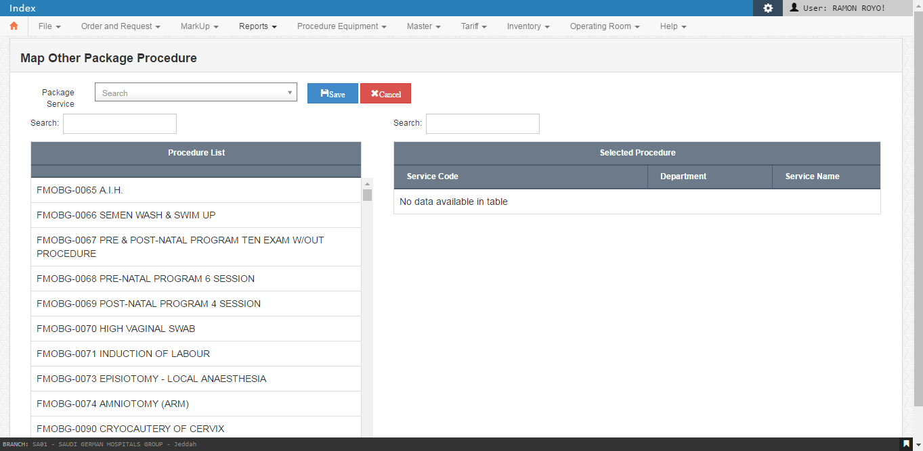

* 1. OP Bill Prefix

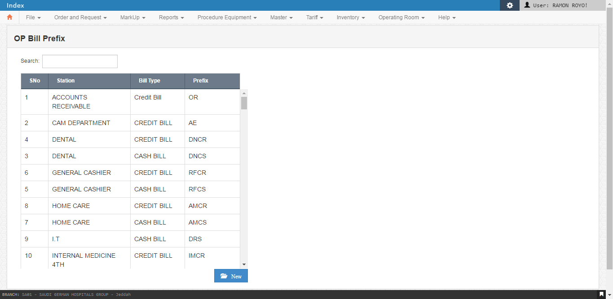

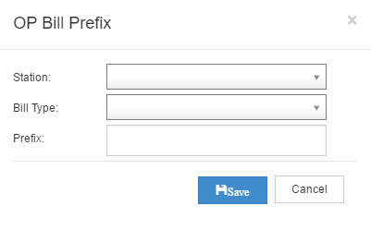

* 1. Machine Mapping

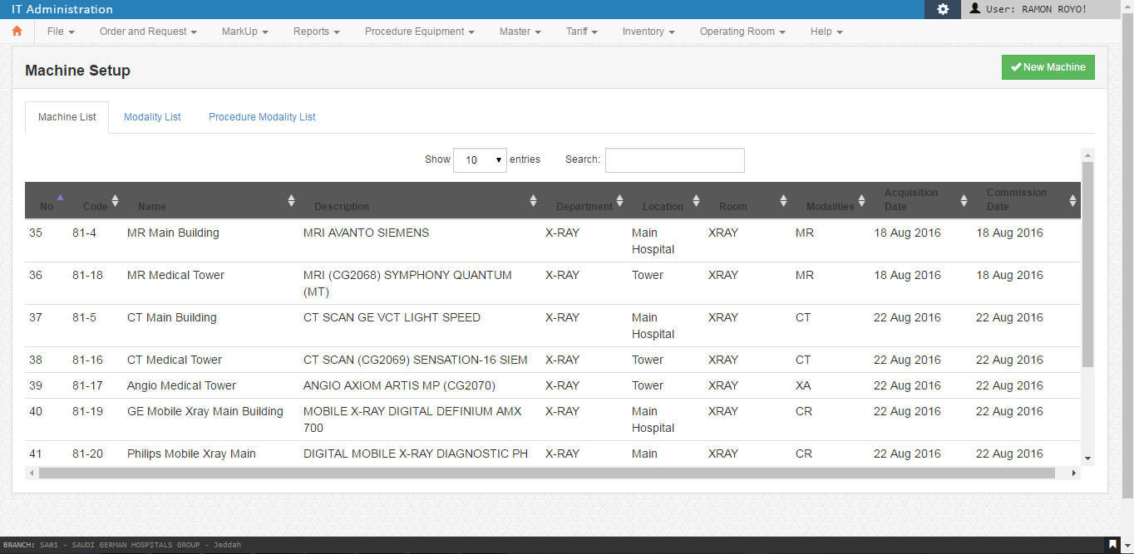

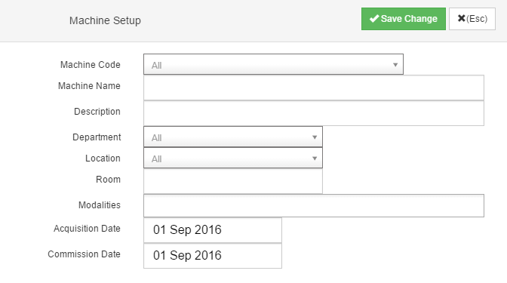

1. General

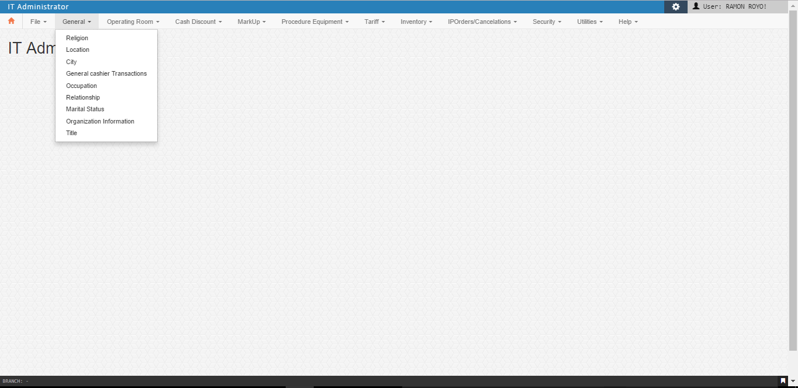

* 1. Religion

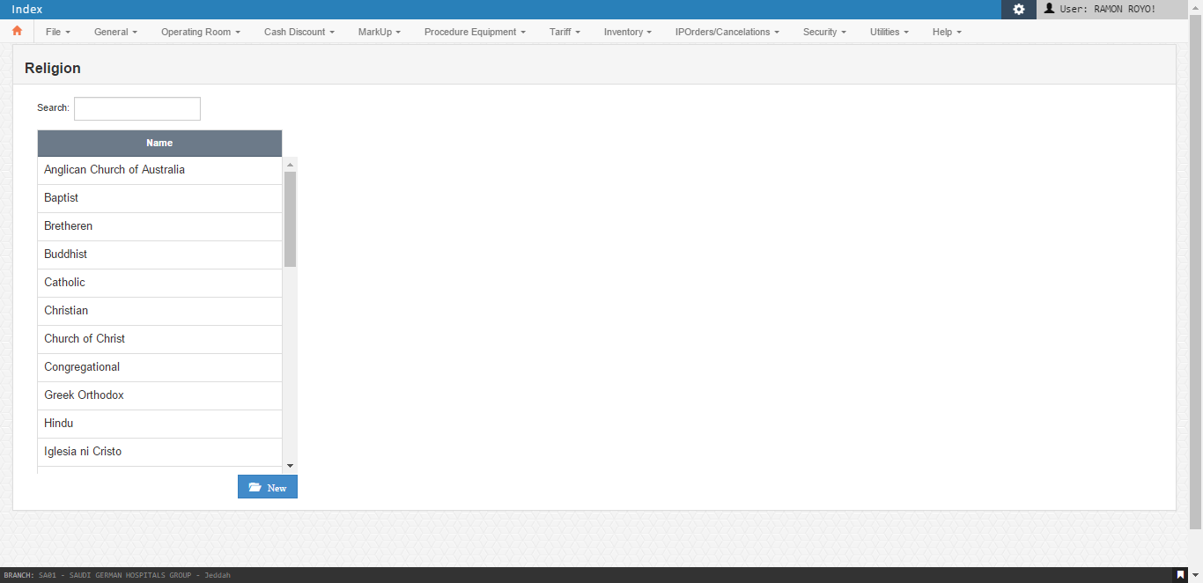

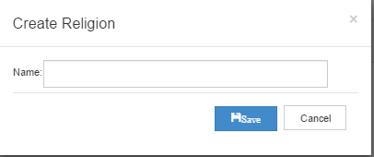

* 1. Location

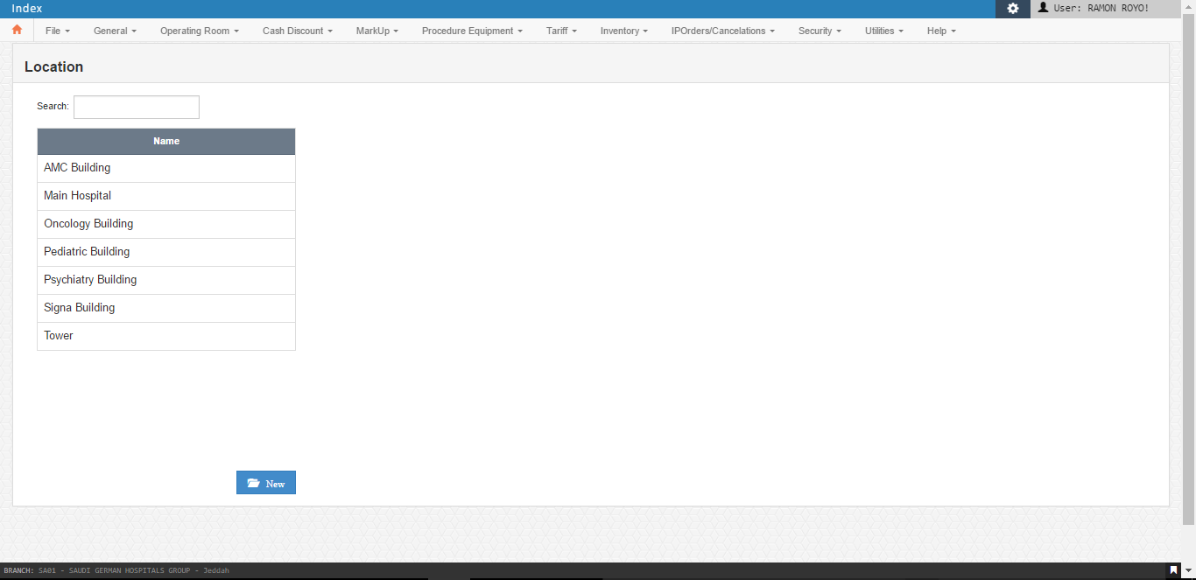

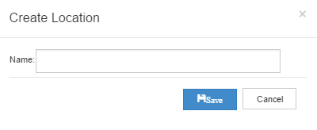

* 1. City

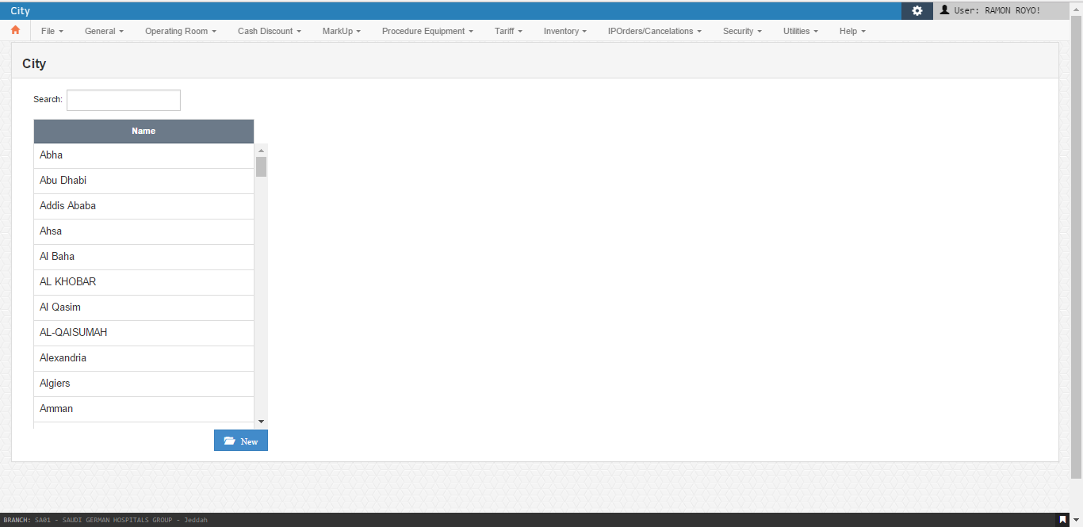

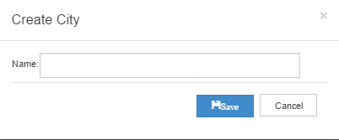

* 1. Gen. Cashier Trans Type

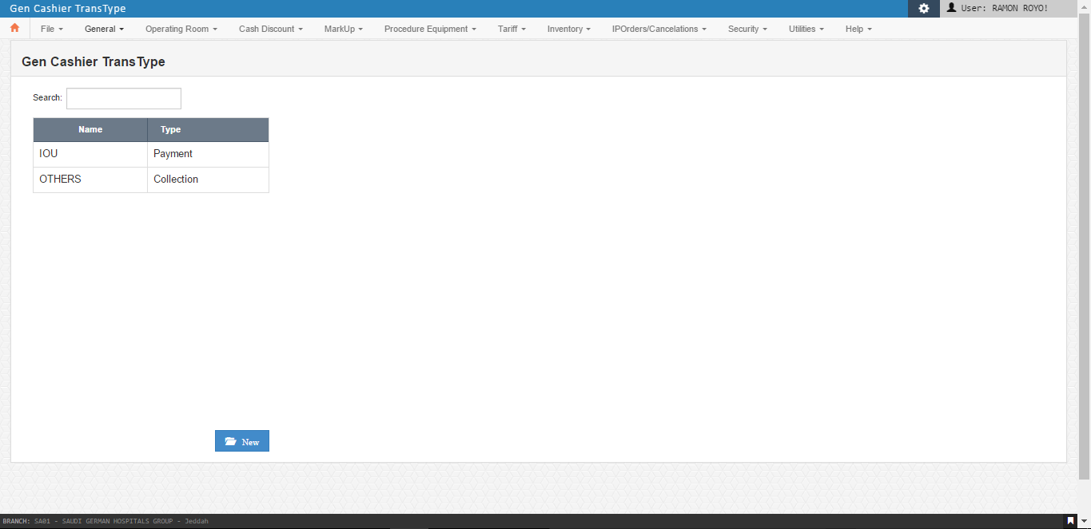

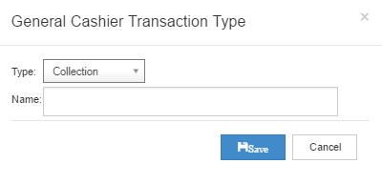

* 1. Occupation

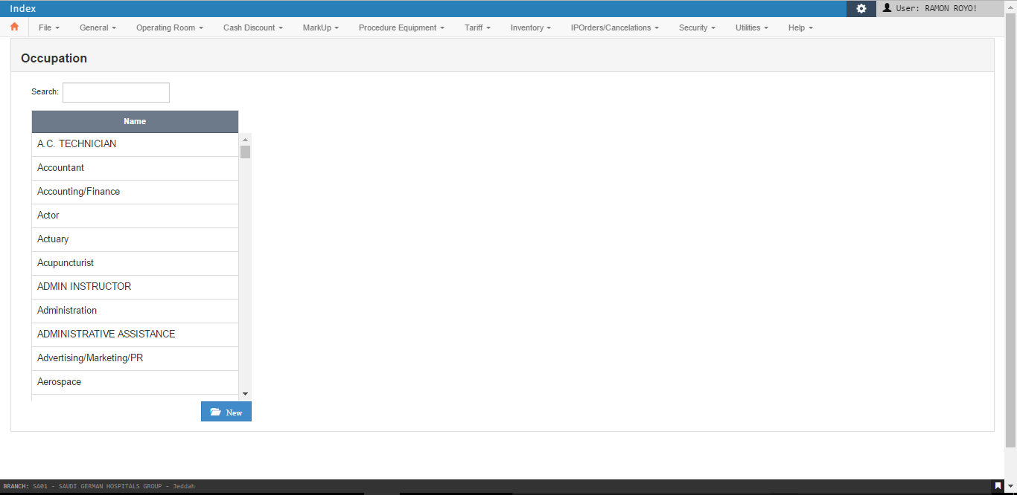

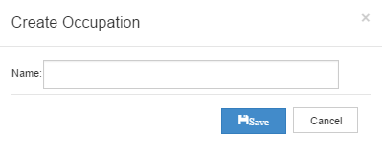

* 1. Relationship

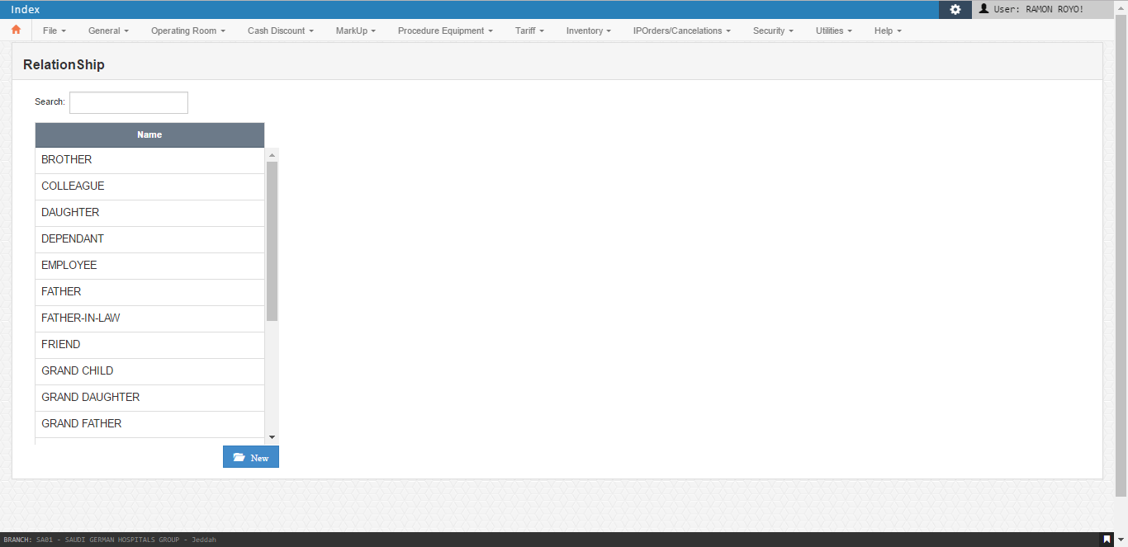

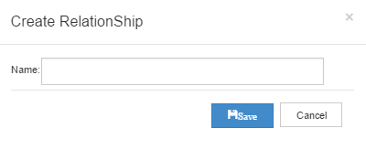

* 1. Relationship

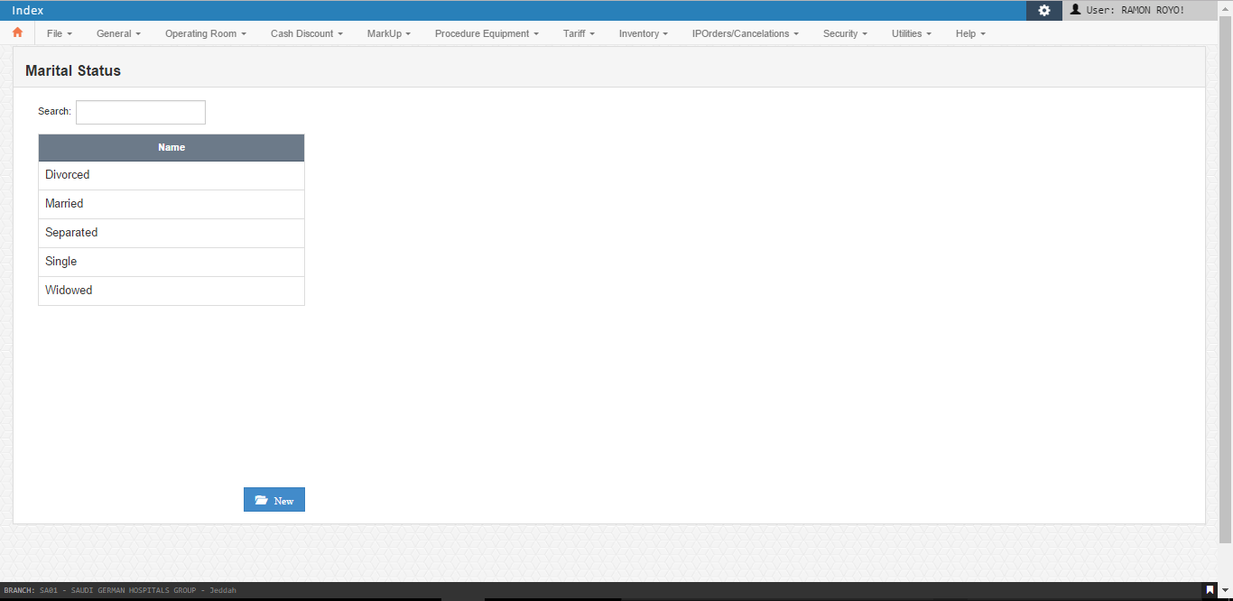

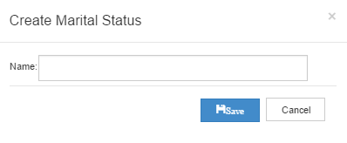

* 1. Organization Information

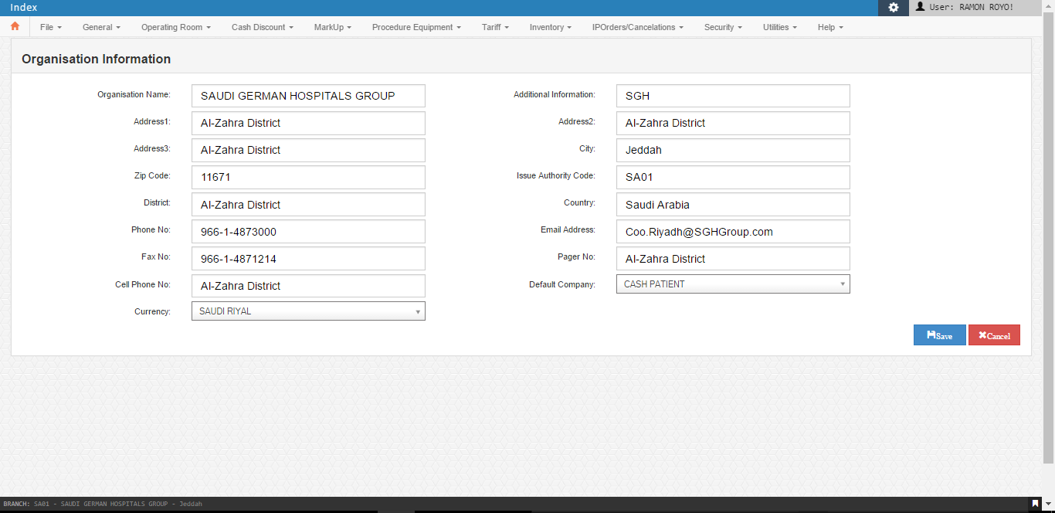

* 1. Title

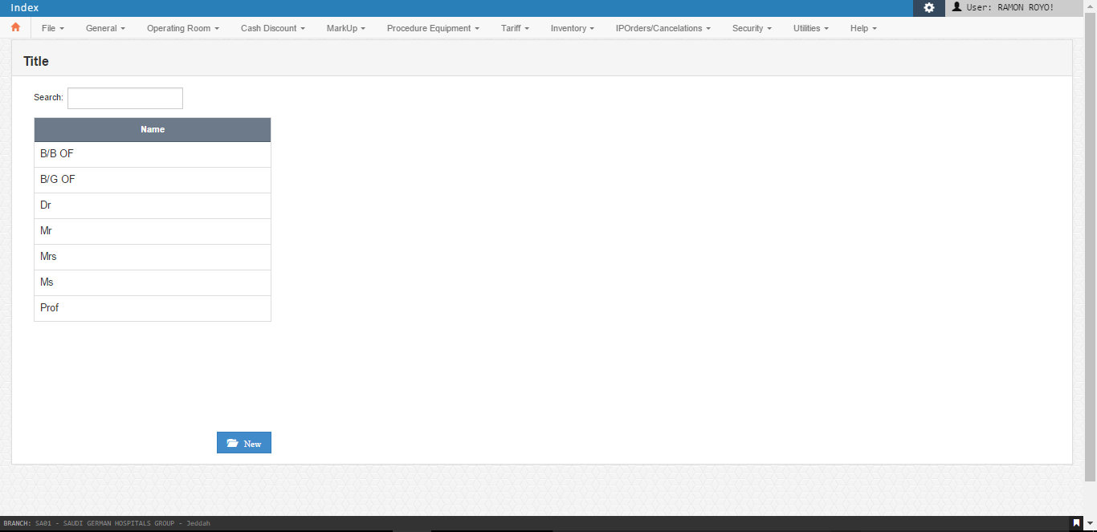

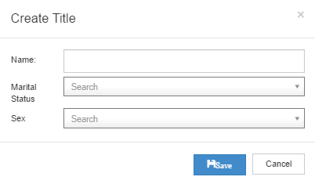

1. Order and Request

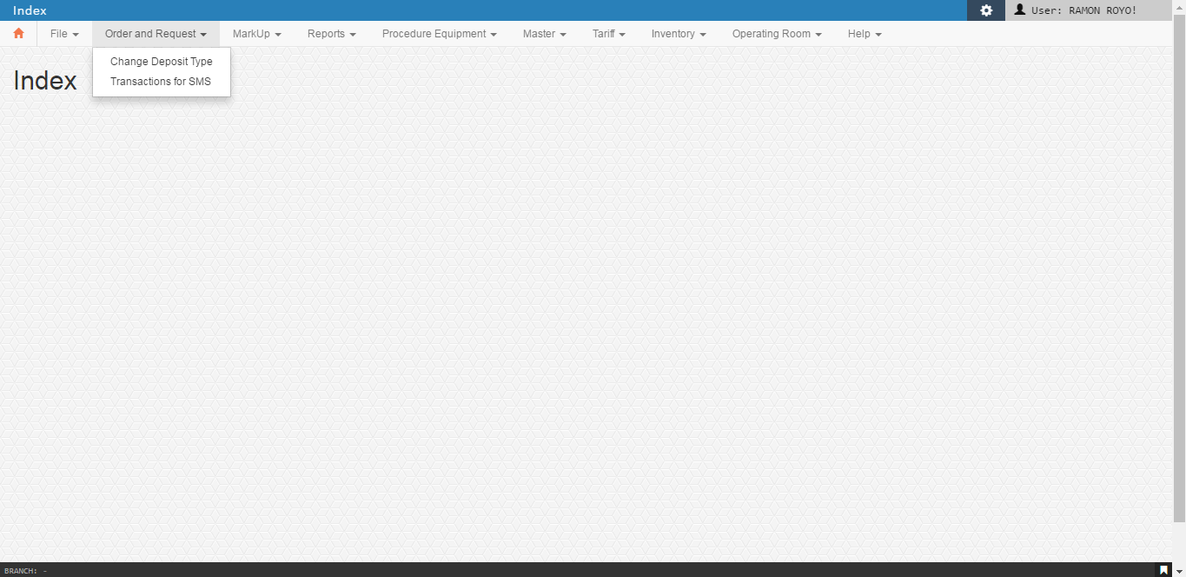

* 1. Change Deposit Type

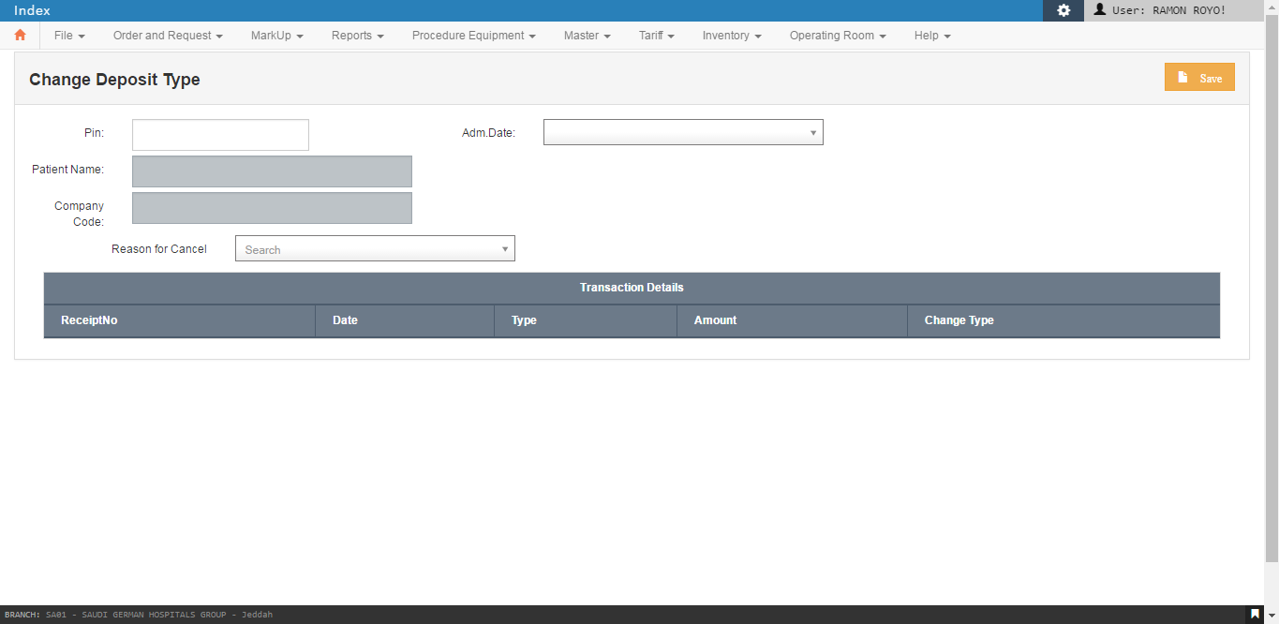

* 1. Transactions for MMS

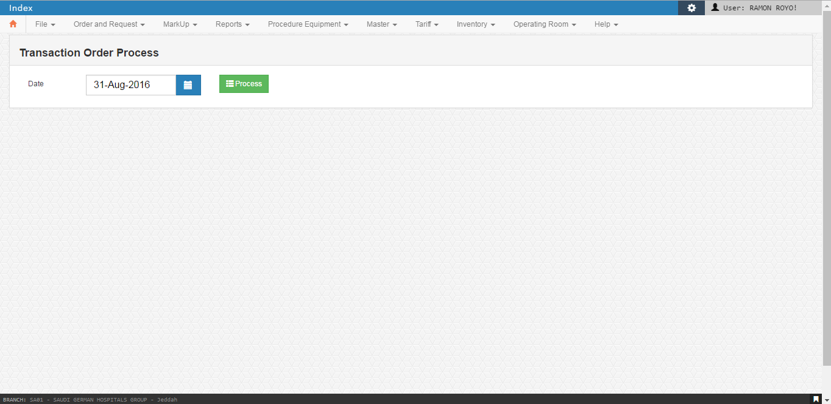

1. MarkUp

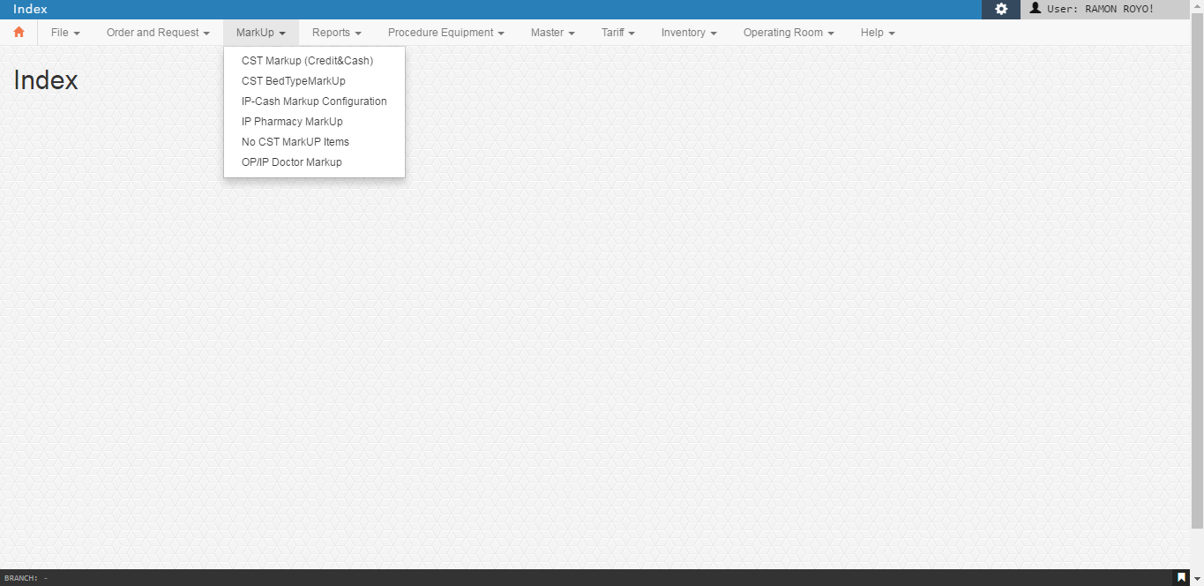

* 1. CST Markup (Credit&Cash)

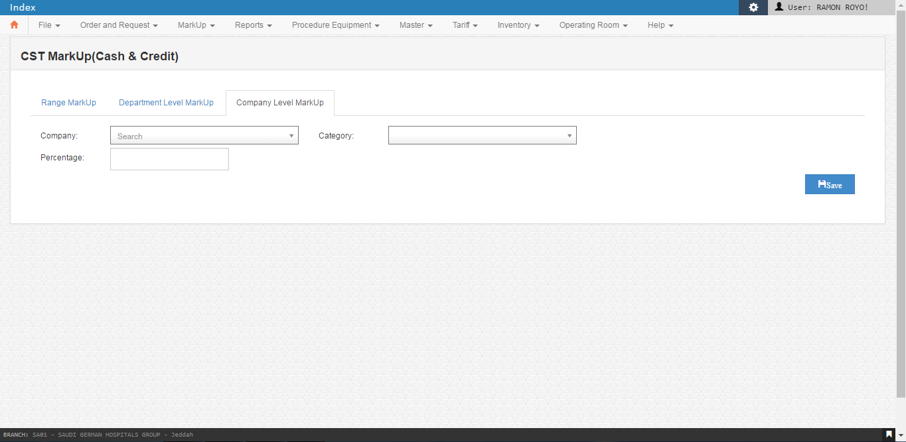

* 1. CST BedTypeMarkup

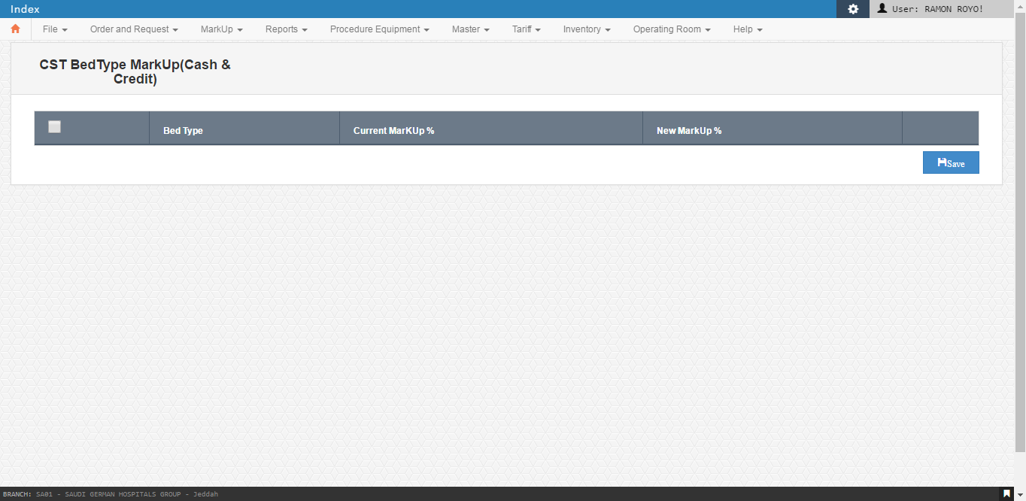

* 1. IP-Cash Markup Configuration

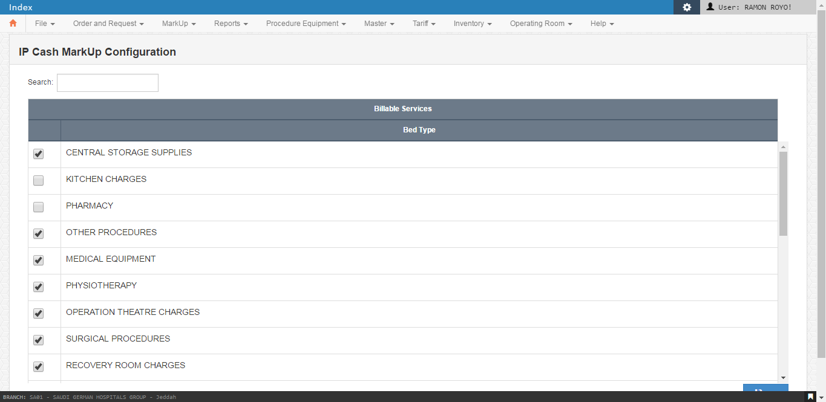

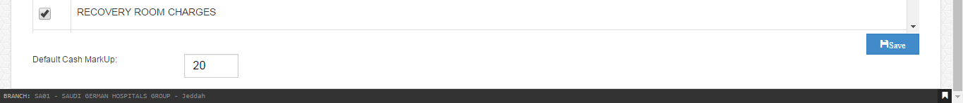

* 1. IP Pharmacy Markup

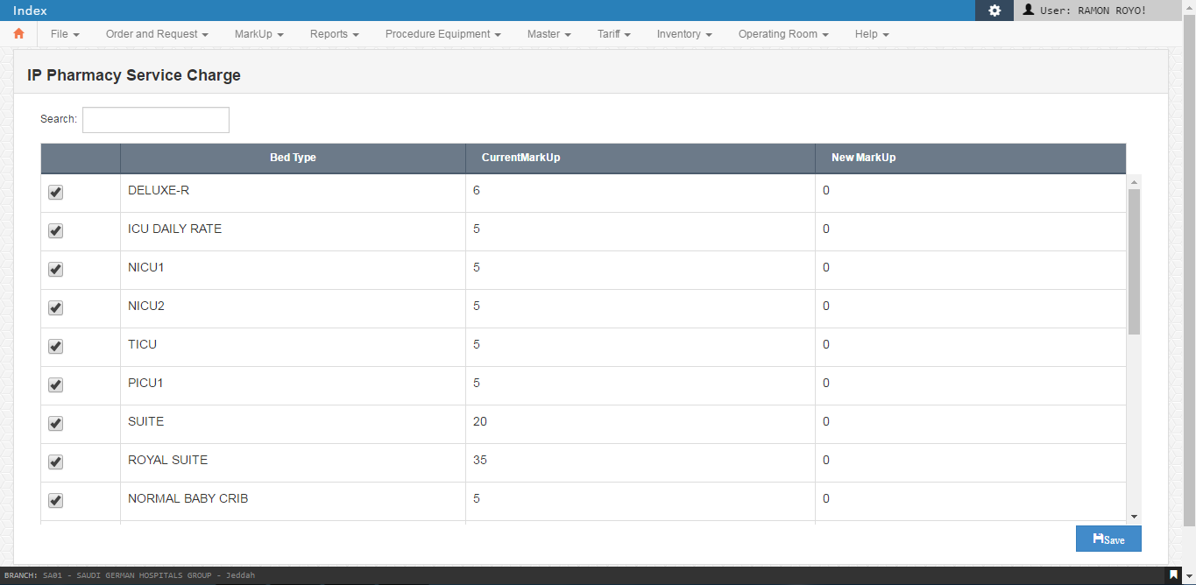

* 1. No CST MarkUp Items

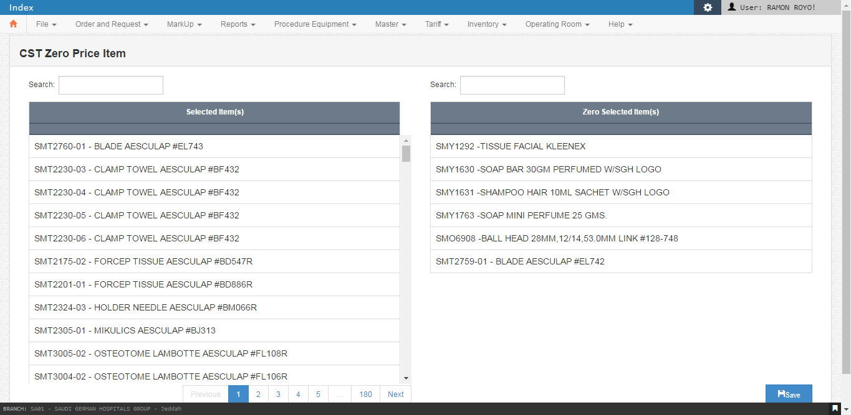

* 1. OP/IP Doctor Markup

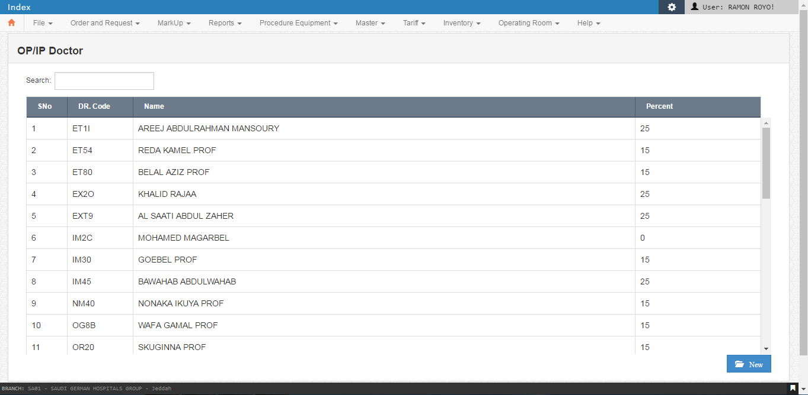

1. Reports

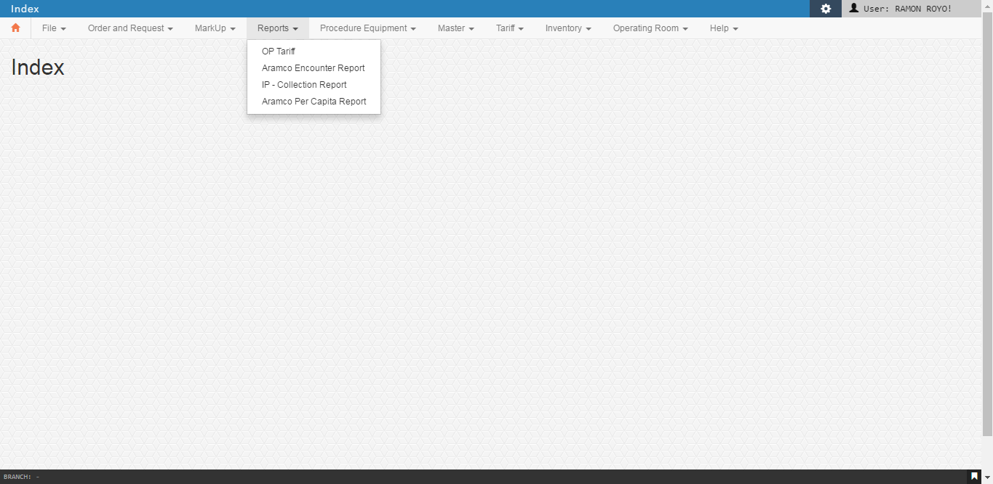

* 1. OP Tariff

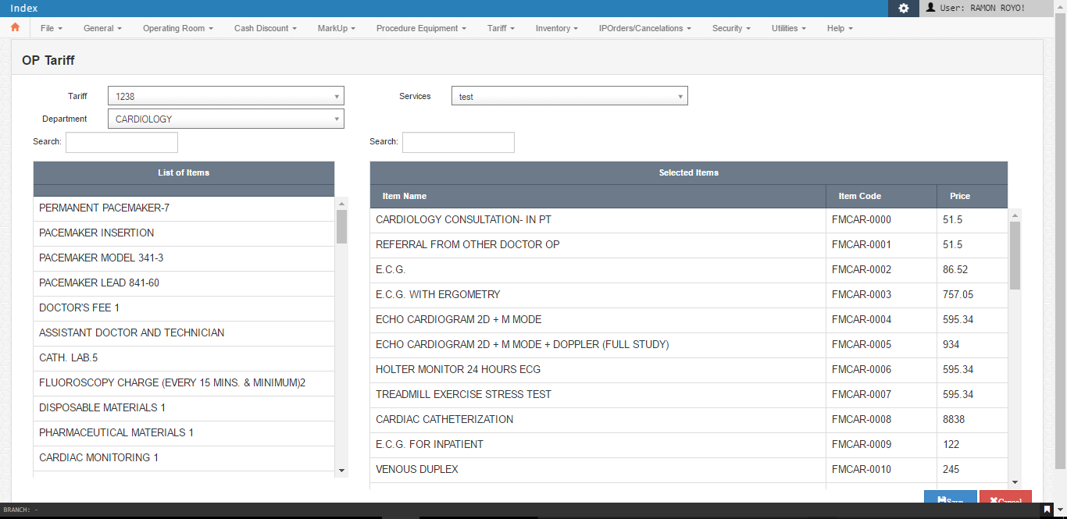

* 1. IP – Collection Report

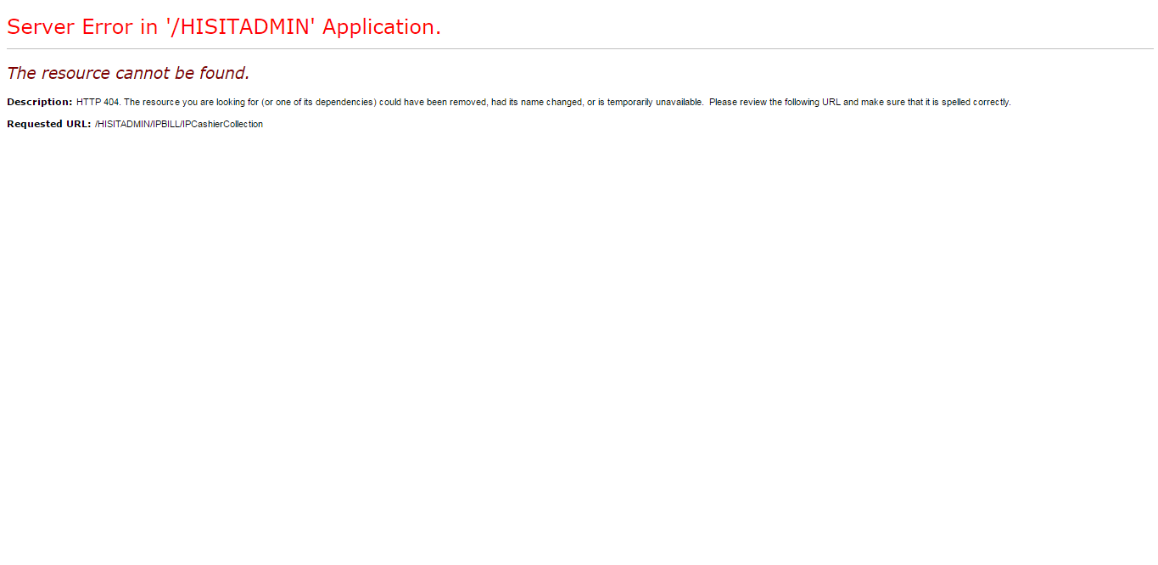

1. Procedure Equipment

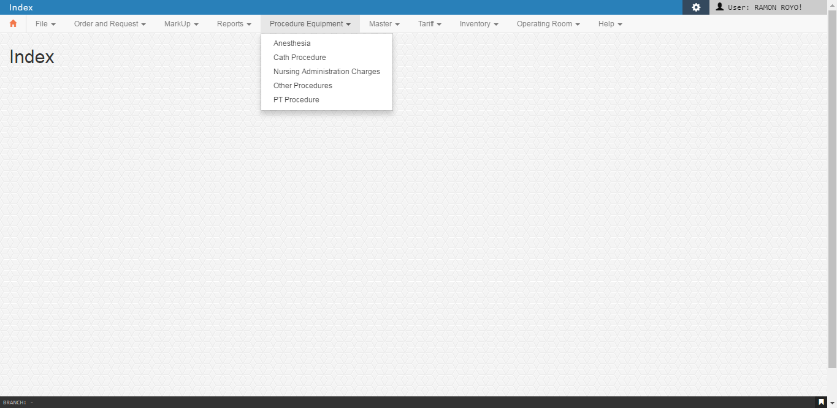

* 1. Anesthesia

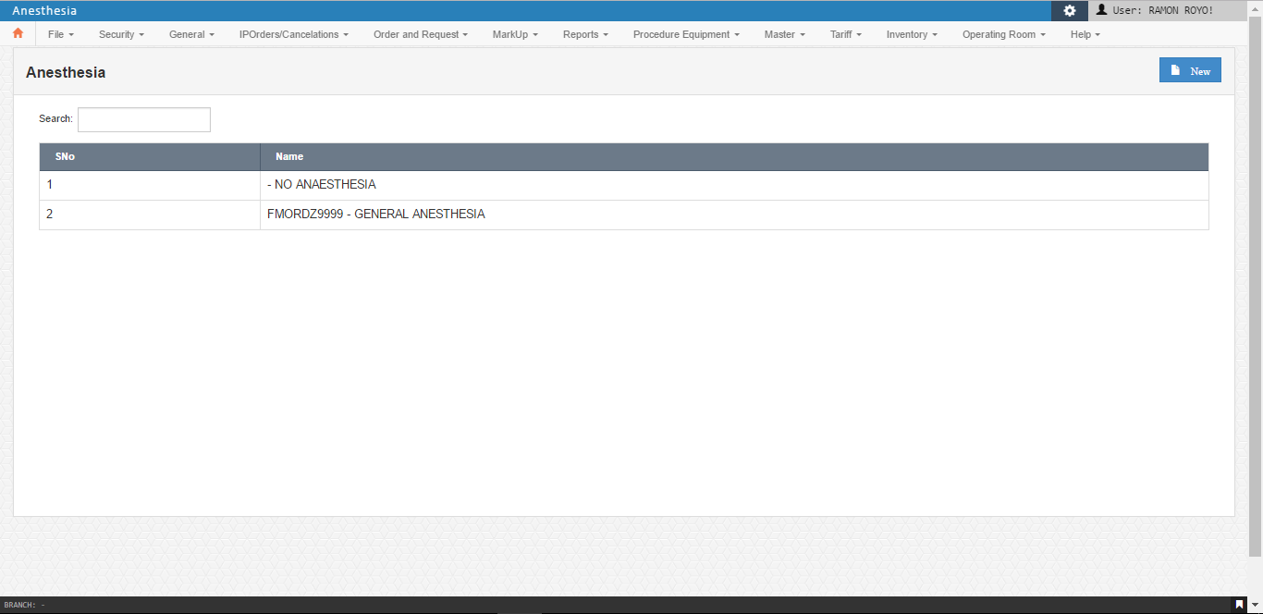

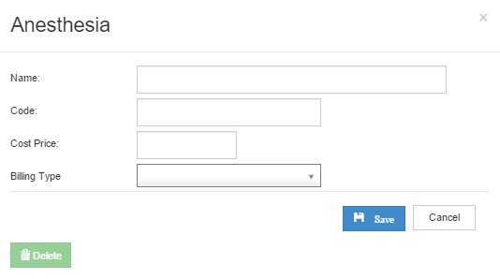

* 1. Cath Procedure

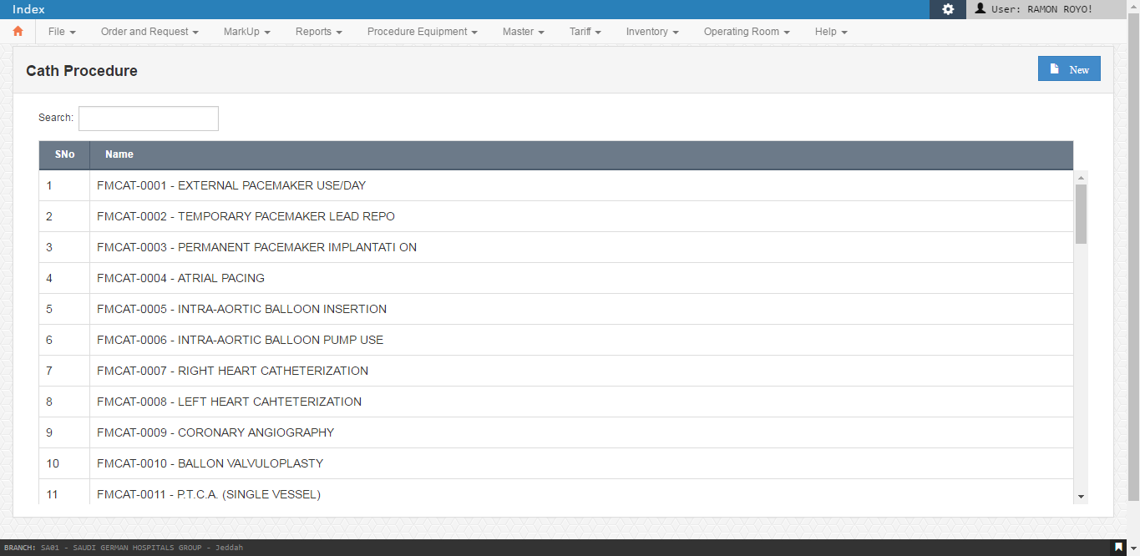

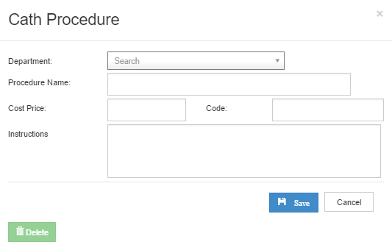

* 1. Nursing Administration Charges

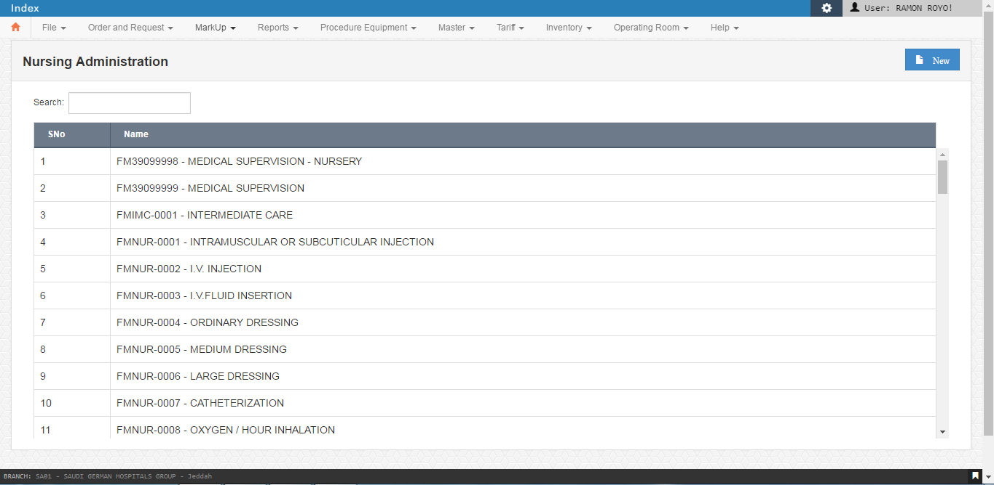

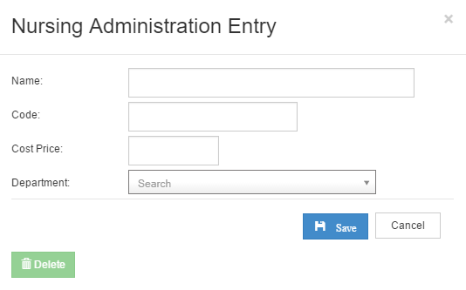

* 1. Other Procedures

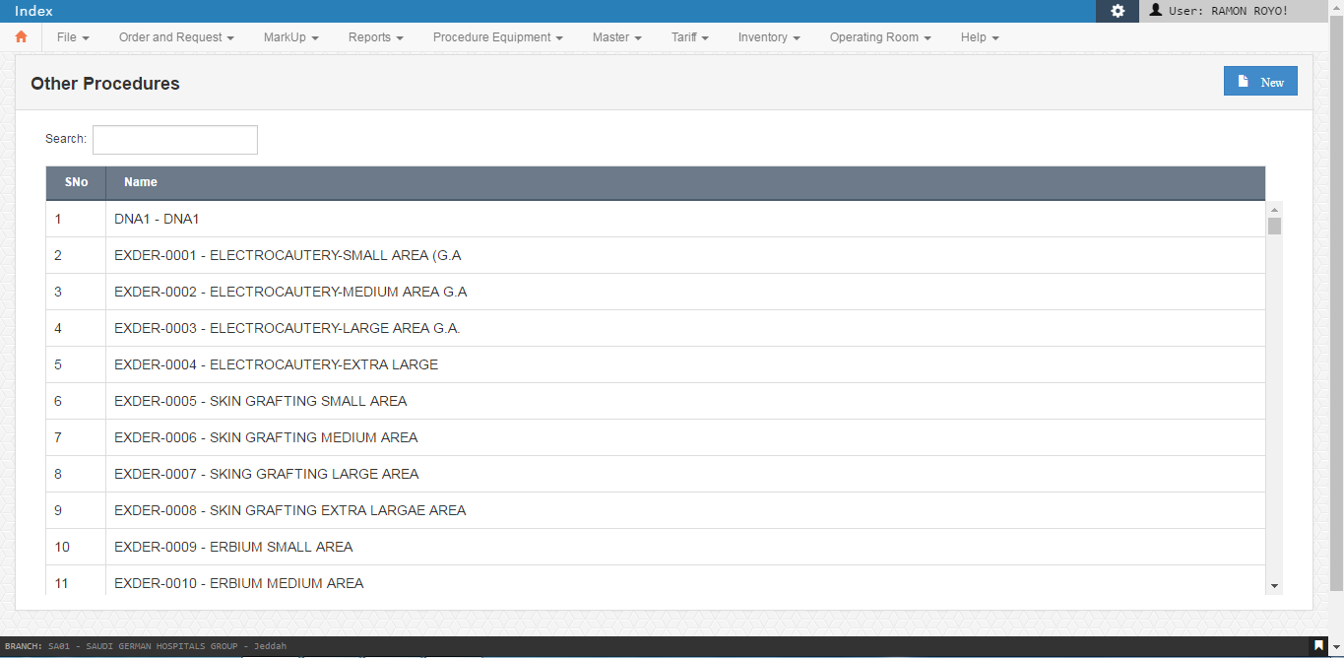

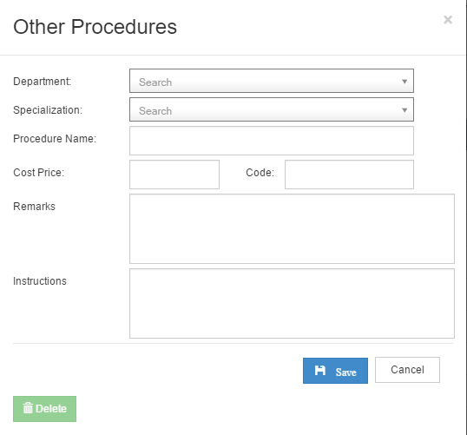

* 1. PT Procedure

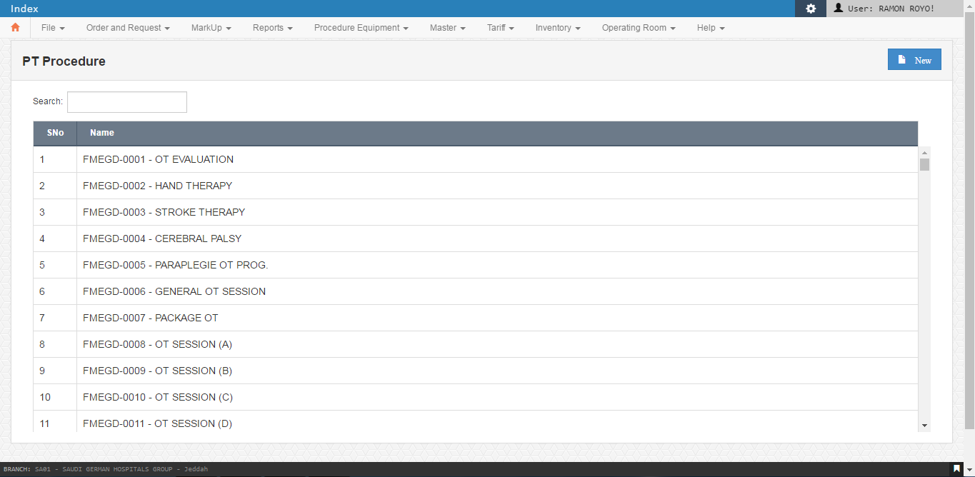

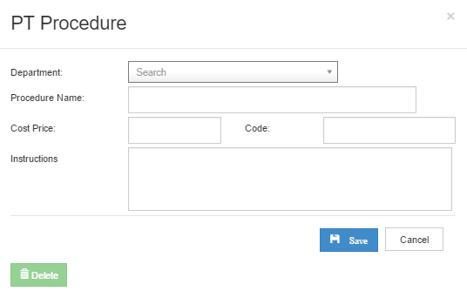

1. Master / Security

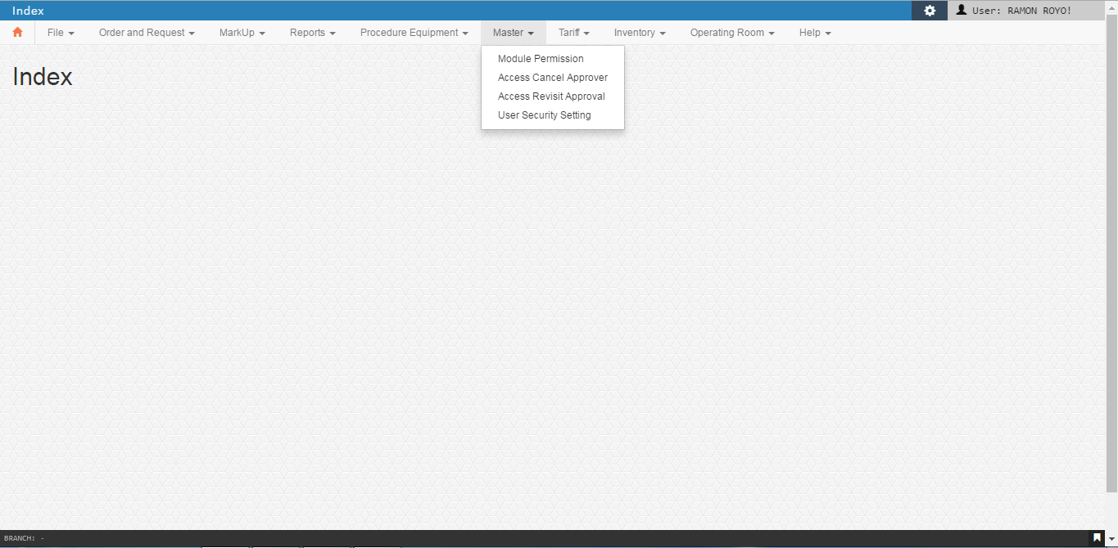

* 1. Module Permission

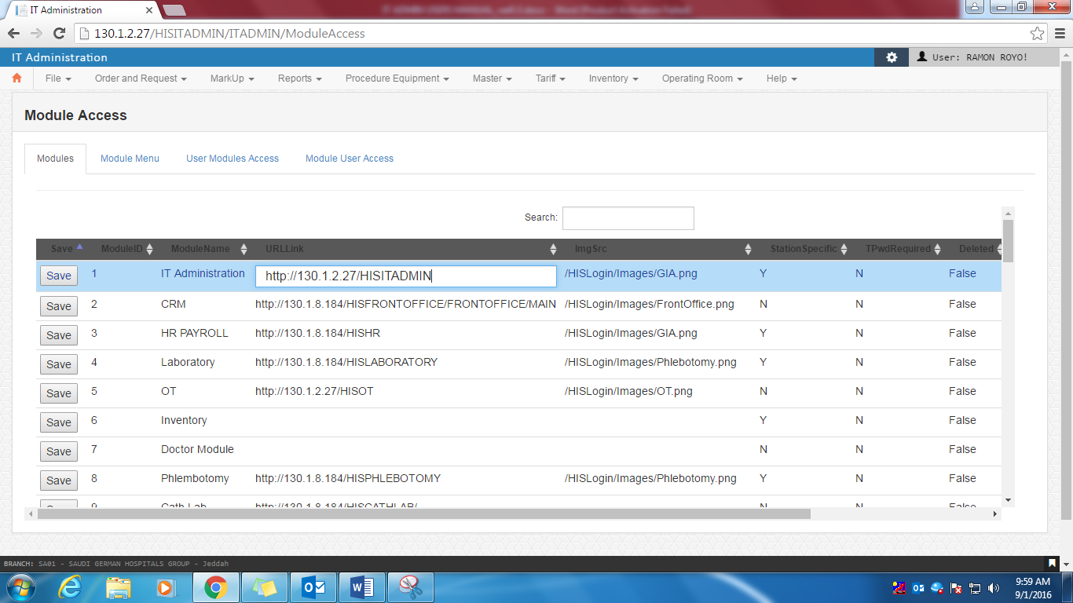

Module menu

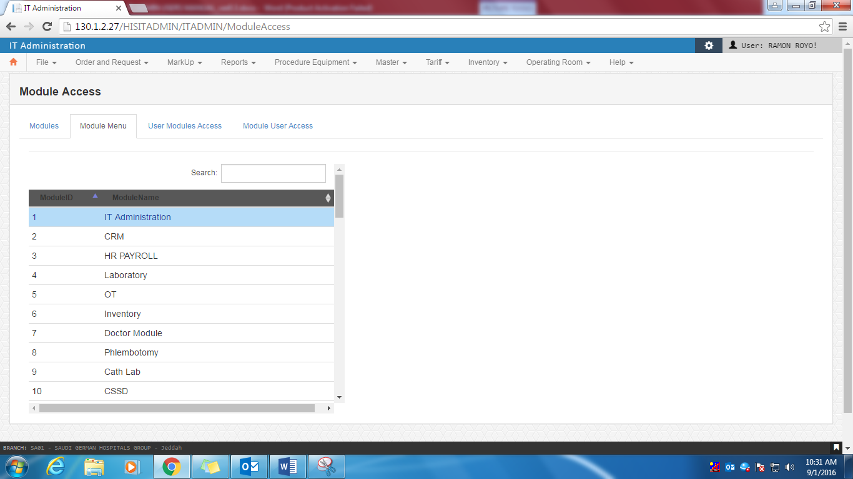

As the user scroll down, the upper part tends to scroll too, tendency is for the

user not to view the upper part, it should be static.

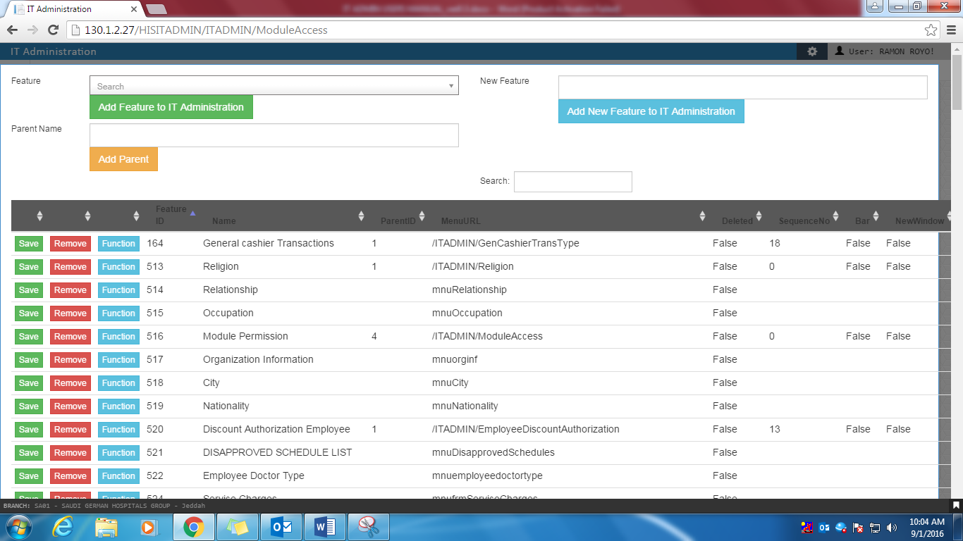 eto bang 3 buttons eh may confirmation box, after maclick o rekta na?



Error occurred after clicking  after clicking back it will exit and go back to main module menu

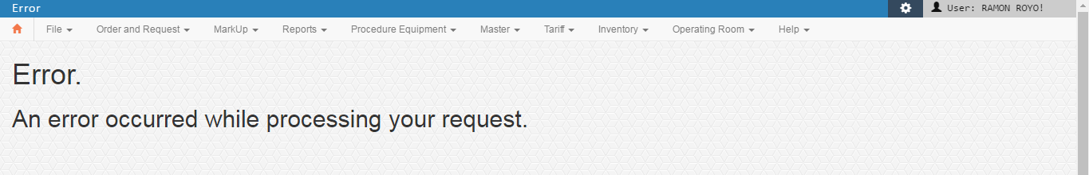

Error occurred after clicking 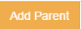 after clicking back it will exit and go back to main module menu

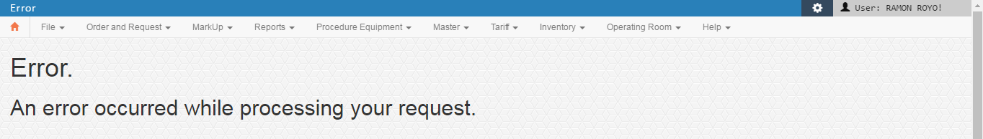

When clicking on 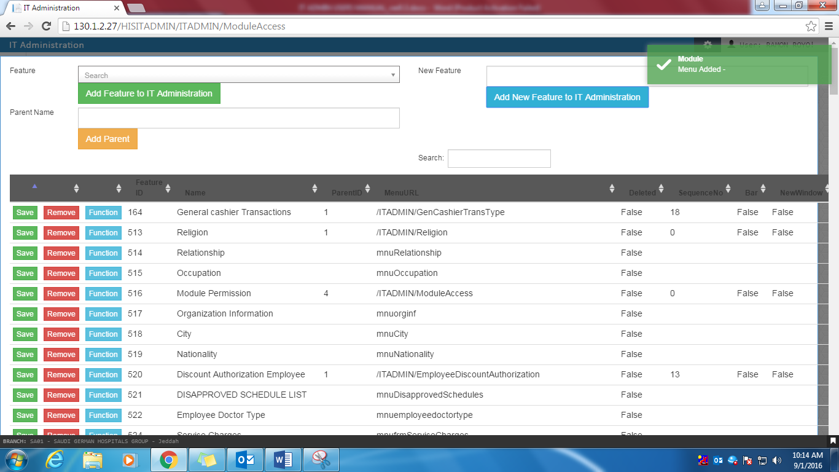this  then nothing happens

When clicking on function, it shows this shadowed screen, and when I click back it exit back to menu

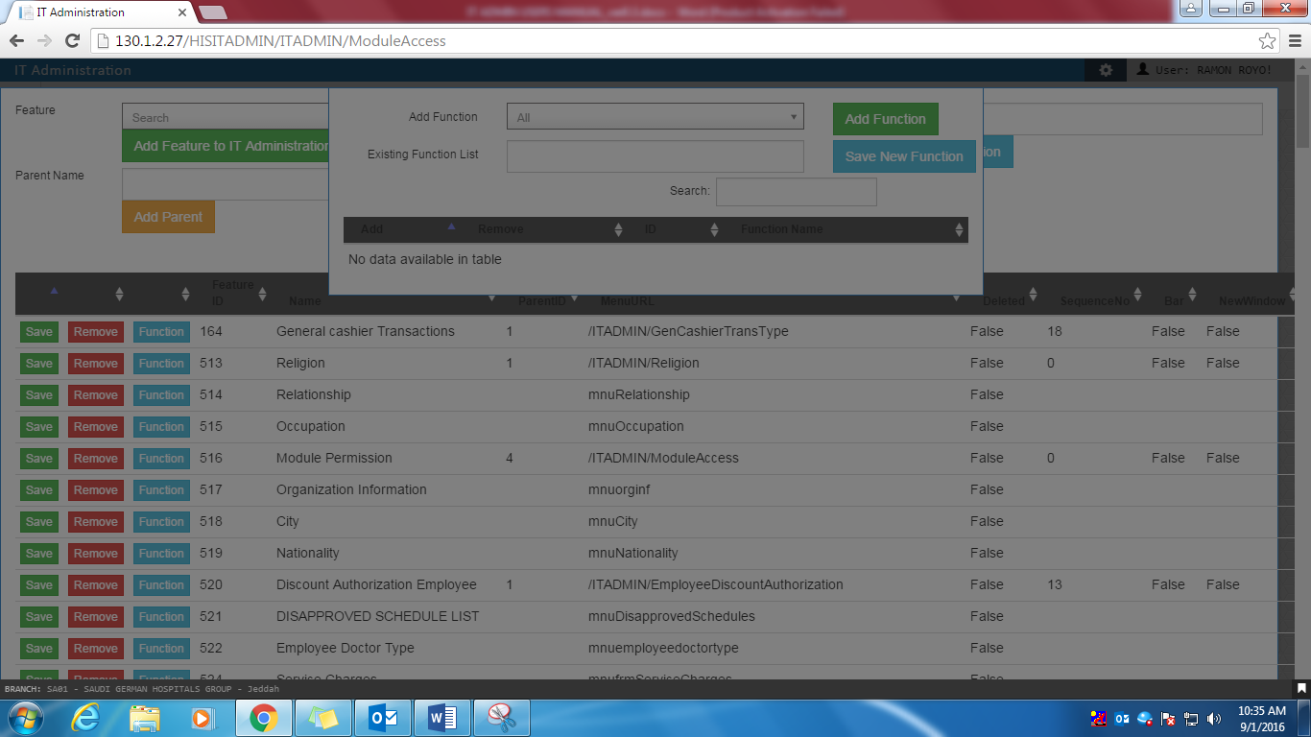

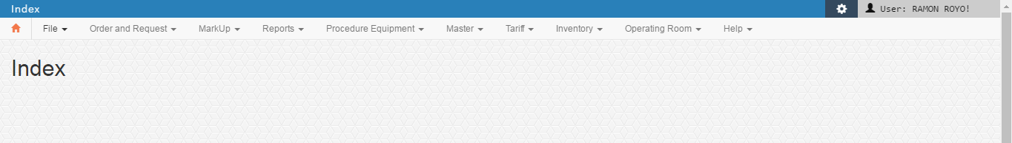

Pag nagclick ba ako ng add automatic ng mag add wala ng confirmation?

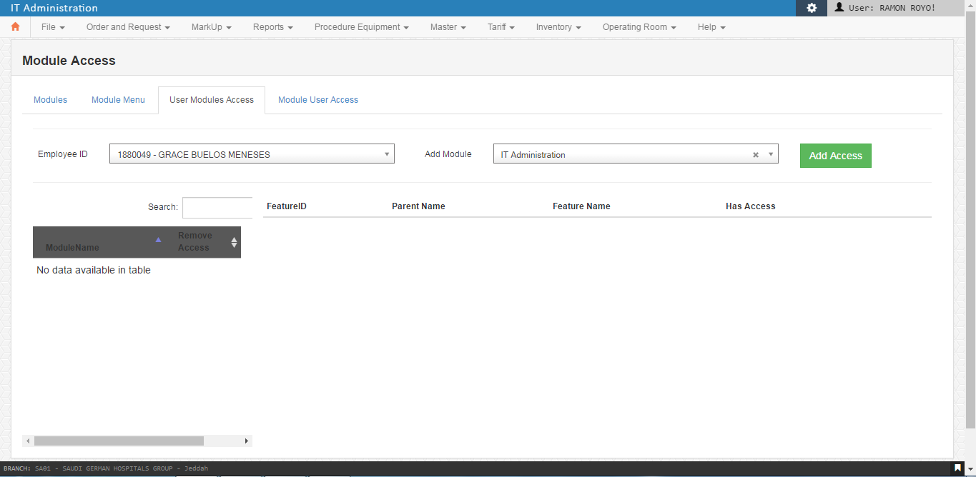

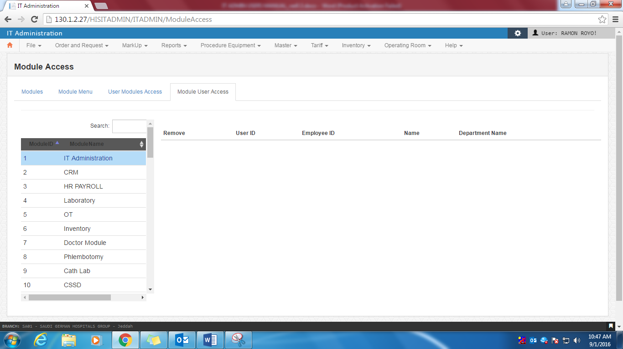

* 1. Access Cancel Approver

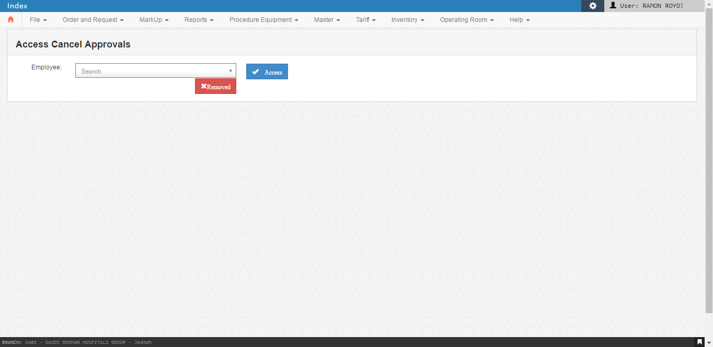

* 1. Access Revisit Approval

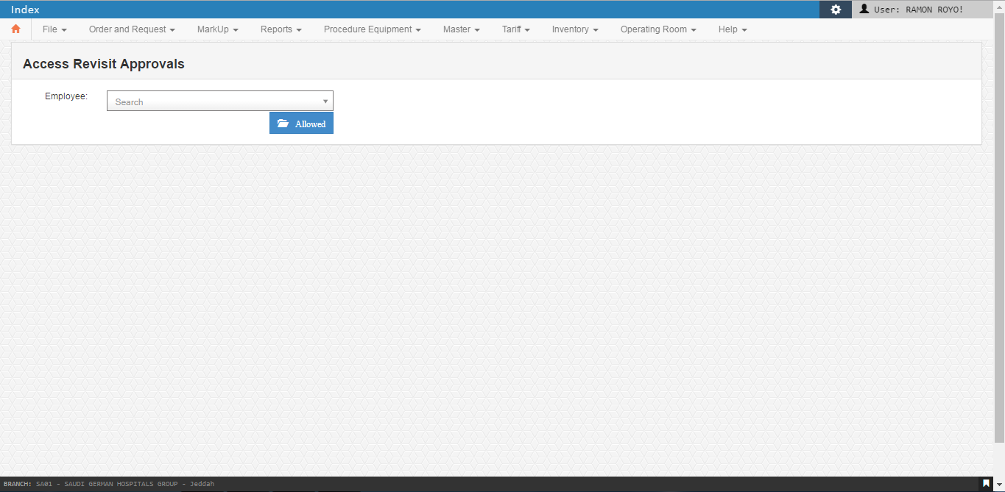

1. Tariff

Every new procedure, they choose cash, then when AR Department will request for the specific company, that’s the time they change tariff code from cash to specific company code.

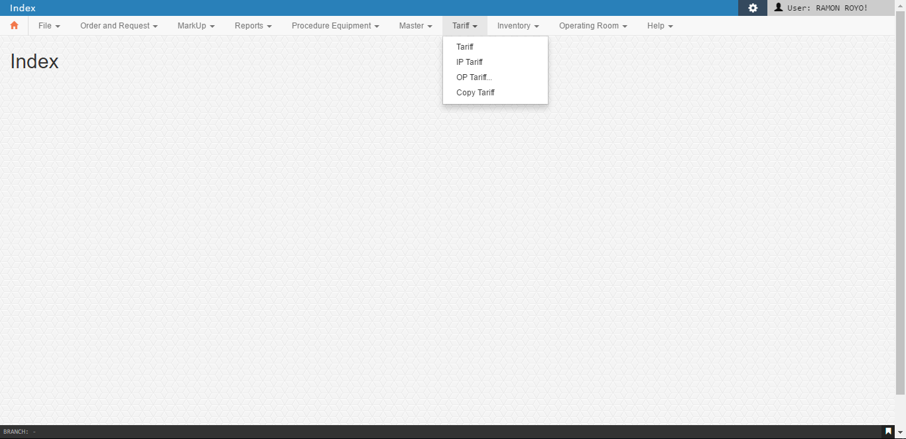

* 1. Tariff

Tariff function is list of Company Code affiliated by SGH but commonly used is cash.

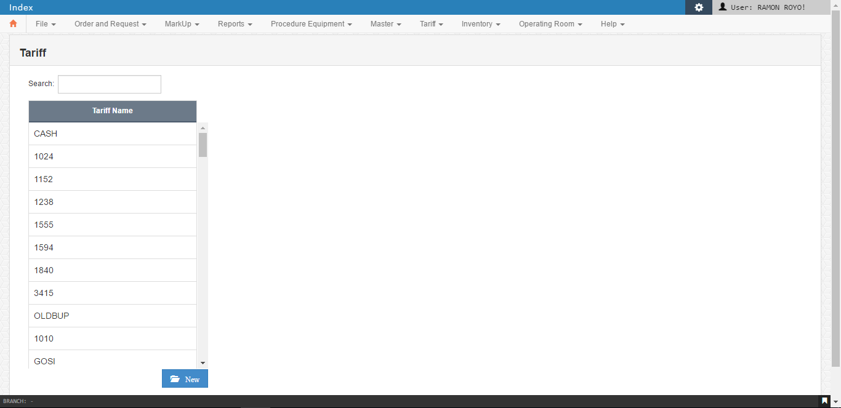

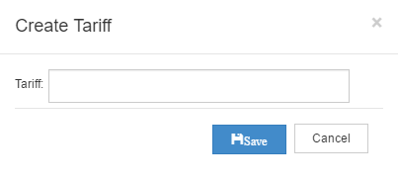

* 1. IP Tariff

In Patient Tariff monitoring - is list of Bed type with price, where they place the current price with date and effectivity, (effectivity of the price is always the 1st day of the month). As you click on the Arrow from item, it will move accordingly, this way the system will show you the different price given per bed type, with effective date.

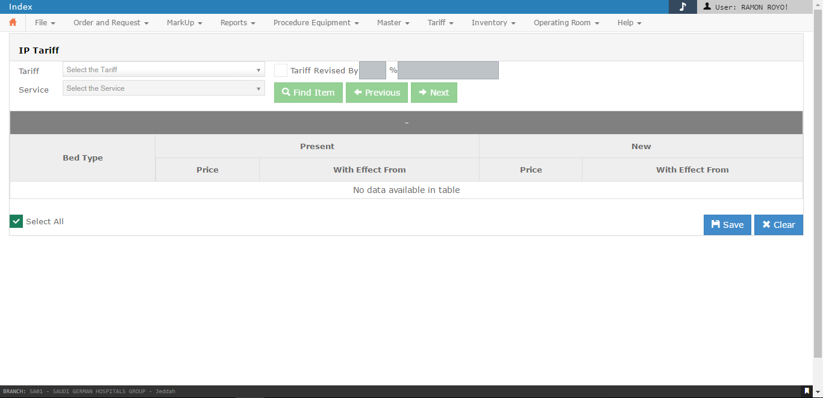

* 1. OP Tariff

Out Patient Tariff monitoring - is list of Bed type with price, where they place the current price with date and effectivity, (effectivity of the price is always the 1st day of the month). As you click on the Arrow from item, it will move accordingly, this way the system will show you the different price given per bed type, with effective date.

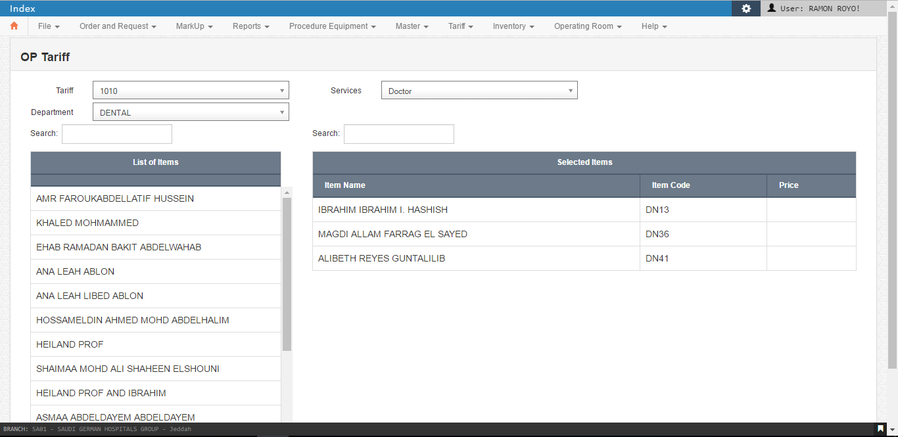

* 1. Copy Tariff

In Patient Tab

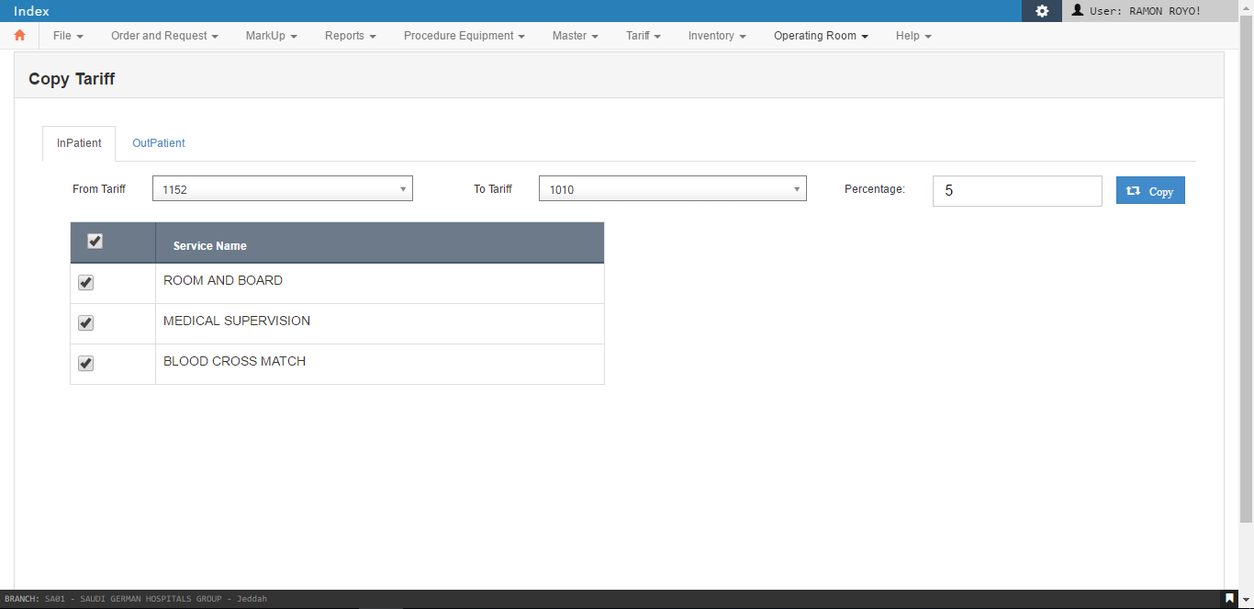

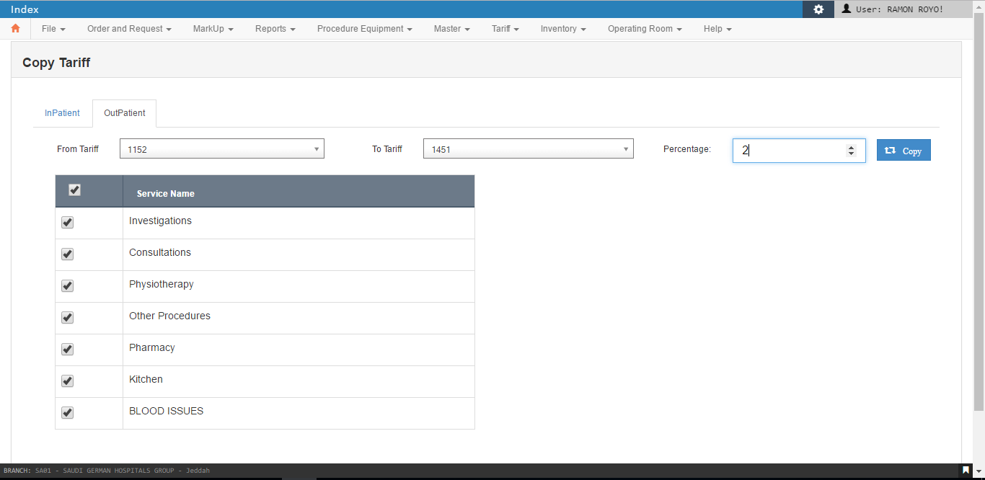

Out Patient Tab

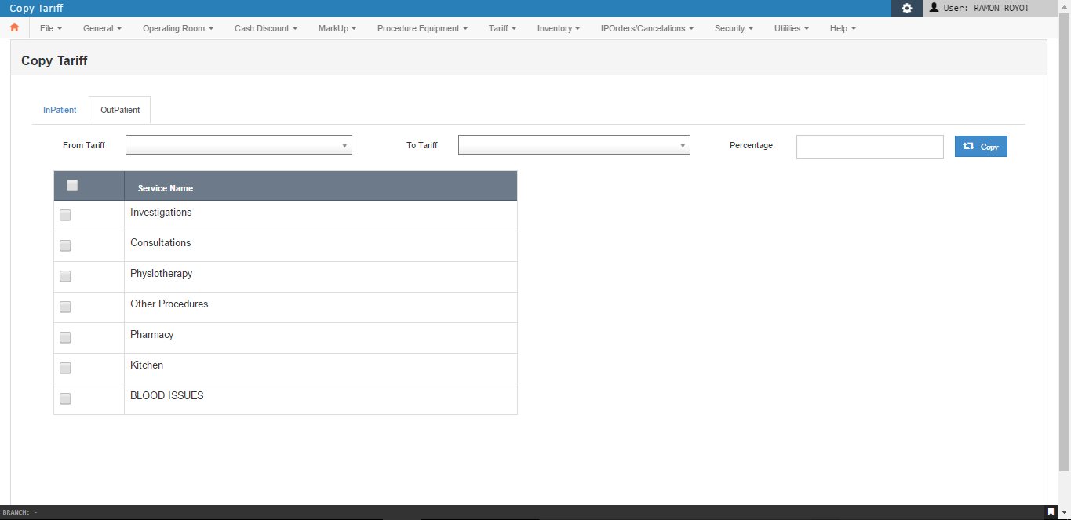

1. Inventory
   1. Holding Stores

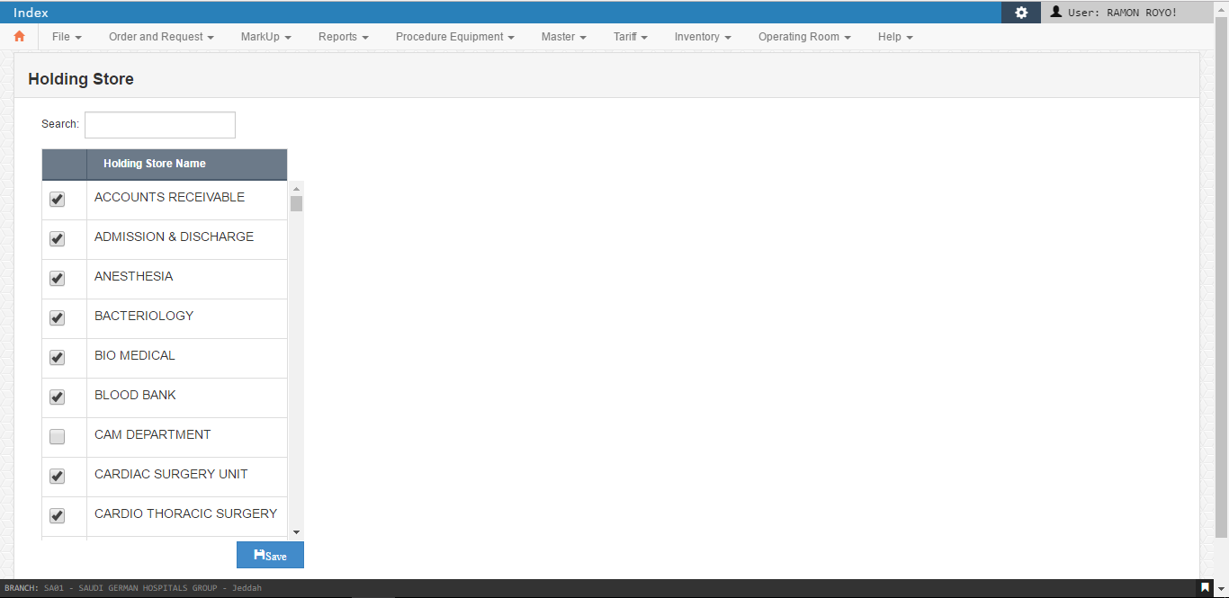

* 1. Sub Stores

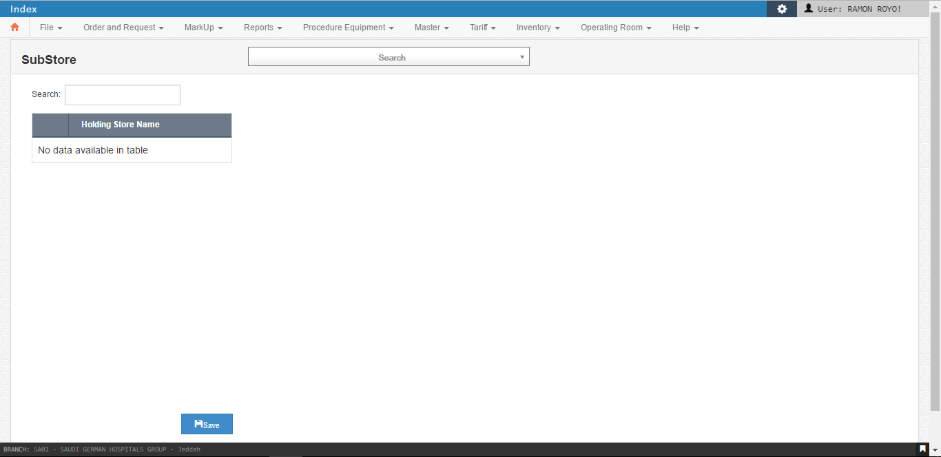

* 1. Category – Station Mapping

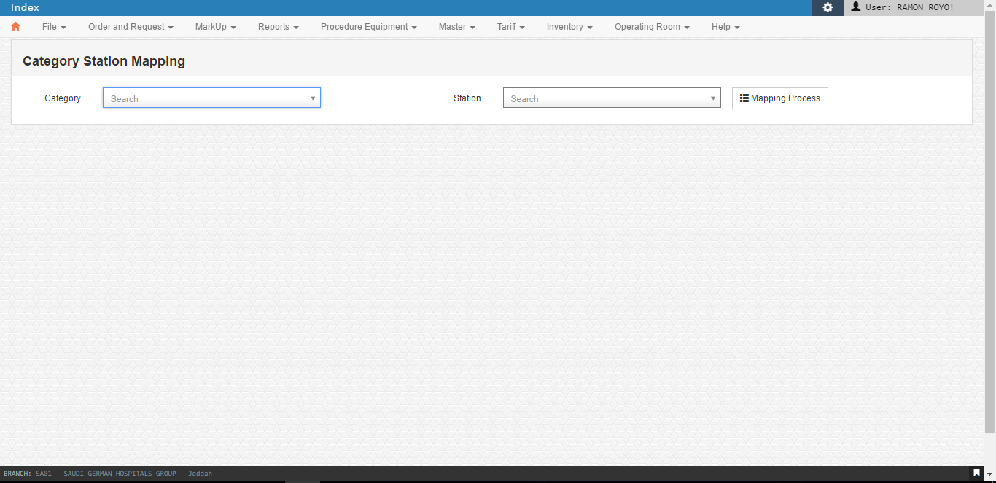

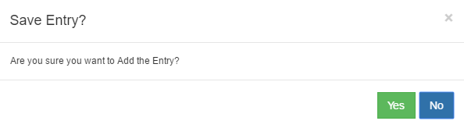

* 1. Ward – Pharmacy Station Mapping

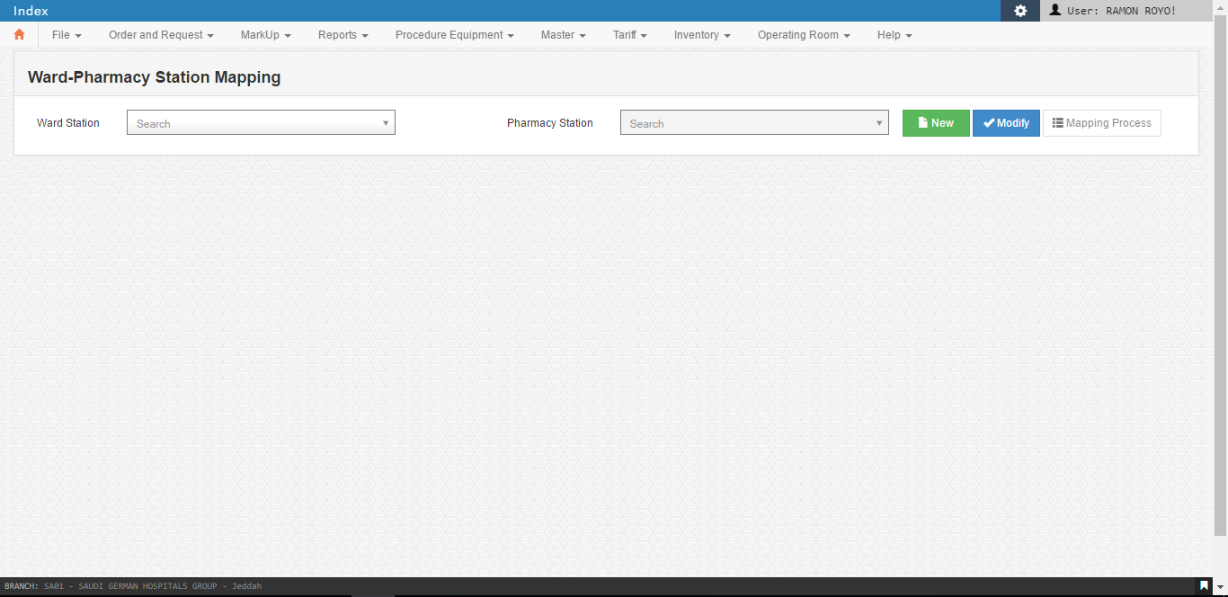

When the user click new button, This will pop out …

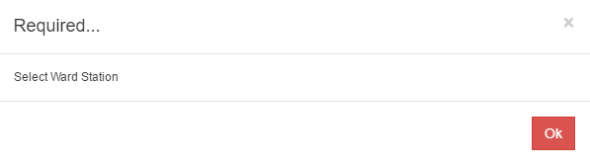

* 1. Transactions

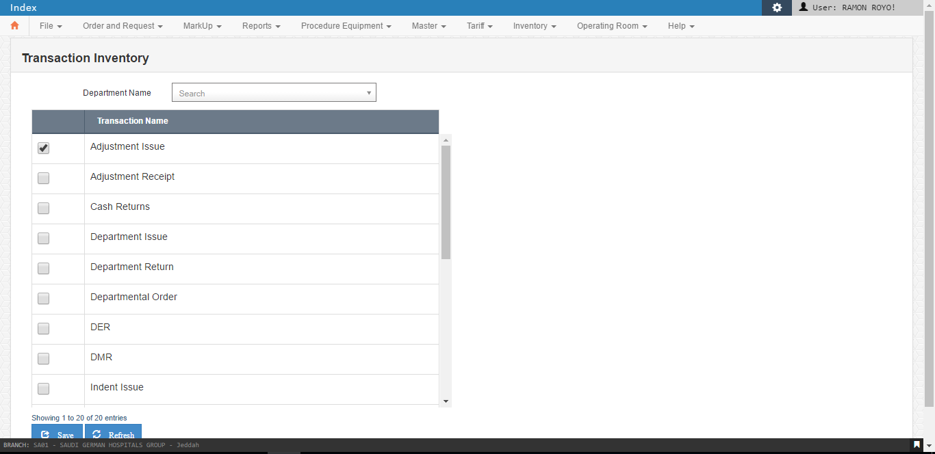

* 1. Item Mapping

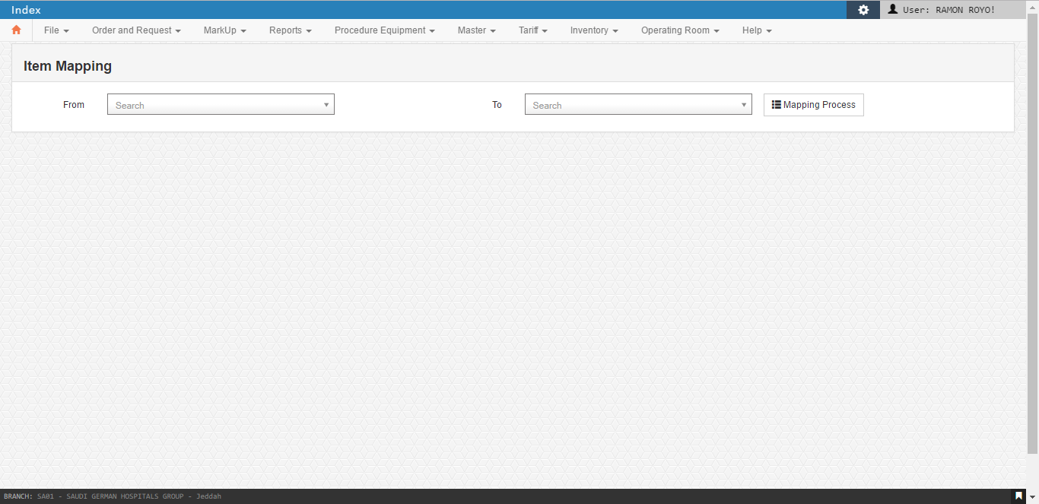



* 1. Reroute Order

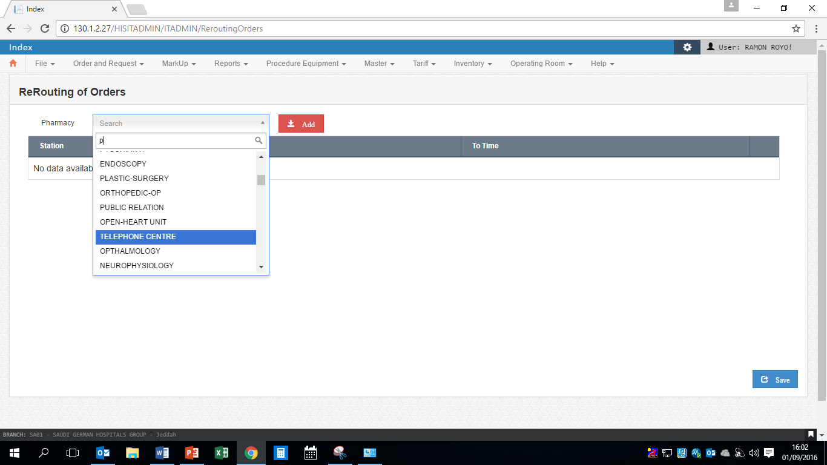

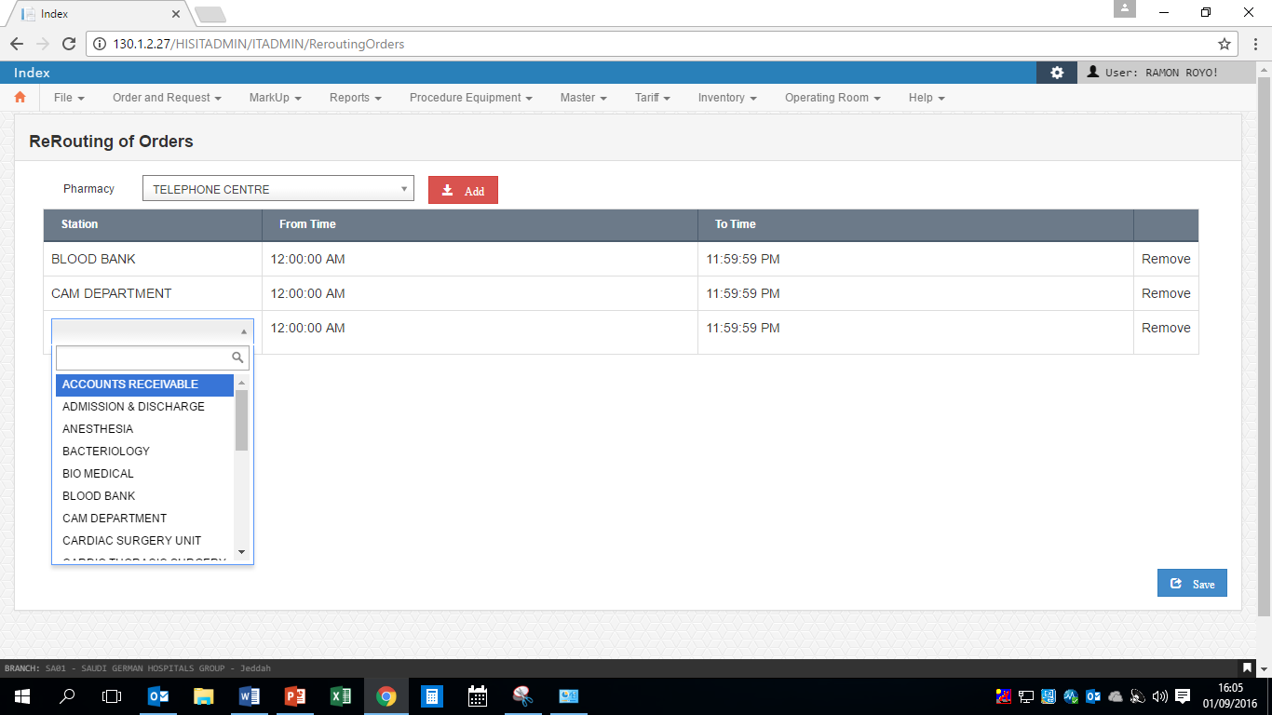

* 1. Inventory Item Markup

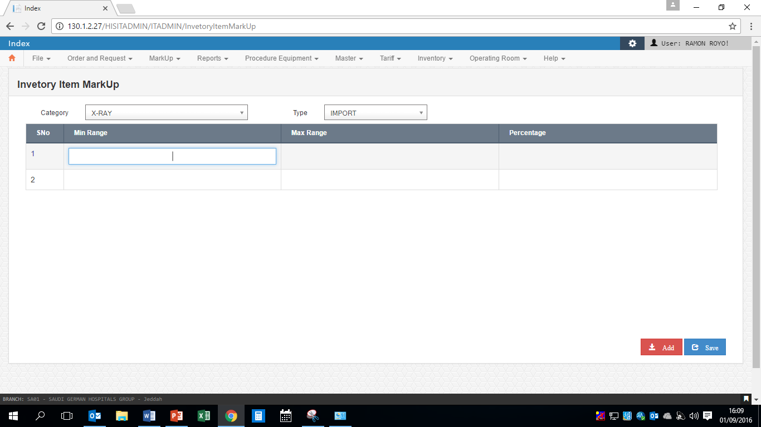

1. Operating Room

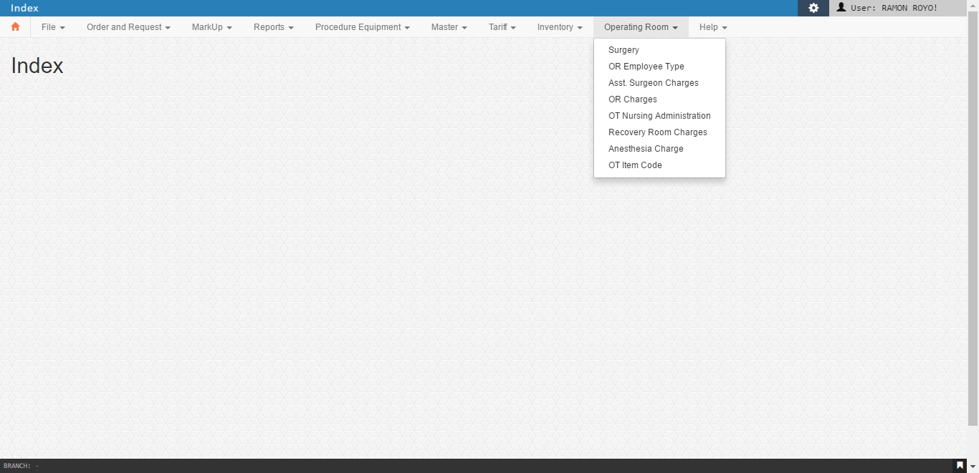

* 1. Surgery

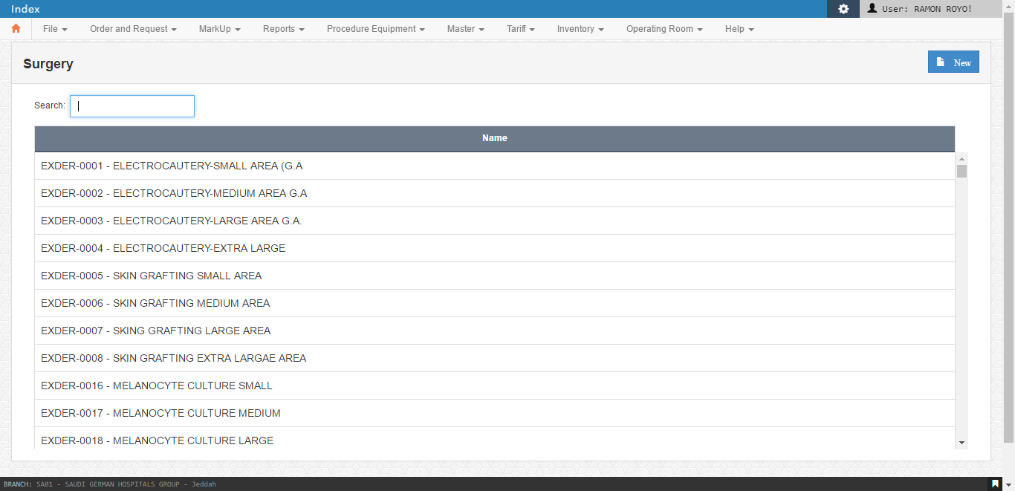

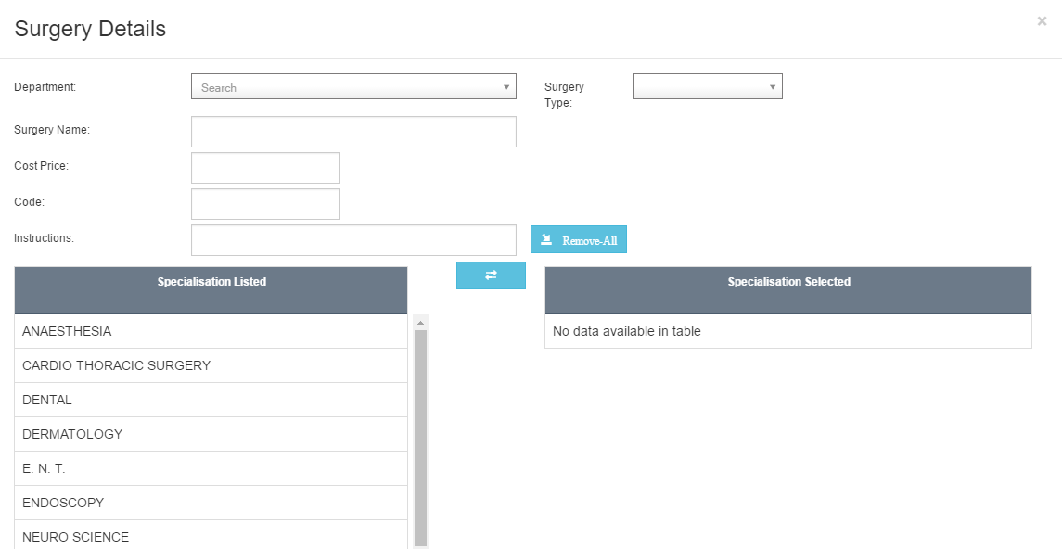

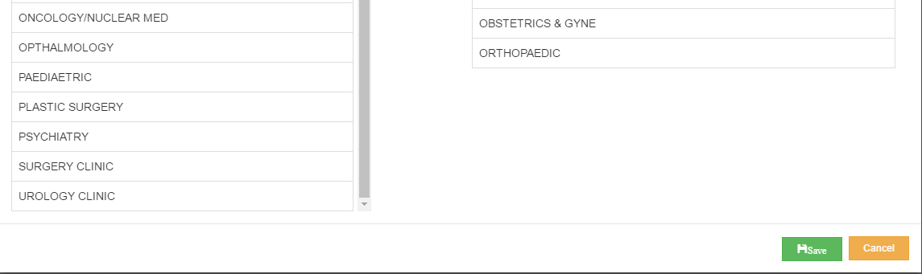

1. OR Employee Type

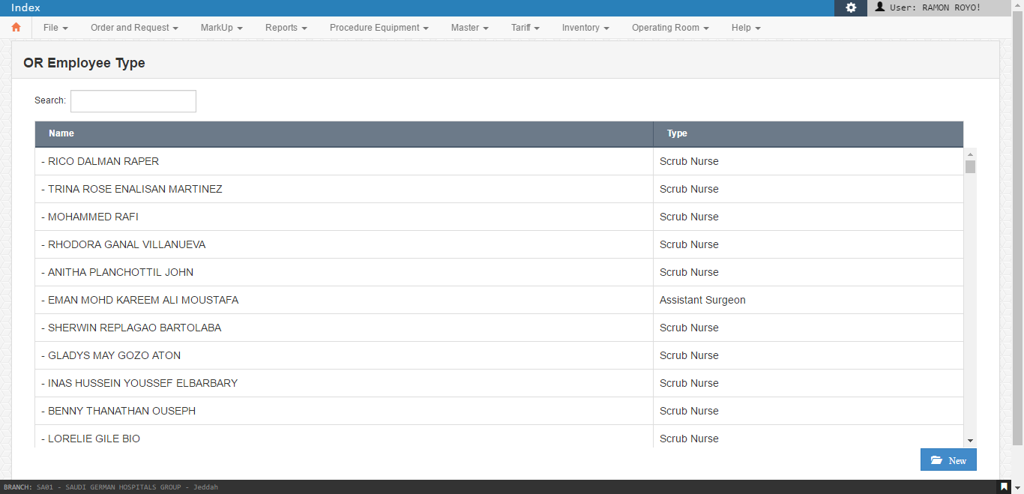

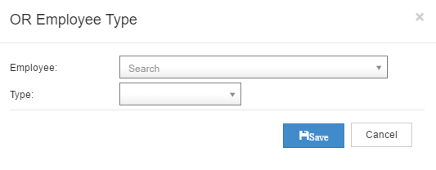

1. Asst. Surgeon Charges

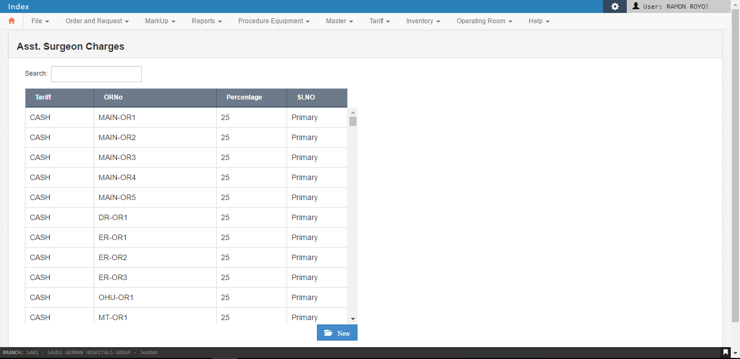

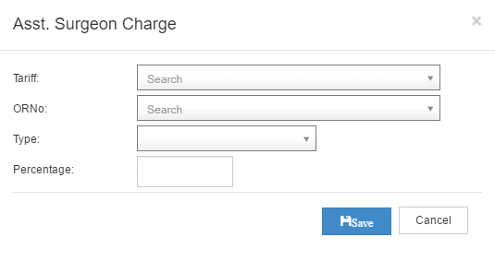

1. OR Charges

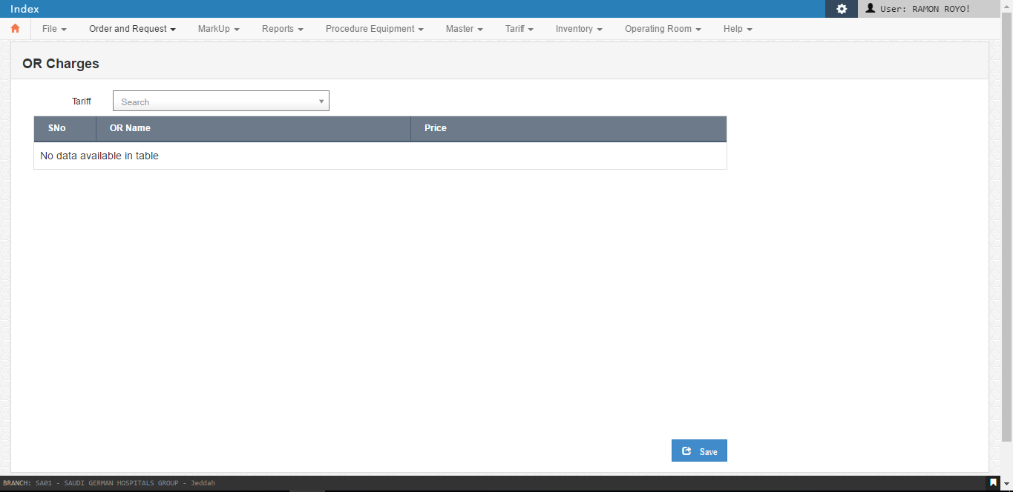

1. OT Nursing Administration

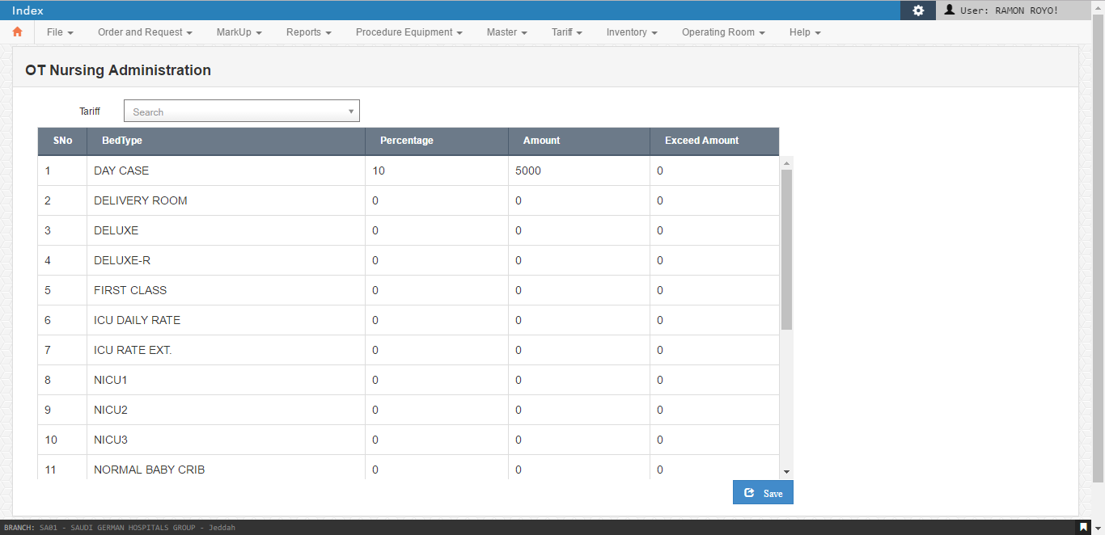

1. Recovery Room Charges

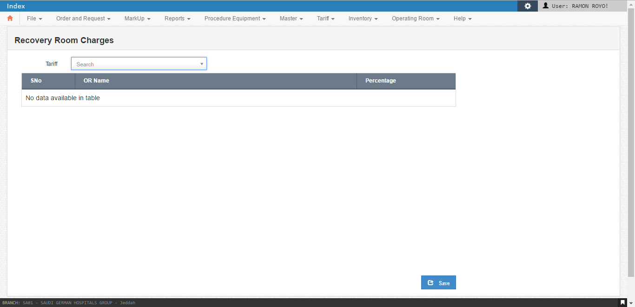

1. Anesthesia Charge

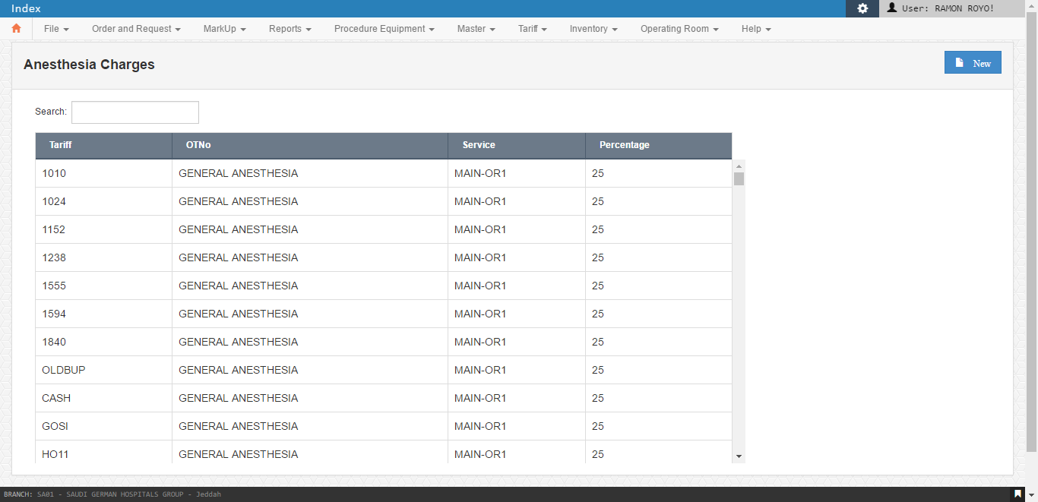

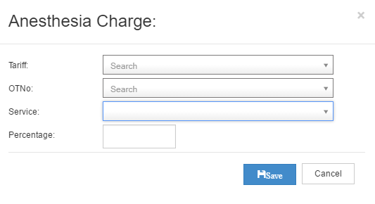

1. OT Item Code

On click user is redirected to Assistant Surgeon Staff.

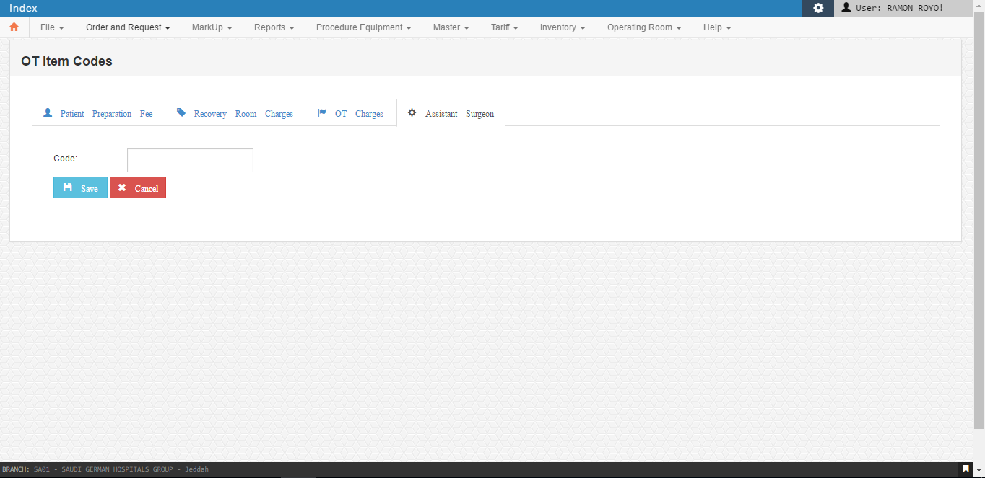

O.T. Charges

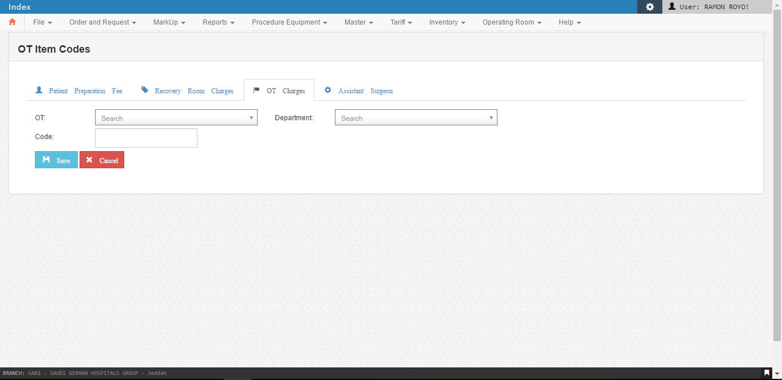

Recovery Room Charges

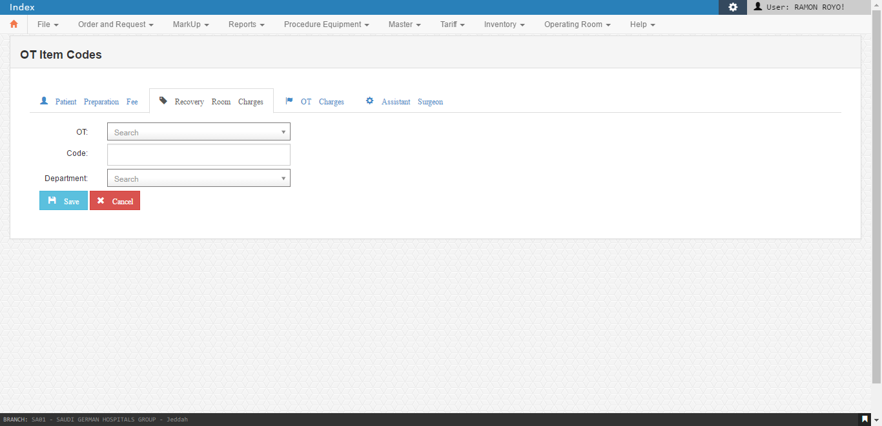

Patient Preparation Fee

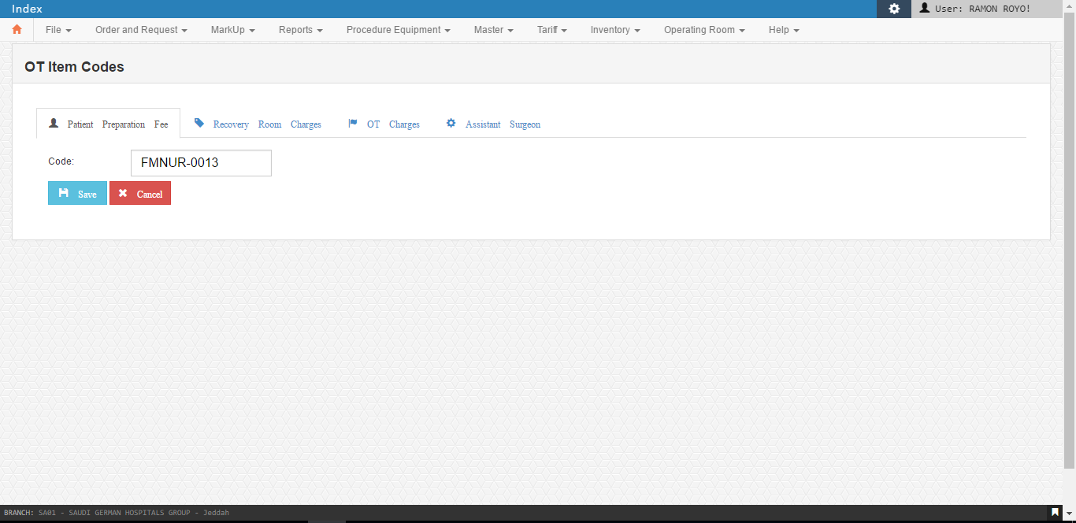

1. Help

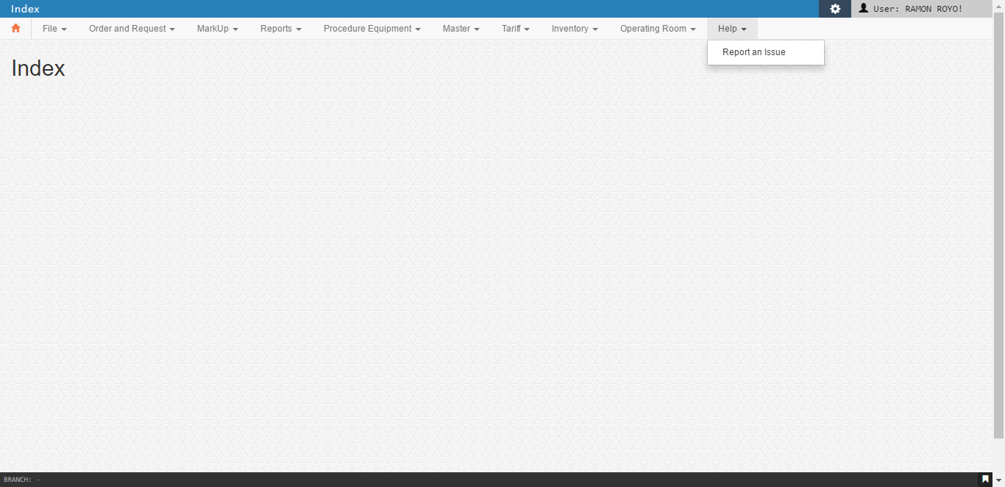

* 1. Report an Issue

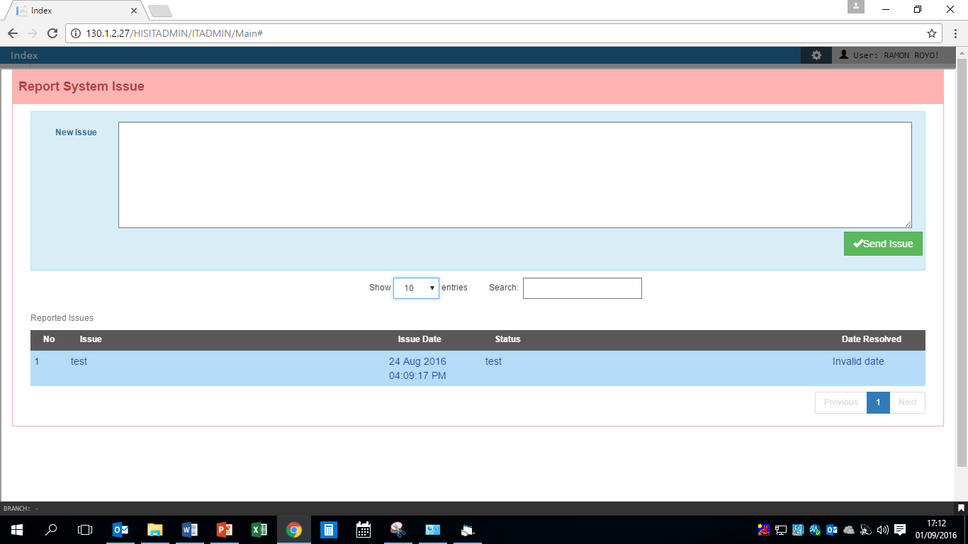

1. Security

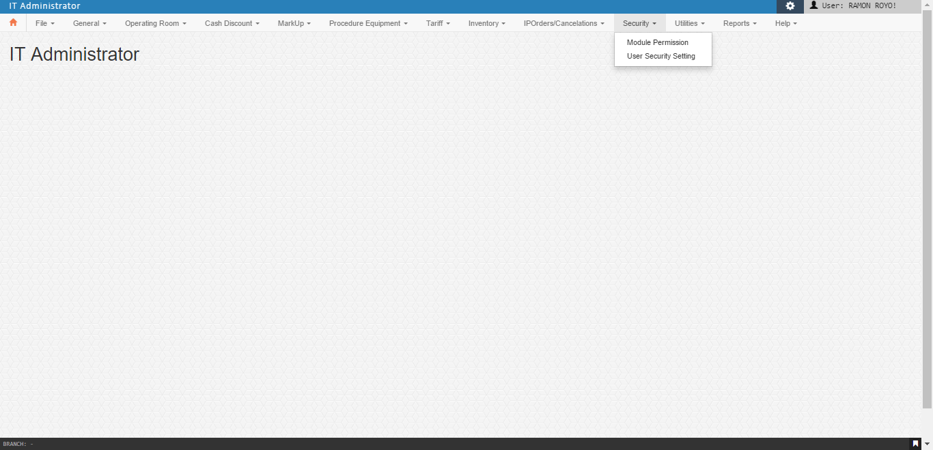

* 1. Module Access

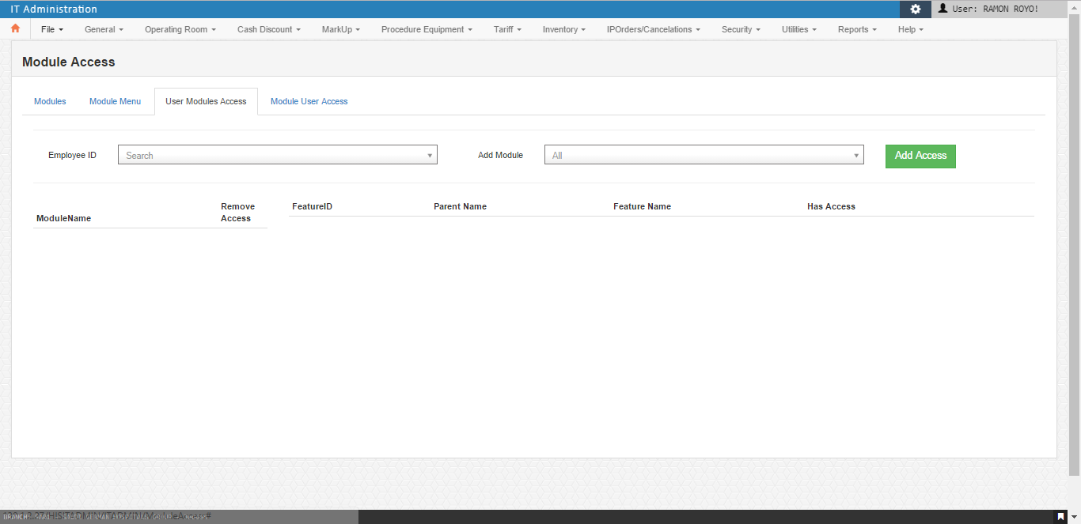

Error occur after click on Add Access

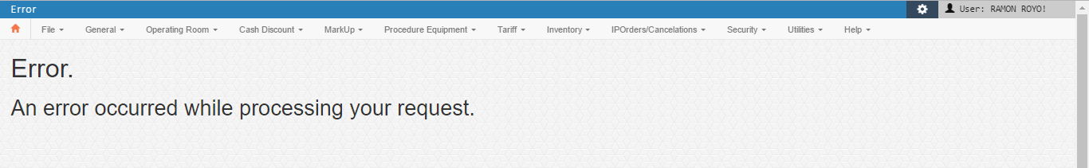

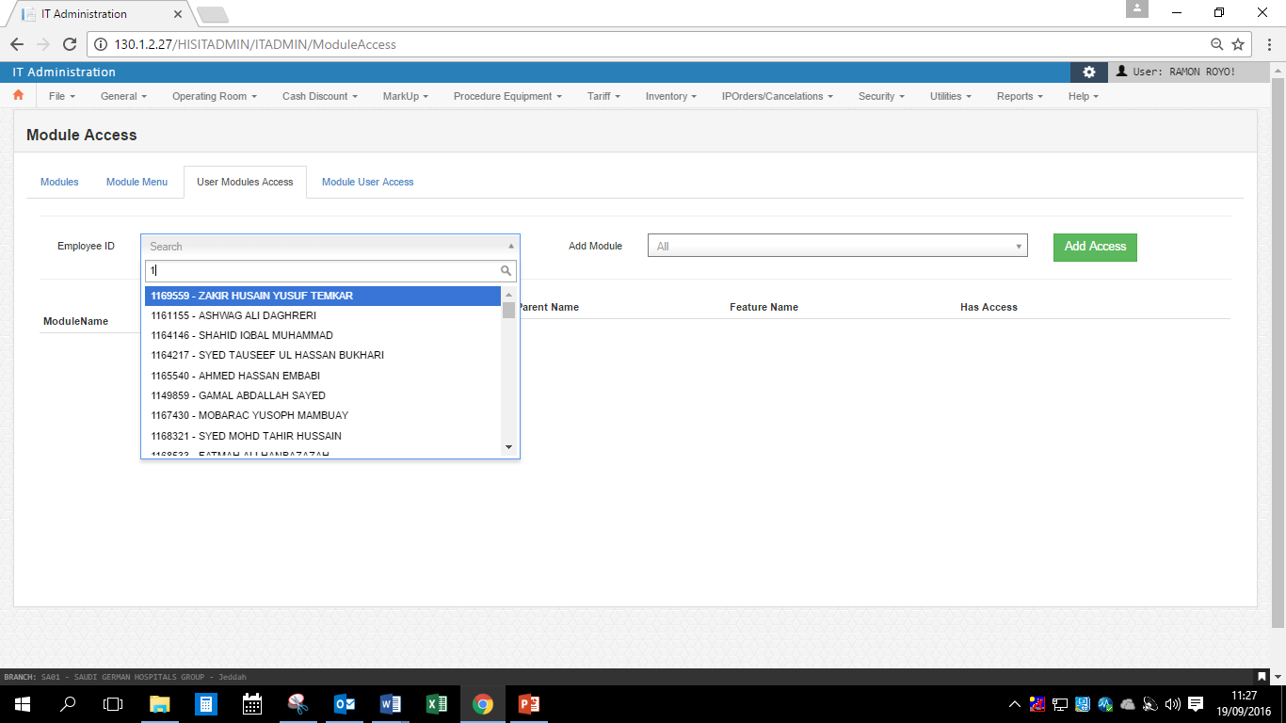

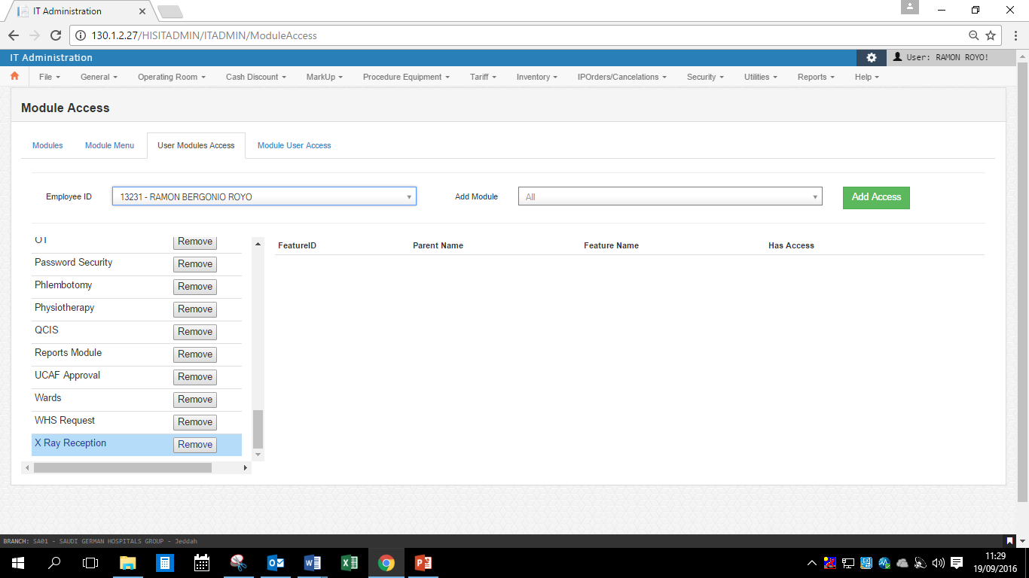

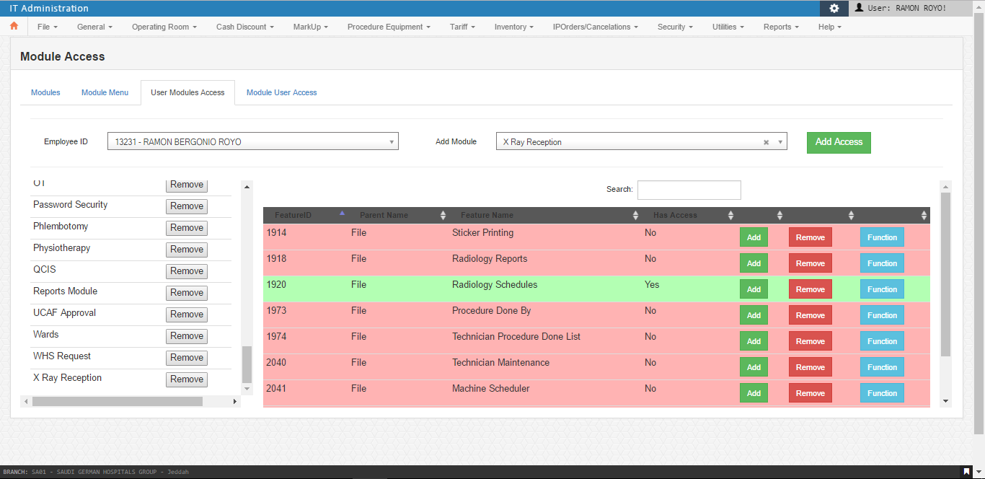

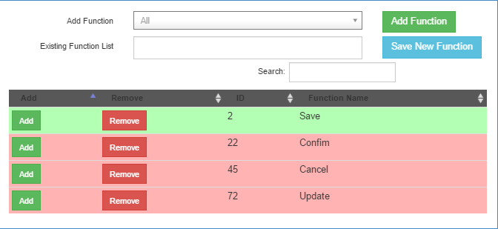

* 1. User Maintenance
     + User Registration Tab

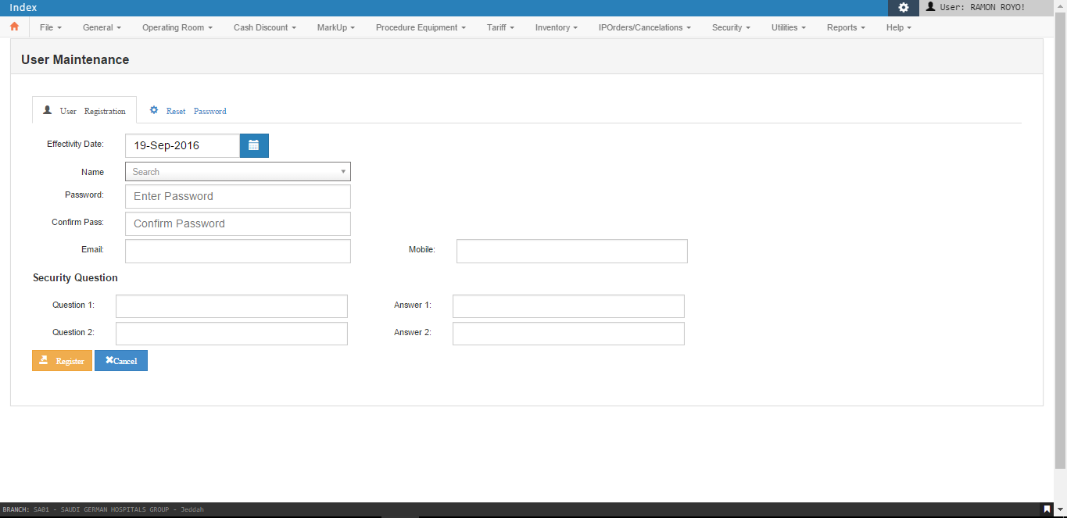

* + - Reset Password

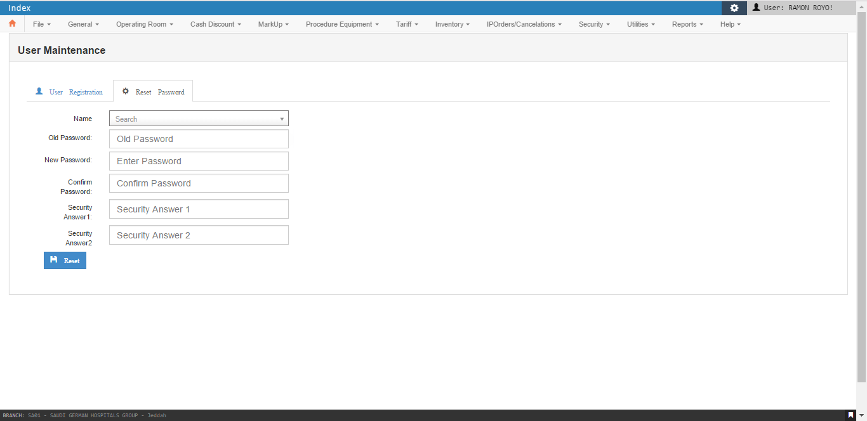

1. Utilities

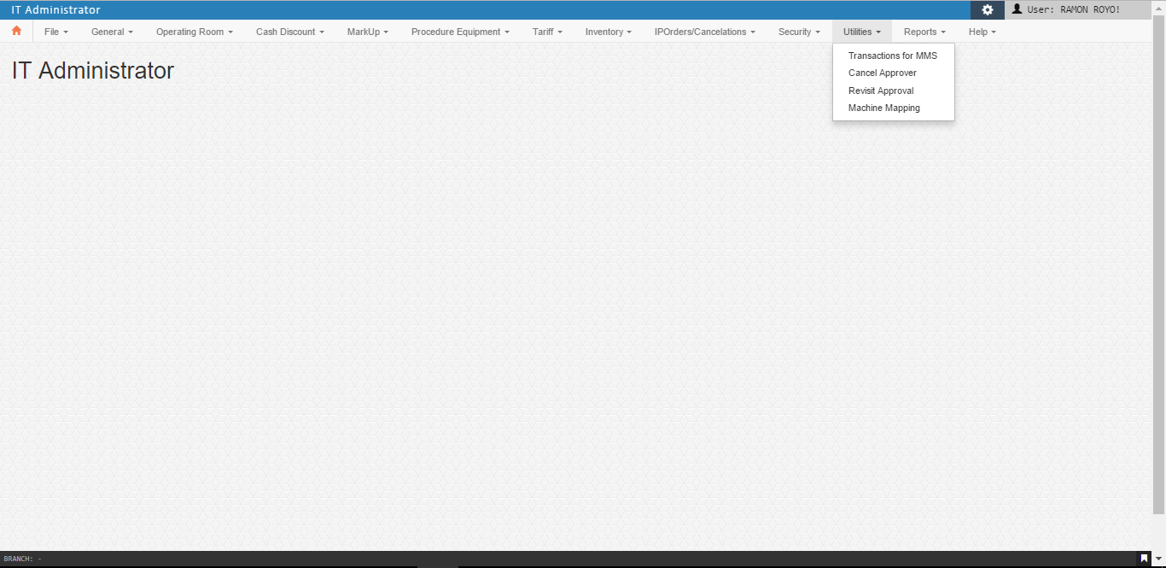

* 1. Transaction for MMS

This utility is a tool for the end user to facilitate the request to process the MMS – Material Management System every 1st day of the month. Purpose is to create a dynamic table for the user of all departments using Items of any Item Categories, such like Pharmacy, clinics, administrator department, Wards etc…

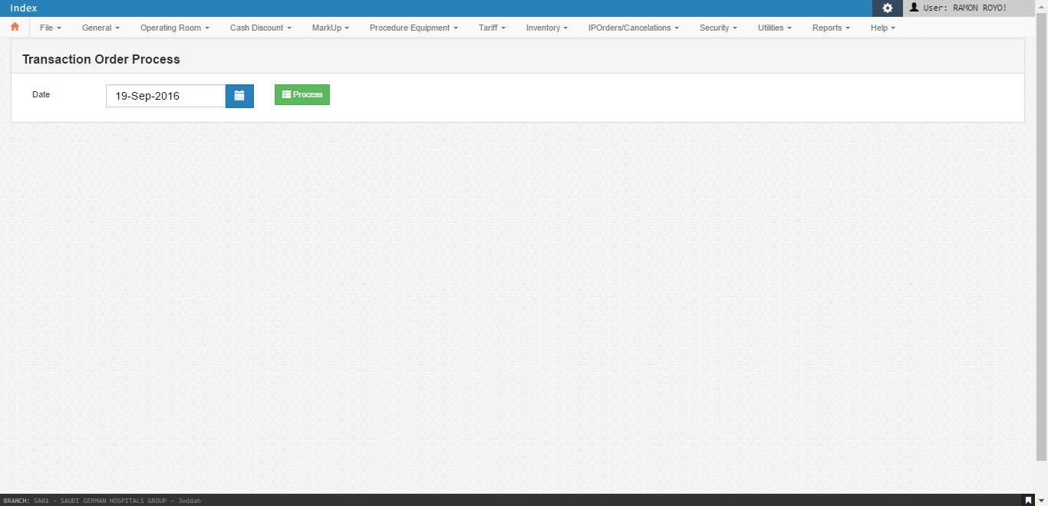

* 1. Access Cancel Approvals

I.T. Admin users use this tool to add employees for the Front Office. Employee to view the list of authorized to cancel billing.

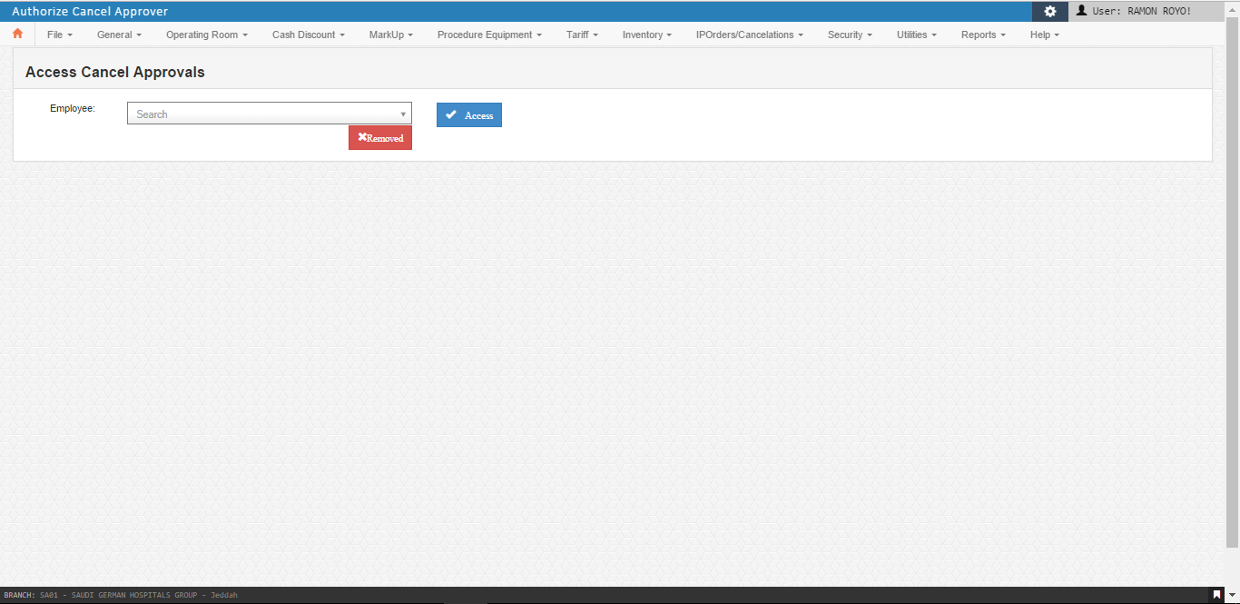

* 1. Revisit Approver

Each Out Patient is allowed to revisit for a number of times depending to the package of the company given to the patient. This function helps the I.T. user set the employee’s rights to access and create approval to adjust the count of visit for OP.

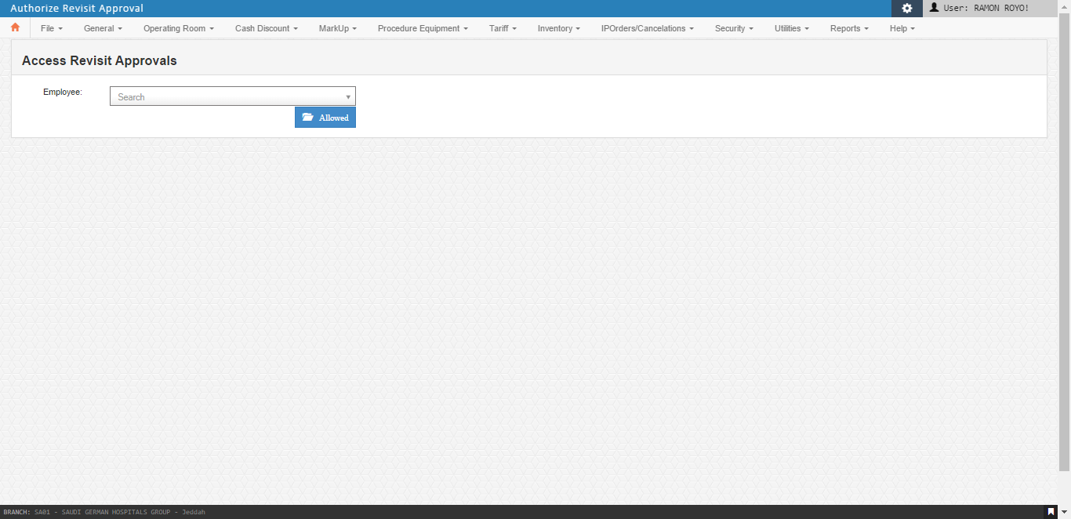

* 1. Machine Setup

This function is for user to process the mapping asset items to Paxera Machine Data.

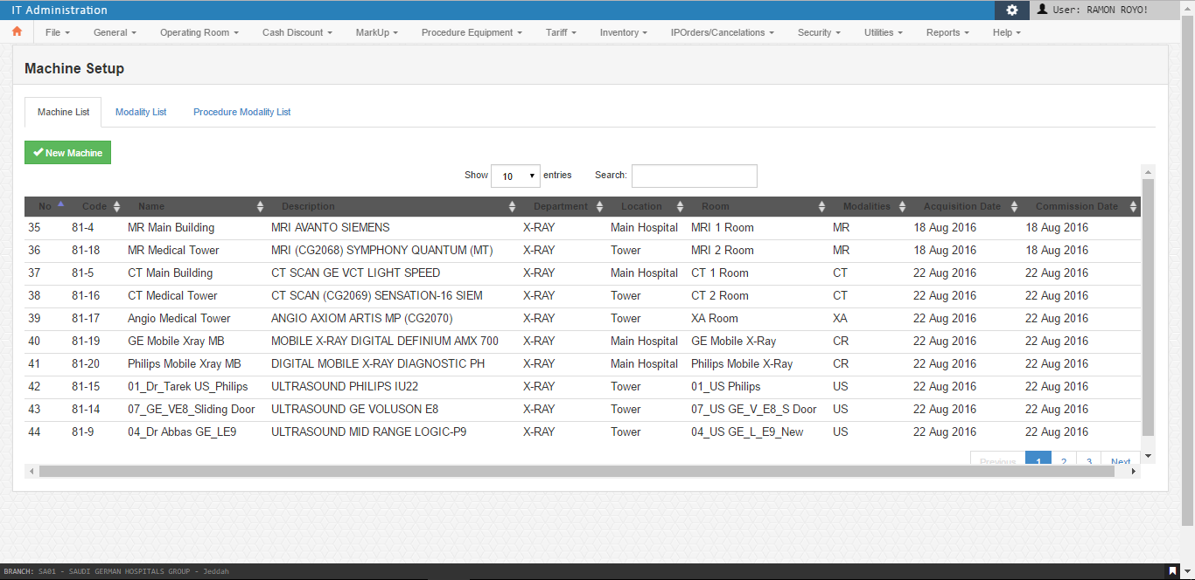

# **Flow of functions**

The functions of HIS is dynamic and in I.T. Admin module this functions are being organized, maintained and monitored. Each user varies on their function accessibility to whatever their work scope. I.T. Administrator set the rules per functions for each user rights.

# **Procedures per Functions**

**I.T. Admin**

1. **File**
   1. General

General; Religion; Title; Marital Status; Relationship; Occupation; Organization Information; City; Nationality

Step 1 : Type the new entry name

Step 2 : Save

* 1. Doctors – Specialization Mapping

Step 1 : Type the Doctor’s ID Number or Code

Step 2 : Double click the Department name to move on the right side

Step 3 : Save

* 1. Operation Room
     + - Surgery

Step 1 : Choose the Department name

Step 2 : Type the newly created surgery name

Step 3 : Choose department in Specializations List then double click

Step 4 : Type the cost price

Step 5 : Type the Code

Step 6 : Categorize if it is Major, Moderate, or Minor Procedure

Step 7 : Save

* + - * OR Employee Type

Step 1 : Type the ID number

Step 2 : Choose the position

Step 3 : Save

* 1. Station
     + - New Station

Step 1 : Click new

Step 2 : Type new Station Name

Step 3 : Choose the Main Location

Step 4 : Type the location

Step 5 : Choose the Station Type

Step 6 : Choose the Department

Step 7 : Type Prefix

Step 8 : Type Code

Step 9 : Save

* + - * Modify Station

Step 1 : Click Find

Step 2 : Double click the Station to be modified

Step 3 : Change the current data to be modified

Step 4 : Note: Prefix and code are cannot be modified

Step 5 : Modify

* 1. Bed

Step 1 : Type the bed name

Step 2 : Choose the Bed Type

Step 3 : Choose the station name

Step 4 : Choose the room name

Step 5 : Type the extension no.

Step 6 : Choose the Status

Step 7 : Choose the Department

Step 8 : Save

* 1. Room

Step 1 : Type the new room name

Step 2 : Type the code

Step 3 : Save

* 1. OP Bill Prefix

Step 1 : Click new

Step 2 : Choose the station

Step 3 : Choose bill type (cash or charge)

Step 4 : Save

* 1. Cash Discount
     + - OP Non discountable items

Step 1 : Choose the service

Step 2 : Double click the items from the left side to be non-discountable items

Step 3 : Double click the items from the right side to be discountable items

Step 4 : Save

* + - * Discount Authorized Employees

Step 1 : Choose outpatient or Inpatient

Step 2 : Choose Discount Types

Step 3 : Double click the employee from the left side to be authorized

Step 4 : Double click the employee from the right side to be unauthorized

Step 5 : Save

* 1. Health Checkup

Step 1 : Choose the company

Step 2 : Type the new health checkup names

Step 3 : Type the code

Step 4 : Input the Price

Step 5 : Choose the department

Step 6 : Choose the items from the investigation, consultation and others to be included

Step 7 : Save

1. **Procedure and Equipment**
   1. Anesthesia

Step 1 : Type the name

Step 2 : Type the code

Step 3 : Type the cost price

Step 4 : Choose the billing type

Step 5 : Save

* 1. Cath Procedure

Step 1 : Choose the Department

Step 2 : Type the procedure name

Step 3 : Type the cost price

Step 4 : Type the code

Step 5 : Save

* 1. Others Procedure

Step 1 : Choose the Department name

Step 2 : Choose the Specialization

Step 3 : Type the Procedure name

Step 4 : Type the cost price

Step 5 : Type the procedure code

Step 6 : Save

* 1. PT Procedures

Step 1 : Choose the Department

Step 2 : Type the new PT Procedure name

Step 3 : Type the cost price

Step 4 : Type the code

Step 5 : Save

1. **Tariff**
   1. Tariff

Step 1 : Type the new code

Step 2 : Save

* 1. IP Tariff

Step 1 : Choose the Tariff code

Step 2 : Choose the Service

Step 3 : Type the Procedure code

Step 4 : Enter the Price

Step 5 : Enter the affectivity date

Step 6 : Save

* 1. OP Tariff

Step 1 : Choose the tariff category

Step 2 : Choose the service

Step 3 : Choose the department

Step 4 : Double click the items

Step 5 : Then assign the price

Step 6 : Save

1. **IP Orders/Cancellation**
   1. Patient Order Cancellation

Step 1 : Type the patient pin

Step 2 : Confirm the patient name

Step 3 : Check for the Order number and procedure code to be cancelled

Step 4 : Check the status

Step 5 : Make a screenshot and save

Step 6 : Then click cancel item

* 1. Release OT Patient Drug Order

Step 1 : Choose the patient Pin

Step 2 : Release

* 1. Cancel Deposit

Step 1 : Type the patient pin

Step 2 : Choose the admission date

Step 3 : Choose General Cancellation as the reason for cancel

Step 4 : Click the payment to be cancelled

Step 5 : Save

* 1. Change deposit type

Step 1 : Type the patient Pin

Step 2 : Choose the admission date

Step 3 : Choose General Cancellation as the reason for cancel

Step 4 : Click the payment to be transferred

Step 5 : Change the payment type to Initial Deposit

Step 6 : Save

1. **Security**
   1. Module Access

Step 1 : Identify the Employee ID

Step 2 : Choose the desired Module to add

Step 3 : Click the Add Access Button

Step 4 : Go to the Added Module, Click the Item

Step 5 : List of Features will show (Pink rows indicate no access and Green rows indicate with access)

Step 6 : Click on Add button to activate and Remove button do deactivate

Step 7 : Click Function Button to Click on Add button to activate and Remove button do deactivate

**I.T. Utilities**

1. **View Discharge Details**

Use for monthly report. Checking the bill of the patient that has been discharged.

To check if there are any variances from their bill so Mr. Carlo can fix it.

* Finance Related Utilities
* Reload Charges from Wipro to Legacy
* View Discharges Details

1. **Clean Up Legacy Admission (Before HOD Process)**

For EOD Report. Process to update the Total Admission for the day.

* EOD Related
* Clean Up Legacy Admission (Before HOD Process)

1. **IP EOD Extraction (New Version)**

For EOD Report. To generate an Excel file with all the In-Patient bill details. Including **Charges, Discounts, Positive Adjustment** and

**Negative Adjustment,** Two (2) Excel File **New Version** and **Old Version**

* EOD Related
* IP EOD Extraction (New Version)

1. **OP EOD Extraction**

For EOD Report. To generate an Excel file with all the Out-Patient bill details. Including **Charges, Discounts, Positive Adjustment** and

**Negative Adjustment,**

* EOD Related
* OP EOD Extraction

1. **Daily Statistics**

For EOD Report. Generate two (2) text file **Inpatient Census** and **Daily Statistical Report.**

* EOD Related
* Daily Statistics

1. **IP Summary Charges of the Day**

For EOD Report. Summary of Inpatient Bill. Generate Three (3) Excel File **Charges, Cancellation** and **Adjustment**

* EOD Related
* IP Summary Charges of the Day

1. **List of OR Done**

For EOD Report. Generate an Excel File with the list of Operation done for the day.

* EOD Related
* List of OR Done

1. **Load Inpatient Interface**

For EOD Report. To synchronize Inpatient Details from Middleware to Oracle Legacy.

* Go To HIS Utilities
* IP Interface
* Load Inpatient Interface
* Click Start.
* After loading, click OK on the message Box.
* Click Close Button

1. **IP EOD Interface**

For EOD Report. To synchronize Inpatient Details from Middleware to Oracle Legacy.

* HIS Utilities
* IP Interface
* IP EOD Interface
* Processing Date = Previous Date
* Click Start.
* After loading, click OK on the message Box.
* Click Close Button

1. **Load Missing Pin**

For EOD Report. To load Missing PIN from WIPRO to Oracle

* HIS Utilities
* OP Interface
* Load Missing PIN
* Click Start.
* After loading, click OK on the message Box.
* Click Close Button

1. **OP EOD Interface**

For EOD Report. To synchronize Inpatient Details from Middleware to Oracle Legacy.

* HIS Utilities
* OP Interface
* OP EOD Interface
* Processing Date = Previous Date
* Click Start.
* After loading, click OK on the message Box.
* Click Close Button

1. **Check Daily TRF**

For EOD Report. WIPRO PIN’s verification if all the PIN’s is loaded to the Legacy.

* HIS Utilities
* OP Interface
* Check Daily TRF
* Transaction Date = Previous Date
* Click Check Legacy PINs and wait until it shows it’s ok to process
* Click Close

1. **Ramadan Cut-off Time for OP**

Use only for Ramadan, to change the time for OP cancellation and EOD start time.

* HIS Utilities
* Ramadan Cut-off Time for OP

1. **Update Doctor’s Code / Email Address**

To update the Doctor’s details (Code, Email, and Category) then if Active or Inactive. Also if he is a Physiotherapist Technician.

* HIS Utilities
* Update Doctor’s Code / Email Address

1. **Cancel Patient Referral (OP)**

To cancel the referral made by the Doctor.

* HIS Utilities
* Cancel Patient Referral (OP)

1. **Merge Room from WIPRO to Legacy**

For EOD Report. To merge data from WIPRO to Legacy.

* HIS Utilities
* Merge Room from WIPRO to Legacy
* Click Process Merging and wait until finished
* Click close.

1. **Change IP Test Requisition Doctor**

To change the Doctor who requests an Investigation for the Inpatient. By Order No. and Admission Date.

* HIS Utilities
* Change IP Test Requisition Doctor

1. **Change Admitting Doctor**

To change the Admitting Doctor of the current admitted patient.

* His Utilities
* Change Admitting Doctor

1. **Download Company Pricelist**

To generate an excel file contain the List of Procedures with Prices for each Department. For Inpatient and Outpatient by TARIFF Name

* HIS Utilities
* Download Company Pricelist

1. **Release Bed Clearance for Cleaning**

To force release the Room from Bed Clearance. Use this option when the Room No. is not available from the vacant room list.

* HIS Utilities
* Release Bed Clearance

1. **Transfer IP Payment from Previous to Present –**

To transfer the Payment of the Patient by T-Receipt, from the selected date to any Admission date Previous or Present.

* Others
* Transfer IP Payment from Previous to Present

1. **Change Pharmacy / CST Items – Cost or Selling Price**

To correct or to update the Pharmacy or CST items Price. Using Item Code and by Batch No.

* Others
* Change Pharmacy / CST Items – Cost or Selling Price

1. **Change Pharmacy Cancel Date**

Openly use for Ramadan, to change the date of the Pharmacy Receipt that has been cancel past 24:00AM to transfer to the previous date.

* Others
* Change Pharmacy Cancel Date

1. **Load Data for Data Warehousing (QLIKVIEW)**

For manual loading of data by BI Tables and Date Ranged.

* Others
* Load Data for Data Warehousing (QLIKVIEW)

1. **Configure HIS User Access**

Use for Copying or to give the user access rights to any HIS Module. Use also to make the User HIS Password to be Default.

* Others
* Configure HIS User Access

1. **Reset HIS Password**

Use for resetting the User HIS Password. Use the default password for the current Password.

* Others
* Reset HIS Password

1. **Cancel Bill Reason**

To Create, Update or Delete Reason for OP Receipt Cancellation.

* Others
* Cancel Bill Reason

1. **Cancelled OP Receipt – Reissue Mapping**

To get all the Receipt Bill Number that has been cancelled, then reissue one by one.

* Others
* Cancelled OP Receipt – Reissue Mapping

1. **OP Cancel Receipt Approval**

Use to approve OP Receipt that has been more than 30 Days, for it can be cancel in the Front Office. By Receipt No.

* Others
* OP Cancel Receipt Approval

1. **Release HIS User Access**

To release and activate again the User Access for the HIS Module that has been temporary deactivate when the user go for a vacation.

* Others
* Release HIS User Access

1. **Pharmacy Cancel Days**

To adjust the Cancellation Days for any Pharmacy Station for the Receipt that has been more than 30days, for it can be cancel.

* Others
* Pharmacy Cancel Days

1. **Manage Security Admin**

To remove selected Role of the User HIS Access.

* Others
* Manage Security Admin

1. **WIPRO HIS EOD PROCESSING**

Use for EOD Processing Report.

WIPRO HIS EOD PROCESSING

* WIPRO AR DATA
  + Open SGH Utilities
  + Click WIPRO-HIS EOD Processing and select WIPRO_AR_DATA
  + Date = Previous Date
  + Click Prepare Button.
* WIPRO DAILY TRF
  + Open SGH Utilities
  + Click WIPRO-HIS EOD Processing and select WIPRO_DAILY_TRF
  + Date = Previous Date
  + Click Port into HIS and wait until finished.
  + Click Merge PIN Charges and wait until finished
  + Click Update Code & Desc and wait until finished
  + Click Port to Middleware and wait until finished
  + When Done, Click Quit Button.
* WIPRO REG TRANS
  + Open SGH Utilities
  + Click WIPRO-HIS EOD Processing and select WIPRO_REG_TRANS
  + Date = Previous Date
  + Click Port into HIS and wait until finished.
  + Click Port to Middleware and wait until finished
  + When Done, Click Quit Button.
* WIPRO PAT VISIT2
  + Open SGH Utilities
  + Click WIPRO-HIS EOD Processing and select WIPRO_PAT_VISIT2
  + Date = Previous Date
  + Click Port to Middleware and wait until finished
  + When Done, Click Quit Button.
* WIPRO INPATIENT
  + Open SGH Utilities
  + Click WIPRO-HIS EOD Processing and select WIPRO_INPATIENT
  + Date = Previous Date
  + Click Go Button

1. **Straight Duty Employee Report**

Use for EOD Report. Generate Excel file listed all permanent Employee that is Straight Duty for the Current Day.

* Payroll Processing
* Straight Duty Employee Report.

# **Reports**

List of report generated by I.T. Utilities in WIPRO but not yet in HIS

1. Cash Tariff IP

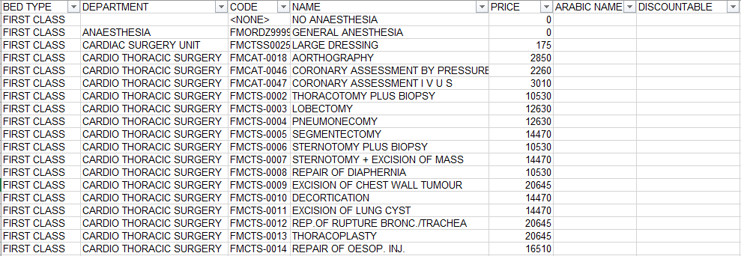

1. Cash Tariff OP

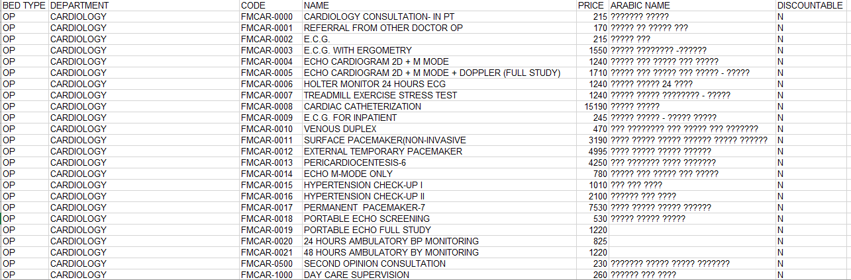

1. Company Wise In-Patients

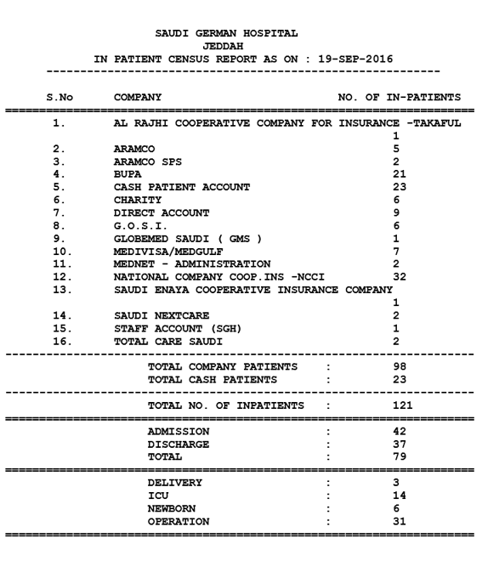

1. Daily Statistical Report

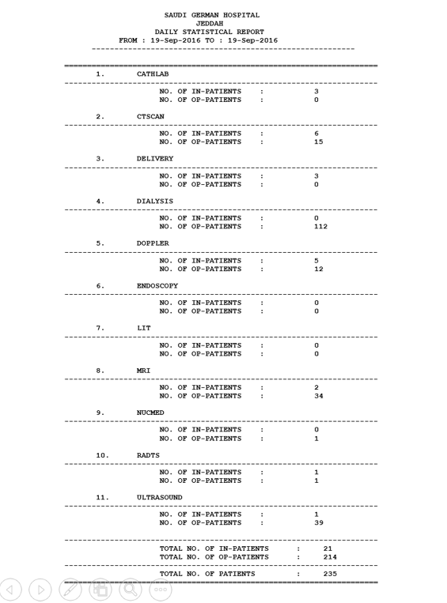

Summary :



1. IP EOD Report New

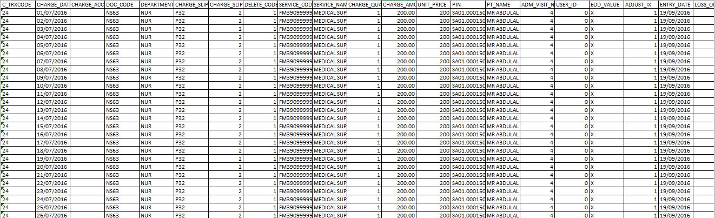

|  |
| --- |
| Field Names : |
| C_TRXCODE |
| CHARGE_DATE |
| CHARGE_ACCT |
| DOC_CODE |
| DEPARTMENT |
| CHARGE_SLIP_NUMBER |
| CHARGE_SLIP_SEQ_NO |
| DELETE_CODE |
| SERVICE_CODE |
| SERVICE_NAME |
| CHARGE_QUANTITY |
| CHARGE_AMOUNT |
| UNIT_PRICE |
| PIN |
| PT_NAME |
| ADM_VISIT_NO |
| USER_ID |
| EOD_VALUE |
| ADJUST_IX |
| ENTRY_DATE |
| LOSS_ON_PACKAGE_DEAL |
| PHA_COST |
| DISCOUNT |
| ROOM_NO |
| SURG_PROC_IND |
| UNIT_CODE |

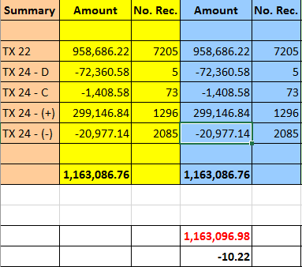

1. IP EOD Report Old

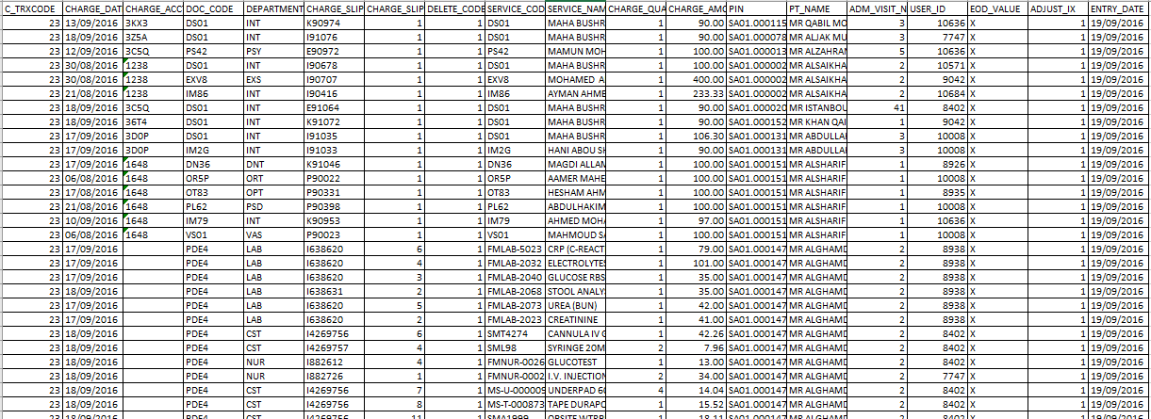

|  |
| --- |
| Field Names: |
| C_TRXCODE |
| CHARGE_DATE |
| CHARGE_ACCT |
| DOC_CODE |
| DEPARTMENT |
| CHARGE_SLIP_NUMBER |
| CHARGE_SLIP_SEQ_NO |
| DELETE_CODE |
| SERVICE_CODE |
| SERVICE_NAME |
| CHARGE_QUANTITY |
| CHARGE_AMOUNT |
| PIN |
| PT_NAME |
| ADM_VISIT_NO |
| USER_ID |
| EOD_VALUE |
| ADJUST_IX |
| ENTRY_DATE |

1. List of Or Done

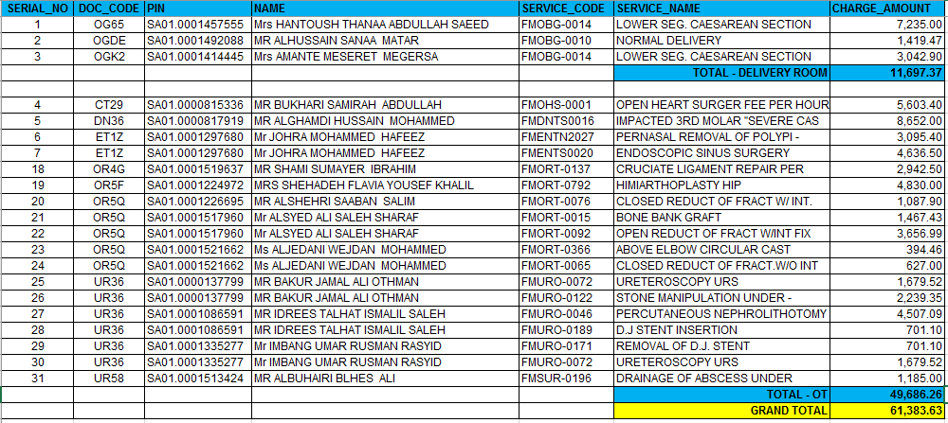

1. OP EOD Report

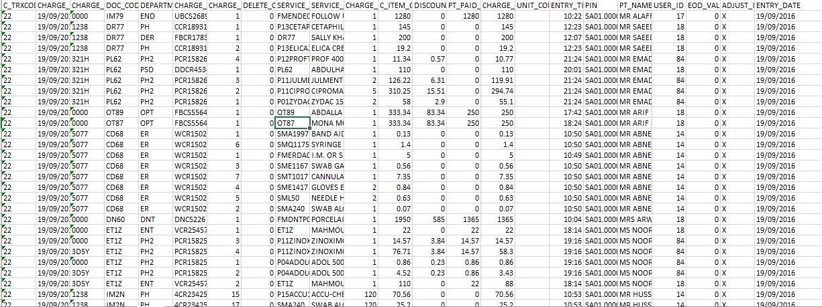

|  |
| --- |
| Field Names |
| C_TRXCODE |
| CHARGE_DATE |
| CHARGE_ACCT |
| DOC_CODE |
| DEPARTMENT |
| CHARGE_SLIP_NUMBER |
| CHARGE_SLIP_SEQ_NO |
| DELETE_CODE |
| SERVICE_CODE |
| SERVICE_NAME |
| CHARGE_QUANTITY |
| C_ITEM_ORG_PRICE |
| DISCOUNT_AMT |
| PT_PAID_AMOUNT |
| CHARGE_AMOUNT |
| UNIT_CODE |
| ENTRY_TIME |
| PIN |
| PT_NAME |
| USER_ID |
| EOD_VALUE |
| ADJUST_IX |
| ENTRY_DATE |

1. Straight Duty Employee Report

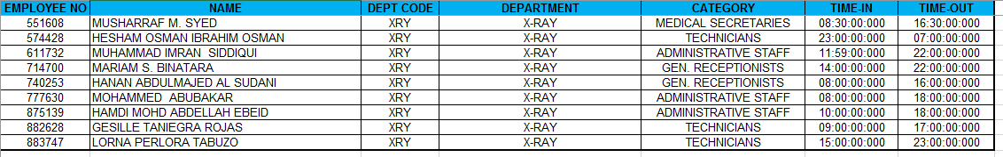

1. Summary Charges of the Day Adjustment

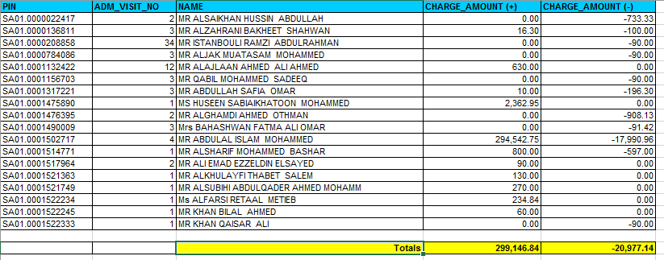

1. Summary Charges of the Day Cancellation

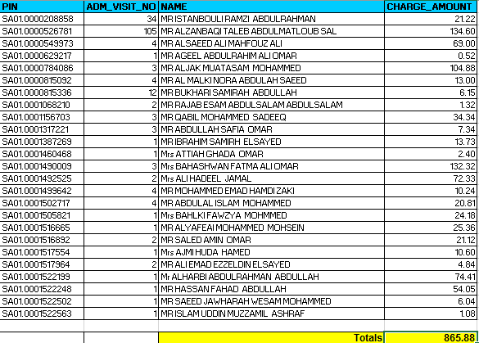

1. Summary Charges of the Day Charges

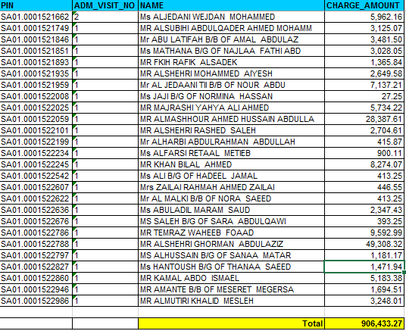

1. View Discharge Details 201608 01 to 09

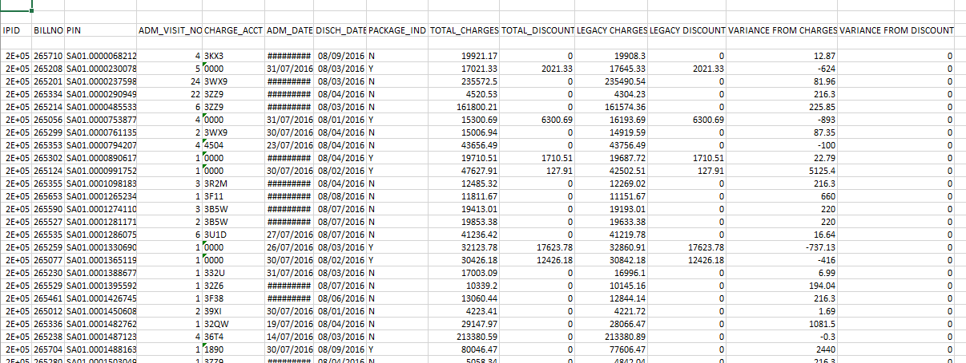

|  |
| --- |
| Field Names : |
| IPID |
| BILLNO |
| PIN |
| ADM_VISIT_NO |
| CHARGE_ACCT |
| ADM_DATE |
| DISCH_DATE |
| PACKAGE_IND |
| TOTAL_CHARGES |
| TOTAL_DISCOUNT |
| LEGACY CHARGES |
| LEGACY DISCOUNT |
| VARIANCE FROM CHARGES |
| VARIANCE FROM DISCOUNT |

# **Terms/Glossary**

|  |  |
| --- | --- |
| OT | Operating Theater also known as Operating Room |
| Tariff | Rates/Pricing |
| OP | Out Patient |
| IP | In Patient |
| HOD | Hospital Operation Dashboard |
| MMS | Material Management System |
| Legacy | An old system used prior to WIPRO |
| EOD | End of Day |

# **Appendix**

Scanned Forms and other related materials

1. Adjustment Slip In & Out Patient

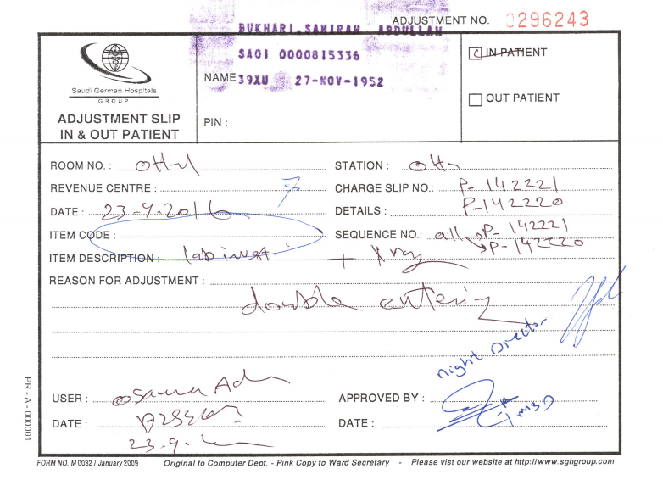

1. Job Request Form

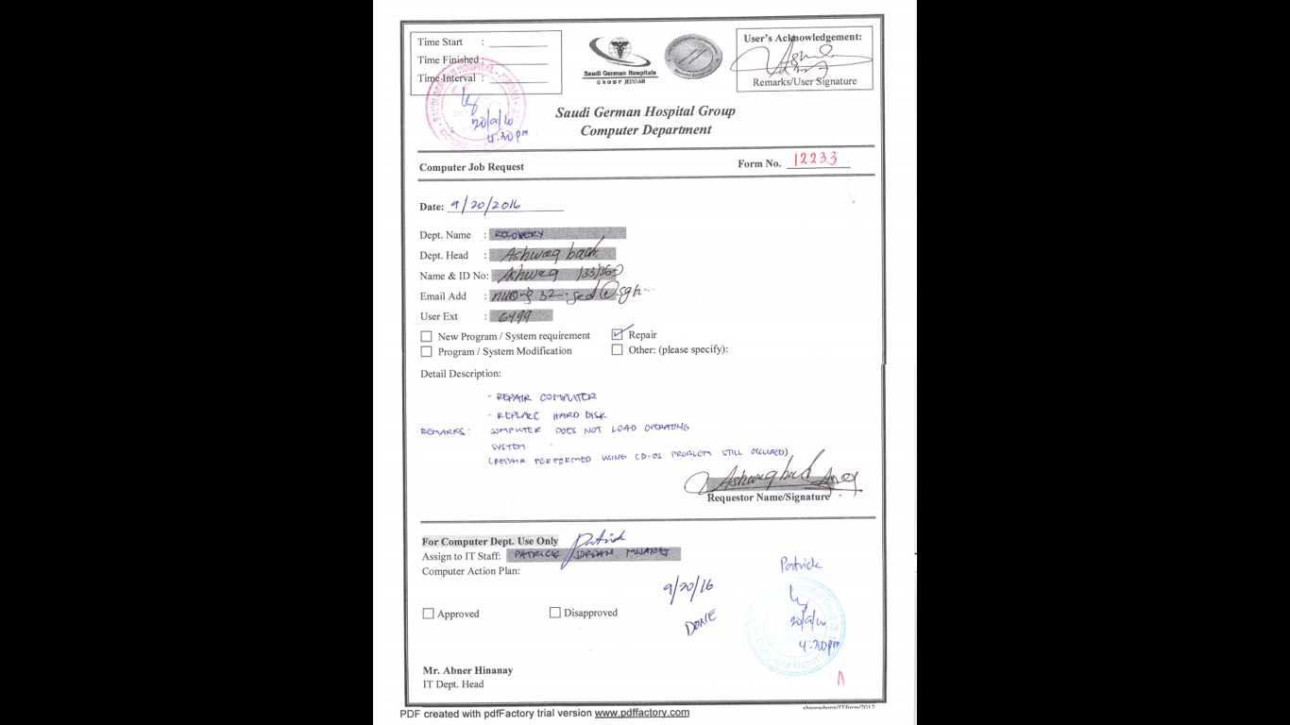

# **FAQ**

Common issues being raised by the end users.

# **Document Revision Log**

|  |  |  |  |
| --- | --- | --- | --- |
| **Date** | **Version No** | **Revised by** | **Description** |
| Aug 30, 2016 | IT ADMIN USERS MANUAL_ver0.1.docx | Grace B. Meneses | Initial Creation of Template |
| Sept 1, 2016 | IT ADMIN USERS MANUAL_ver0.2.docx | Grace B Meneses | Approved Template |
| Sept 1, 2016 | IT ADMIN USERS MANUAL_ver0.3.docx | Grace B Meneses | Gathering Materials, start of screen shots |
| Sept 4, 2016 | IT ADMIN USERS MANUAL_ver0.4.docx | Grace B Meneses | Wireframe |
| Sept 5, 2016 | IT ADMIN USERS MANUAL_ver0.5.docx | Grace B Meneses | Wire Frame & Update Screen Shots of Functions |
| Sept 6, 2016 | IT ADMIN USERS MANUAL_ver0.6.docx | Grace B. Meneses | Mapping of Functions |
| Sept 8, 2016 | IT ADMIN USERS MANUAL_ver0.7.docx | Grace B. Meneses | Started Utilities |
| Sept 8, 2016 | IT ADMIN USERS MANUAL_ver0.8.docx | Grace B. Meneses | Resizing and adjusting pages and alignments |
| Sept 20, 2016 | IT ADMIN USERS MANUAL_ver0.9.docx | Grace B. Meneses | Definition Function of Utilities  Update Logo Creation |
| Sept 20, 2016 | IT ADMIN USERS MANUAL_ver0.10.docx | Grace B. Meneses | Definition Function of Utilities and its Procedures |
| Sept 22, 2016 | IT ADMIN USERS MANUAL_ver0.11.docx | Grace B. Meneses | Updated Security and Utilities Modules based on Menu Update  Reports |
| Sept 22, 2016 | IT ADMIN USERS MANUAL_ver0.12.docx | Grace B. Meneses | Scanned Materials for the Appendix and Document Log |

# **Document Sign Off**

|  |  |  |  |  |
| --- | --- | --- | --- | --- |
| **Name** | **Position** | **Comments** | **Signature** | **Date** |
| Mr. Abner Hinanay | Group IT Manager |  |  |  |
| Mr. Peter Carmelo | Group Business Application Manager |  |  |  |
| Mr. Jerico Seguenza | Lead - Computer Programmer |  |  |  |
| Grace B. Meneses | Technical Writer |  |  |  |